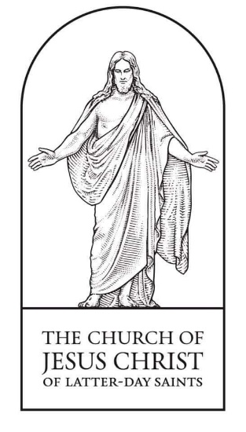  You are invited to attend  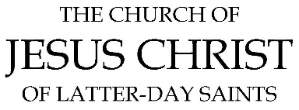  1020 N. Lake Forest Dr. McKinney, TX 75071  (469) 925-6693  SUNDAY  10:30 AM – 12:30 PM  McKinney 3rd Ward | You are invited to attend  1020 N. Lake Forest Dr. McKinney, TX 75071  (469) 925-6693  SUNDAY  10:30 AM – 12:30 PM  McKinney 3rd Ward
You are invited to attend  1020 N. Lake Forest Dr. McKinney, TX 75071  (469) 925-6693  SUNDAY  10:30 AM – 12:30 PM  McKinney 3rd Ward | You are invited to attend  1020 N. Lake Forest Dr. McKinney, TX 75071  (469) 925-6693  SUNDAY  10:30 AM – 12:30 PM  McKinney 3rd Ward
You are invited to attend  1020 N. Lake Forest Dr. McKinney, TX 75071  (469) 925-6693  SUNDAY  10:30 AM – 12:30 PM  McKinney 3rd Ward | You are invited to attend  1020 N. Lake Forest Dr. McKinney, TX 75071  (469) 925-6693  SUNDAY  10:30 AM – 12:30 PM  McKinney 3rd Ward
You are invited to attend  1020 N. Lake Forest Dr. McKinney, TX 75071  (469) 925-6693  SUNDAY  10:30 AM – 12:30 PM  McKinney 3rd Ward | You are invited to attend  1020 N. Lake Forest Dr. McKinney, TX 75071  (469) 925-6693  SUNDAY  10:30 AM – 12:30 PM  McKinney 3rd Ward
Find a church building   | Find a church building
Find a church building | Find a church building
Find a church building | Find a church building
Find a church building | Find a church building

