Toomey Times

Volume 12 We all know who wrote and typeset this….me, me, me, (Holly) December 1998

Thank you for all the wonderful letters and cards! We love hearing from you and reading about how you and your families are doing. Please keep those cards and letters coming! Now here’s how we did in 1998…

Our Family

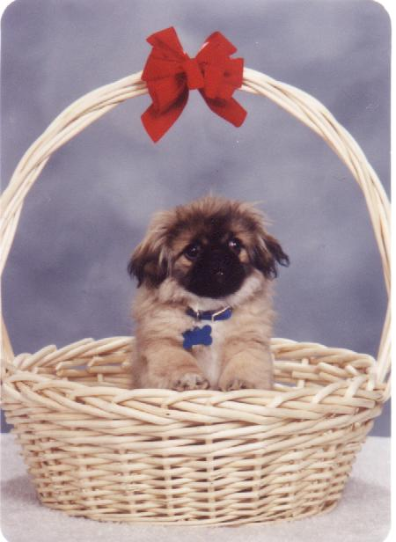
David (10), now in the 4th grade, is a budding gourmet chef (blue scrambled eggs, pancakes, fruit and custard pie). He enjoys soccer and is very computer literate (for example: he dialed up the Internet on his own, found a free maze generating game and downloaded it onto his Palm Pilot). He received his Bear Badge earlier this year and is now in the Webelos den. David’s highlights of 1998 include soccer, the dolphins at Sea World, and being the only one in his class to receive a Jolly Rancher recently for listening so well to his school teacher all day long.

Jonathan (6) prefers to be called “Jon” but assures Mom that it’s okay if she calls him “Jonathan.” He is currently enjoying the 1st grade. In addition to being our numbers man Jonathan has become a tremendous artist. He has already sold some of his picture books! A charmer and very sociable, Jonathan makes friends everywhere we go. Jonathan’s most remembered things this year were swimming in PG pool, sharing a room with Andrew, and visiting Grandpa Toomey where Grandpa gave him a candy bar when we left.

Andrew (3) is attending Joy School. “A” stands for Andrew — “that’s my name!” He enjoys being read to. His favorite TV shows are “Little Bear” and “Blue’s Clues,” which he has to have his Blue’s Clues notebook while watching. Andrew’s favorite color is blue (he’s crazy about the blue Power Ranger). He loves to swim, had lessons again from Pam Hartley, and can hardly wait to return to Lagoon. Andrew’s favorite things about 1998 were Lagoon (almost every night he asks when we’re going again) and playing with Xena.

Harold left CallWare in March and now works as a Product Manager for AXENT Technologies, an information security software company located only 4 miles from home. He travels a lot and enjoys life and work even more than before. Harold and Holly continue to enjoy their callings as Family History Consultants.

Holly is still “Mom” 24 hours a day. She teaches Joy School every fifth week. Aside from the normal judge, jury, chauffeur, nurse, and counselor stuff mommies do, she did a lot of gardening, canning and sewing this year. She is a wonderful wife and mother and is often referred to by Harold

as his “better two-thirds.” She makes the house a home.

“Emily” Gecko Toomey, a beautiful African Fat Tailed Gecko joined our family in February as Jonathan’s pet. The fatter her tail is the healthier she is. Gecko is often found hiding under her water dish. She is exciting to watch when we feed her crickets as she raises her tail and shakes it like a rattler before striking her meal. Jonathan entered Gecko in the Lindon Days Pet Show in August. She won first place in the “Most Unusual” category!

Xena “Warrior Puppy” Toomey, our newest member of the family, is a fluffy purebred Pekinese. Holly sent Harold and the boys out for crickets (Tarantula and Gecko food) and they came back with a puppy. The boys all signed a puppy maintenance contract before Xena’s stay became official. Harold calls her his non-allergy producing “kitty.”

Escaping Utah Valley

We can summarize this year with one word – travel. Harold gives Holly most of his frequent flier tickets as a peace offering since she so valiantly watches the kids while he travels.

January took Harold and Holly to Florida using two such free tickets. EPCOT and St. Cloud were our first stop where we visited our good friends Marie and Corinne White. We traveled through Florida in a convertible, which was great fun. In the Everglades we met a BBC filming crew and a family from England visiting Florida for the first time, having their vacation filmed for a show on the BBC channel. We stayed in the Ivy House in Everglades City and took an airboat tour through the everglades. After visiting the smallest post office in the US, we traveled down through the Keys, staying in Key West for a few days where we basked in the Keys’ atmosphere and watched the sun set on a balcony by the ocean.

In April the family went to San Diego, visiting Dog Beach (a favorite of David), Old Town, the Mormon Battalion Visitor’s Center, Sea World (a family favorite), and the San Diego Zoo. We also took our first harbor cruise, at which time the captain assured Jonathan that they had never had a shark jump on the ship and had never actually seen one on the harbor tour. And of course, Jonathan made some good friends on the cruise. We also ate at a great restaurant with glass walls, so we could see the sea gulls and the beautiful lights on the harbor ships.
The family returned to their favorite weekend spot in Vernal Utah during the summer. We visited the Dinosaur Quarry, the National Field House Museum, and the new LDS temple in Vernal. We rendezvoused to eat breakfast with Holly’s former missionary companion, Phebe Jane Hall, who lives in Vernal. Weekend getaways are great.

AXENT Technologies had a fun office day at the Lagoon amusement park in August. The whole family went accompanied by Joe and Marcia (Harold’s parents) and some cousins. We particularly enjoyed the Rattlesnake Rapids ride and the picnic dinner at the AXENT pavilion.

Harold and Holly took a weekend jaunt to Mesquite, Nevada in August and ventured out into the boondocks in a Hummer—a real thrill!

Shortly before Thanksgiving, Holly traveled with her mother, Zella Morrow, to Virginia. They explored Colonial Williamsburg where they listened to Thomas Jefferson speak. In Jamestown they stood where Pocahontas “did cart wheels” (maybe), and saw a plaque in honor of Edward Maria Wingfield, an uncle to a direct ancestor of Holly’s. The Yorktown battlefield, where Cornwallis surrendered to Washington in the Revolutionary War, was a very humbling, gratitude building and awesome experience for Holly. “A spirit of great reverence engulfed me as I contemplated the roles my ancestors played in that period of history and the tremendous part the hand of God had in those historical events of Yorktown and Jamestown.”

Thanksgiving was a hoot with Jeff and Rebecca Harris’ family, in Burley, Idaho. We went swimming, four wheeling, skeet shooting, played with Palm Pilots and Donald’s digital camera and more! It was a great holiday spent with the Toomey side of the family.

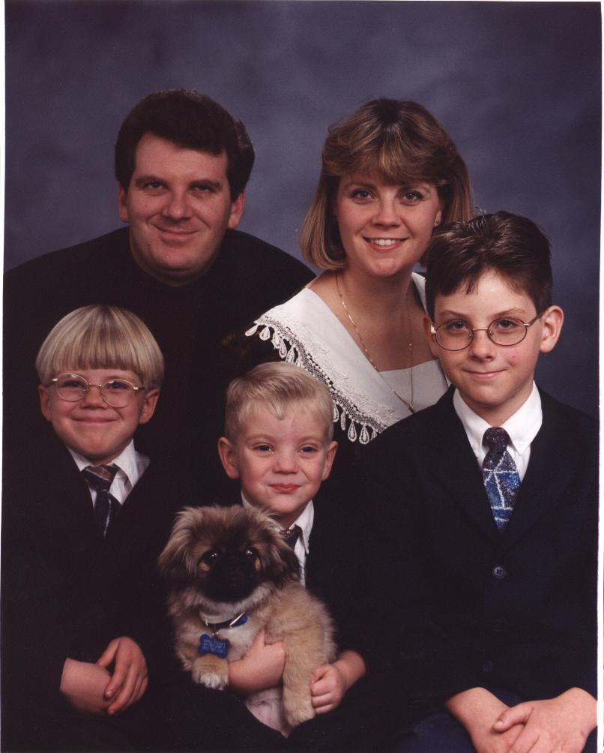
This time of year always causes feelings of gratitude for the freedoms we have in this country. Visiting Yorktown particularly caused feelings of reverence in Holly as she realized the powerful role Heavenly Father played in the founding of this country—for our freedom of religion and other freedoms we share. Thanksgiving always causes one to ponder on all we are thankful for. Thanksgiving is the perfect prelude to Christmas, at which time we celebrate the birth of Jesus Christ, our Redeemer. As we begin the New Year, may we continue to ponder upon the wonderful gifts we have been given and use them to help us enjoy life to its fullest.

With love from,

Harold, Holly, David,

Jon, and Andrew

Contacting Us

Harold & Holly Toomey
464 North 750 East
Lindon, UT 84042-1541

Home: (801) 785-0464
Mobile: (801) 376-1545 (Harold)
Mobile: (801) 360-4898 (Holly)
Work: (801) 227-3731
Fax: (801) 227-3781
Email: htoomey@ibm.net (Personal)
Email: htoomey@axent.com (Business)
Internet: www.toomey.org

PS – Every Toomey Times ever written can be found on the Internet at http://www.toomey.org/family/times/. Family web pages, recent photos, birthday lists, and email addresses are also on this web site. Pay us a visit next time you are on-line.

