Toomey Times
Volume 13
December 1999

Yes, its true, the Toomey family is now “Pretty in Pink.” Here’s our seasonal update.

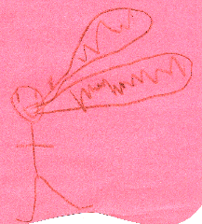
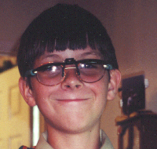
David (11) earned the highest achievement in Cub Scouts —the Arrow of Light Award —and began Boy Scouts this year. His loves include computers, dolphins, hummingbirds, his father, Key Lime pie and NY cheesecake, collecting Pokémon cards (his favorite is Mew), and the website www.shockwave.com for the great games. The highlight of his year was his trip to the Florida Keys with his dad. “I swam with Bottlenose Dolphins and had a variety of cakes and pies for lunches. I also met Marie and Corinne White (Mom’s mission friends) in St. Cloud.” David is always willing to help others. He loves to cook, especially elaborate breakfasts.

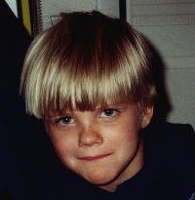
Jonathan (7) has grown a half-a-foot taller this year. After much effort he is reading very well, especially in the scriptures. Sometimes he can be found reading the Bible when he should be sleeping (and often he’s found playing when he’s supposed to be sleeping). His goal is to become the #1 reader at Lindon Elementary. Jonathan loves swimming, riding his bike, Pokémon cards and has become a talented artist. He also enjoys playing the card games “Five Crowns” and “Uno.” In the year 2000 he looks forward to turning eight, because “I get to be baptized AND be in Cub Scouts.”
"Heather Talking"
by Andrew


Andrew (4) has a heart of gold. His favorite color is consistently blue. When he grows up he wants to be the blue Power Ranger. He also plans to marry Monica, Alauna, Jessie AND Ani. (Dad says, “No man can serve more than one master.”) His loves this year have been swim lessons and playing at the pool, baths, anything chocolate, and starting real cars and motorboats. His favorite song is “I will go, I will DO, the things the Lord commands…”, and he can often be found singing lullabies to Heather. Andrew’s obsession is bearing his testimony and speaking in church.

Famous quotes from Andrew include:
 “Some people in the world eat dessert BEFORE dinner!”
 “Mom, it’s morning.” (Harold’s favorite)
 For Christmas he wants “that, that, that, and that, and….”
 While watching advertisements, during morning TV, he can be heard to say, “I’d like that. I’d like that….”
 “I love my sister. I’m going to let her do anything she wants, except go in the street and eat chocolate.” (Holly’s favorite)


Heather (soon-to-be 4 months) appropriately decided to be born three weeks early on Labor Day (9-6-99). It was a near perfect delivery. Daddy finally got his little girl! Sorry world, but she will be spoiled. Her favorite pastimes are smiling and coohing and staring at the “Jesus” light (she

probably thinks it’s Jesus?!). She really likes her baby swing. She now tries to laugh when Mom tickles her tummy and smiles at herself in the mirror.

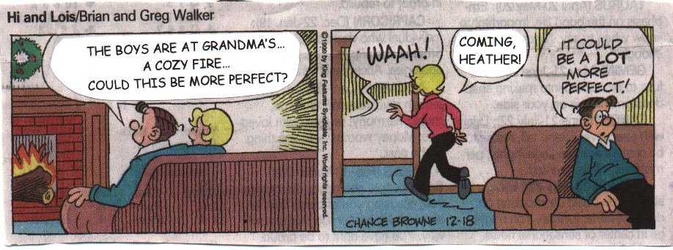
(Harold and Holly on a quiet evening)

Because we now have three boys and a girl, Harold plans on having a singing group named “3 Hits and a Miss.” But when will he have time for that? Busily traveling, he now has visited 14 different countries in his lifetime, including Mexico, China, and Japan this year alone! Currently, he enjoys updating our family website www.toomey.org, helping friends and neighbors with their PC problems, networking the Family History Center, being a Boy Scout merit badge counselor for genealogy, computers, and pioneering, and celebrating the recent release of the product he manages at work. Harold loves to spend quality time with the boys on weekends.

Holly was pregnant most of the year, but still managed to grow a vegetable garden during the summer, remodel the master bathroom, plan and attend a family vacation to Yellowstone and The Grand Teton National Parks, Cody and Thermopolis Wyoming, and attend most of the boys’ soccer games and practices. She recently celebrated her 13th wedding anniversary with Harold in San Francisco. Currently, she sings in the church choir and attends obedience school with Xena, the dog, (Xena’s training her well). Harold says, “The shrew has been tamed.” Holly also helps in Relief Society (the women’s organization at church), and is swamped with boy and baby stuff.

Xena may be swamped with baby puppy stuff at the end of January. That’s still questionable. She is, however, being house trained, and is learning how to sit and heal upon command.

Contacting Us

Harold & Holly Toomey
464 North 750 East

Lindon, UT 84042-1541

Home: (801) 785-0464
Mobile: (801) 376-1545 (Holly)
Mobile: (800) 857-7410 (Harold)
Work: (801) 227-3731
Fax: (435) 330-3234
Email: harold@toomey.org (Personal)
htoomey@axent.com (Business)
holly@toomey.org
david@toomey.org
jonathan@toomey.org
andrew@toomey.org
heather@toomey.org
Internet: www.toomey.org

Have a Merry Christmas and a Crisis-Free Y2K!

With love from,

Harold, Holly, David, Jon, Andrew and Heather



