


Toomey Times

Volume 18
December 2005

Another fantastic year has passed. Ready or not here is our annual update.

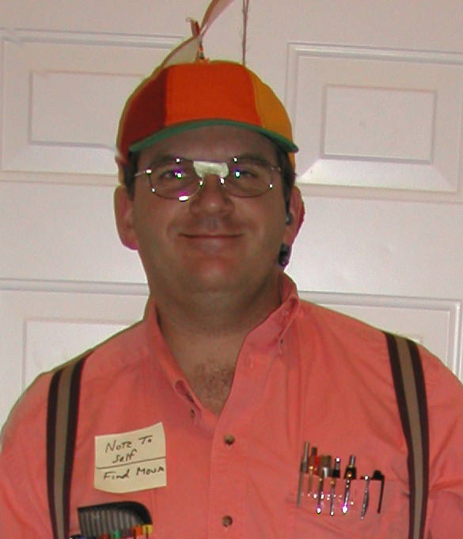
Harold, dressed here in his computer nerd Halloween costume, left Symantec in November after eight years. He is currently in between jobs and will keep you posted. He was released as Ward Executive Secretary and is now serving with the Ward boy scout troop once again. Harold was awarded the BSA District Extra Miler Award.


Holly has kept busy just getting everyone everywhere they need to go. She is also involved in Cub Scouting, teaching Taekwondo, and being Parent Council Secretary at Andrew and Heather’s school. She recently joined the Mary Kay team.

The Stake Young Men / Young Women Pioneer Trek was one of Holly’s highlights. Holly and Harold were two of the Ma’s and Pa’s of a pioneer family as 250 youth and 80 adult leaders pushed 40 handcarts up a mountain for three days.

Another highlight for Holly was attending her first international Taekwondo competition with several classmates in Las Vegas. Not only did she enjoy the company of those with her, but she came out of the competition with two more gold medals!


David (17) had major knee surgery in January and slowly bounced back to earn his black belt. Currently he co-teaches a Taekwondo class with Holly. He is a youth counselor for a special needs youth group, which he loves participating in. He has gone on 3 dates, one in a stretch limousine chauffeured by his dad.
During the summer, he went to EFY (Especially for Youth) at BYU for the 2nd time. He also enjoyed an exclusive solid hour of running around in the dark playing Laser Tag with his family on his birthday, and he has decided he would like to be a Clinical Psychologist when he grows up.

“It’s hard to decide” which one thing was the highlight of David’s year. It’s a toss-up between earning his black belt, co-teaching, youth counseling, and EFY. He is close to reaching his long-time goal of being both an Eagle Scout AND a black belt.
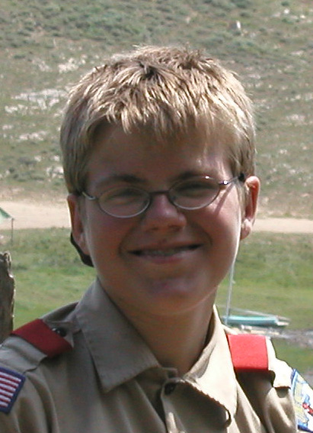
Jonathan (13) LOVES snow-boarding (even more than video games)! He is good for a beginner. Jonathan is a fast learner. He even enjoys a good wipe-out.

He is currently serving as Deacons Quorum President. He was also in the Pleasant Grove Manila Stake Pioneer Play.

The highlights of Jonathan’s year were snowboarding and ice skating. As you can see, he loves the snow and ice. He has just spent 2 hours building a large snow fort in our back yard.


Andrew (10) has decided he is going to be an actor. He was Harry (one of the twin lost boys) in his school play “Peter Pan,” and he will play Monroe in the 5th grade Lewis and Clark play. He looks forward to being in “Hope of America” with other 5th graders in 2006, and he will try-out for the Lincoln Pageant play at his school in February.

He earned his Advanced Green Belt in Taekwondo this year, and he is an assistant in a Taekwondo class. Andrew also played Baseball this year.
Andrew’s claims to fame are: 1) Star Wars Episode III came out on his birthday (he’s a HUGE fan), 2) he’s so strong he can pin down a teenager, and 3) he’s better at shooting a rifle than his father is (who is an NRA sharp shooter).

Last year he got a Siberian hamster named Stripey. Stripey is such a joy, particularly since his biological clock was adjusted, so he’s not making noise all night.


Heather (6) is still our princess. She loves kinder-garten! She loves to come up with homework to do and has a never-ending thirst for learning.

She played Soccer for her first time this year. She loves ponies, Care Bears, and dinosaurs! She always has something to say. Her current quest is to dissect a “real live” frog. She’s our little scientist and bug lover, and she will make a very good nurse or scientist when she grows up.

Each day we look to the Savior and try to do, say, and think as He does. We’re not perfect, but we’re trying. Throughout all the challenges and learning experiences we have, we know we are exceedingly blessed.

During this Christmas season we pray that you, too, may see the blessings through the trials, and thank God for His wonderful gift of His son Jesus Christ and all that He has given us.

Please keep in touch:

Harold & Holly Toomey

1376 North 1100 East

American Fork, UT 84003-3245

Home: (801) 492-1526
Home Office: (801) 847-0633 (VoIP)
Mobile: (801) 830-9987 (Harold)
Mobile: (801) 830-9986 (Holly)
Mobile: (801) 830-9984 (Marcia)
Mobile: (801) 830-9985 (David)
Internet: http://www.toomey.org/family/times/ (Toomey Times Archives)
Email: <first name>@toomey.org

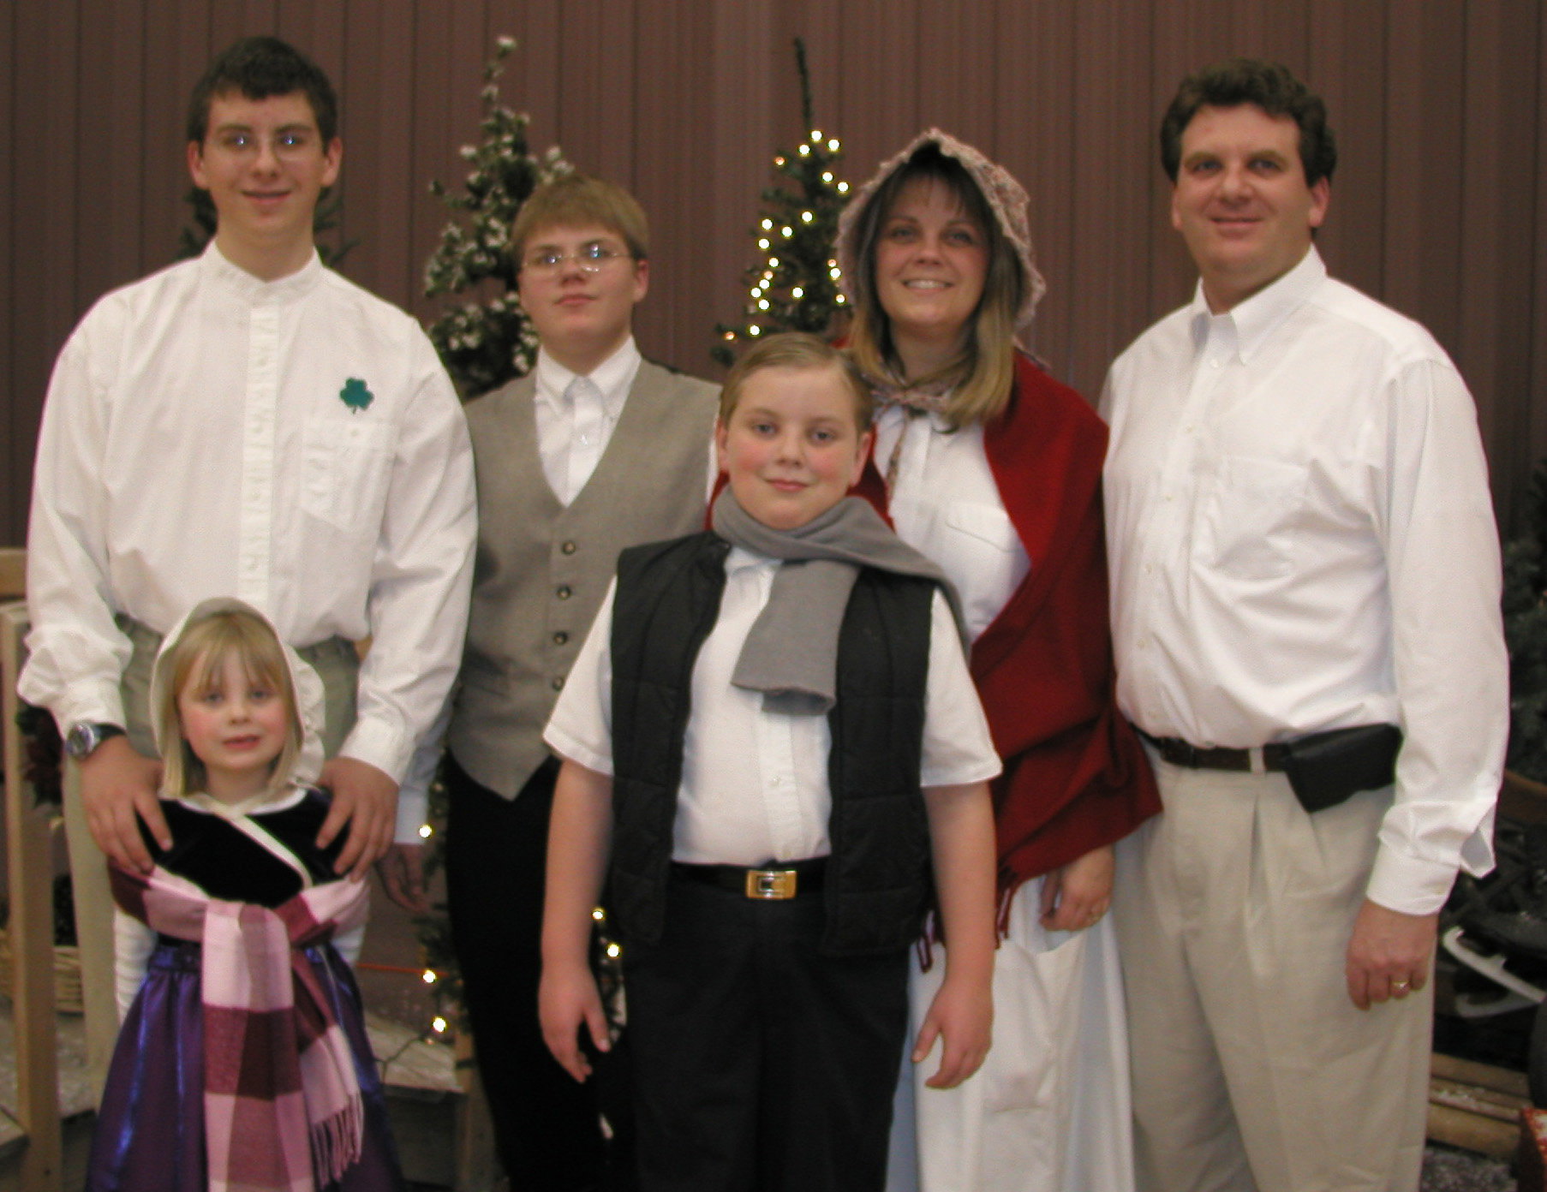



Merry Christmas

