

Toomey Times
December 2007
Volume 20

TX


Andrew (12) had a very busy year. He celebrated his birthday party at the Christa McAuliffe Space Education Center in Pleasant Grove, UT. He enjoyed playing at Boondocks with “just his dad” and then again with Micah Shenk and David. In Texas he attended the Star Wars Exhibit at the Fort Worth Museum of Science and History. He was a wreath bearer, with his cousin Sara Wade, in the Edward Maria Wingfield Memorial Service at Jamestown VA in April. He also loved water tubing with his new scout troop and biffing in almost every possible way.
Andrew confesses the highlights of his year were playing Mayor Shinn in his Utah school’s production of “The Music Man”, moving to Texas, getting his hamster, Buddy, and being in the 7th grade.
He would like to tell all his friends in Utah that “I miss you and hope you have a Merry Christmas and a Happy New Year!

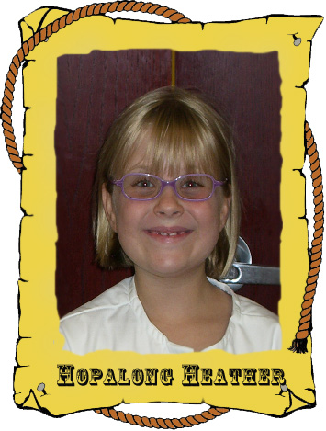
Heather (8) was a busy girl this year, being a Girl Scout in American Fork and a towns-person in “The Music Man” with Andrew. She recently finished after-school Spanish Camp. Heather loves learning Spanish!
She realized her life-long goal in September when she was baptized. Grandma Toomey, Grandma Morrow, and Grandpa Toomey all came to her baptism in Texas. Now Heather enjoys Activity Days every other week with the other eight year old girls in our church.
One of Heather’s pieces of art was recently displayed at the Heard Natural Science Museum here in McKinney, TX. In December she sang her first duet in church.
Heather wants everyone to know that we “have a pool”; she got two Hermit Crabs for her birthday, and

she now has a boy “Baby Alive.” She says to give “Hugs and kisses to everyone!”
When asked what she liked this year about vacation, Heather responded, “There was no vacation or at least I don’t think there was.”
Because there was no embarrassing moment about Heather in our last Christmas letter, she insisted one be put in the letter this year. Her most embarrassing moment was when she was accidentally late for school because she was “lost” reading a Book Fair book in the library. “I kind-of had to sign a ‘Your Child Made a Bad Choice’ paper.” She had a hard time getting over that incident.
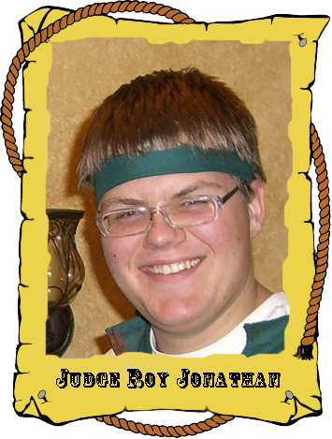
Jonathan (15), having graduated from 9th grade, is now in 10th grade at McKinney North High School. He only has 2½ years of high school left! “Yee haw!!”
Jonathan is committed to waking up extremely early for Early Morning Seminary. He leaves the house at 6:30 a.m. and doesn’t return until after 4:30 p.m. since high school begins late here.
Jonathan’s highlights of the year were attending EFY for the second time, helping with the haunted house at “The Zone” in McKinney and being a flag bearer in a memorial service for Edward Maria Wingfield at Jamestown VA in April. He enjoys designing Web sites on the computer, swimming in our pool (especially when it’s freezing in Utah), and being exactly as tall as Harold is now – 6’ 0.5”.

David (19) graduated from American Fork High School and is 6’ 2.5” tall. He began working at PetSmart, where he learned a lot about animals and sales. He is currently learning the ropes of selling things on eBay while saving for a 2-year religious church mission.
David’s church responsibilities include helping the full-time LDS missionaries in our area.
Since Texas has different plants and germs than Utah, the family has been “adjusting to” these germs on and off. David usually only gets affected slightly, probably due to his choice to no longer eat chocolate, but one recently had him down an entire week.

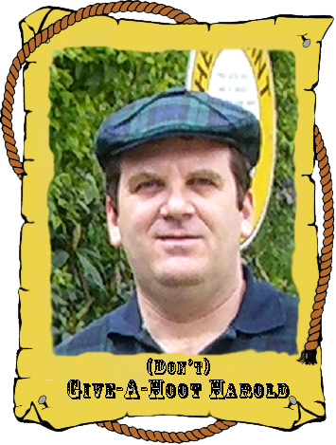
Harold (44) now works at the McAfee Plano office. There he helps McAfee build enterprise-class info security products used by large banks and the federal government.
Harold is serving as the Deacon’s Quorum Advisor and Assistant Scoutmaster. He had this calling several times before and still loves it.
The family theme for this year was Relocation. Moving 2 truck loads, 4 cars, 4 kids, 1 grandma, 4 birds, our dog Pappy, a chinchilla, and driving over 1,400 miles was a true adventure.
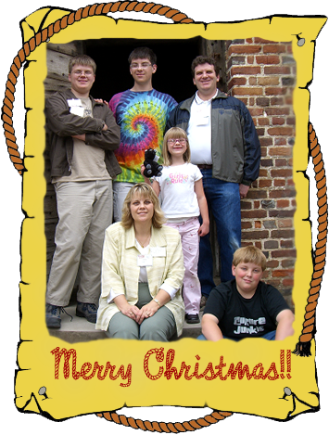
The highlight of the relocation from Utah to Texas was when the engine of the U-Haul truck containing all our irreplaceable valuables caught fire in Kansas. A pickup truck driver stopped, pulled out his fire extinguisher, and saved the day.
We feel blessed to have sold our home in Utah with the market being so down lately. We have felt the Lord’s guiding hand throughout the entire relocation experience.

Holly (21) is serving with the Public Affairs Committee of our church, which keeps the church involved in the community. This kept her very busy October through December, with the “Make a Difference Day” luncheon and annual “Christmas Crèche,” both hosted at McKinney’s LDS Stake Center.
Our family went to Jamestown, Williamsburg, and Yorktown with the Wingfield Family Society for a reunion in April during the Jamestown 400th Anniversary celebration. We learned so much and met many wonderful people.
The move to Texas proved eventful. And though we met many “good Samaritans,” Holly does not wish to repeat that experience any time soon. She was challenged in ways she never knew were possible, and she was humbled and strengthened by the whole event. Now that the rough stuff is over (for now anyway), Holly can honestly say, “I love the area, the people, the house, and the weather!”

We certainly feel the blessings of a loving Father in Heaven. We hope 2008 brings many wonderful experiences to all of you as 2007 has to our family.

Please keep us updated on you and your family!

Our new contact information is:
Harold & Holly Toomey
8609 Herns Meadow Lane
McKinney, TX 75071-5938

Home: (972) 548-2262 - Local to TX
(801) 492-1526 - Local to UT (VoIP)
Mobile: (801) 830-9987 - Harold
(801) 830-9986 - Holly
(801) 830-9985 - David
(801) 830-9984 - Marcia
Work: (972) 963-7510 - Harold
Fax: (972) 963-7529 - Harold
Email: <first name>@Toomey.org
Web: http://www.toomey.org/family/times

