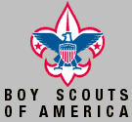
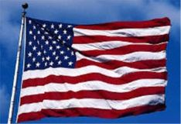
Troop 1197 Flag Posting
Participation Roll 2002
Page 1

Name | 21 Jan  Human Rights Day |  | 18 Feb  President’s Day |  | 18 May  Armed Forces Day |  | 27 May  Memorial Day |  | 14 Jun  Flag Day |  | 4 July  Independence Day |  | 25 July  Pioneer Day
Name | AM | PM | AM | PM | AM | PM | AM | PM | AM | PM | AM | PM | AM | PM

David Toomey

Dallin Johnson
Thomas Cox

Mason Porter
Bobby Kittell
Brian Harris
Chandler Warr
Marston Na’Oupu
Gray Lund
.

Troop 1197 Flag Posting
Participation Roll 2002
Page 2

Name | 2 Sep  Labor Day |  | 11 Sep WTC Remembrance Day |  | 14 Oct  Columbus Day |  | 5 Nov  Election Day |  | 11 Nov  Veteran’s Day |  | 28-29 Nov  Thanksgiving Holiday
Name | AM | PM | AM | PM | AM | PM | AM | PM | AM | PM | AM | PM | AM | PM

David Toomey

Dallin Johnson
Thomas Cox

Mason Porter
Bobby Kittell
Brian Harris
Chandler Warr
Marston Na’Oupu
Gray Lund
.

