Harold’s Calculus 3
Multi-Coordinate System
Cheat Sheet
29 November 2022

 | Rectangular | Polar/Cylindrical |  | Spherical | Parametric | Vector | Matrix
Point | 2D  $$f\left(x\right)= y$$  $$\left(x, y\right)$$  $$\left(a, b\right)$$  3D  $$f\left(x, y\right)=z$$  $$\left(x, y, z\right)$$  4D  $$f\left(x, y, z\right)=w$$  $\left(x, y, z, w\right)$  • | $(r , θ)$ or $r ∠ θ$ |  | $(ρ , θ, ϕ)$  $$x=ρ sin ϕ cos θ$$  $$y=ρ\sin{ϕ\sin{θ}}$$  $$z=ρ cos ϕ$$  $$ρ^{2}= r^{2}+ z^{2}$$  $$ρ^{2}= x^{2}+y^{2}+ z^{2}$$  $$\tan{θ}=\left(\frac{y}{x}\right)$$  $$ϕ= \cos^{-1}\left(\frac{z}{\sqrt{x^{2}+ y^{2}+ z^{2}}}\right)$$  $$ϕ= \cos^{-1}\left(\frac{z}{ρ}\right)$$ | Point (a,b) in Rectangular :  $$x\left(t\right)=a$$  $$y\left(t\right)=b$$  $$<a,b>$$  $t=3^{rd} variable, usually time$,  with 1 degree of freedom (df) | $$\vec{r}= 〈x_{0}, y_{0}, z_{0}〉$$  $$\vec{r}= x\hat{i}+y\hat{j}+z\hat{k}$$ | $$\begin{matrix}\left[a\right] & \left[x\right]\end{matrix}= \left[b\right]$$
 |  | Polar Rect.  $$x=r\cos{θ}$$  $$y=r\sin{θ}$$  $$z=z$$  $$\tan{θ}=\frac{y}{x}$$ | Rect. Polar  $$r^{2}= x^{2}+y^{2}$$  $r= ± \sqrt{x^{2}+ y^{2}}$  $$θ=\tan^{-1}\left(\frac{y}{x}\right)$$
Line | Slope-Intercept Form:  $$y=mx+b$$  Point-Slope Form:  $$y- y_{0}=m (x-x_{0})$$  General Form:  $$Ax+By+C=0$$  $$where A and B≠0$$  Calculus Form:  $$f\left(x\right)=f^{'}\left(a\right) x+f(0)$$  where $m = f’(a)$  3-D:  $$\frac{x- x_{0}}{a}= \frac{y- y_{0}}{b}= \frac{z- z_{0}}{c}$$ | 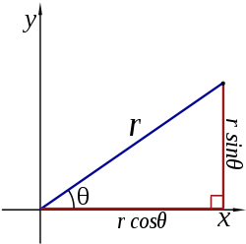  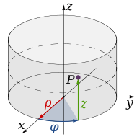 |  | 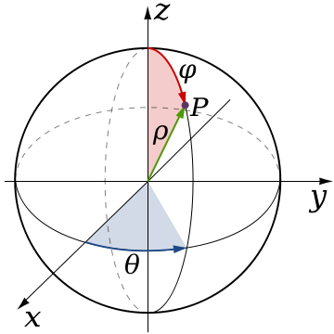 | $$<x,y> = <x_{0},y_{0}>+ t<a,b>$$  $$<x,y> = <x_{0}+at,y_{0}+bt>$$  where  $$<a,b> = <x_{2}-x_{1}, { y}_{2}-y_{1}>$$  $$x(t)= x_{0}+ ta$$  $$y(t)= y_{0}+ tb$$  $$m=\frac{∆y}{∆x}=\frac{{ y}_{2}-y_{1}}{x_{2}-x_{1}}=\frac{b}{a}$$ | $$\vec{r}= \vec{r_{0}}+t \vec{v}$$  $$= 〈x_{0}, y_{0}, z_{0}〉+t 〈a, b, c〉$$ | $$\left[\begin{matrix}a & b\end{matrix}\right] \left[\begin{matrix}x \\ y\end{matrix}\right]= \left[c\right]$$  $$\left[\begin{matrix}a & b \\ c & d\end{matrix}\right] \left[\begin{matrix}x \\ y\end{matrix}\right]= \left[\begin{matrix}e \\ f\end{matrix}\right]$$
Plane | $$a\left(x- x_{0}\right)$$  $$+ b\left(y- y_{0}\right)$$  $$+ c\left(z- z_{0}\right)=0$$  $$ax+by+cz=d$$  $$where d= ax_{0}+by_{0}+cz_{0}$$  $$f\left(x, y\right)= Ax+By+C$$ | $$(r , θ, constant)$$  $$\left(0≤r< ∞\right)$$  $$(0≤θ< 2π)$$  $$where r and θ take on all$$  $values in their domain$s |  | $$(ρ , θ, constant)$$  $$\left(0≤ρ< ∞\right)$$  $$(0≤θ< 2π)$$  $$where ρ and θ take on all$$  $$values in their domains$$ | $$r= r_{0}+ sv+tw$$  where:  - s and t range over all real numbers  - v and w are given vectors defining the plane  - $r_{0}$ is the vector representing the position of an arbitrary (but fixed) point on the plane | $$n ⦁ \left(r- r_{0}\right)=0$$ | 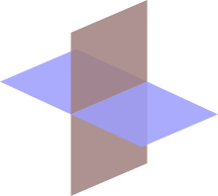
Conics | General Equation for All Conics:  $$Ax^{2}+Bxy+Cy^{2}+Dx+Ey+F=0$$  where  $$Line: A=B=C=0$$  $$Circle: A=C and B=0$$  $$Ellipse: AC>0$$  $$or B^{2}-4AC<0$$  $$Parabola: AC=0$$  or $B^{2}-4AC=0$  $$Hyperbola: AC<0$$  $$or B^{2}-4AC>0$$  Note: If $A+C=0$, square hyperbola  Rotation:  If B ≠ 0, then rotate coordinate system:  $$\cot{2θ}=\frac{A-C}{B}$$  $$x=x'\cos{θ-y'\sin{θ}}$$  $$y=y'\cos{θ+x'\sin{θ}}$$  New = (x’, y’), Old = (x, y)  rotates through angle $θ$ from x-axis  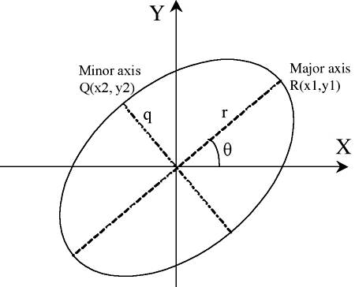 | General Equation for All Conics:  Vertical Axis of Symmetry:  $$r=\frac{p}{1-e\cos{θ}}$$  Horizontal Axis of Symmetry:  $$r=\frac{p}{1-e\sin{θ}}$$  $$where p=\left\{\begin{aligned} a \left(1-e^{2}\right) \\ 2d \\ a \left(e^{2}-1\right)\end{aligned}\right.for \left\{\begin{aligned} 0≤e<1 \\ e=1 \\ e>1\end{aligned}\right.$$  p = semi-latus rectum  or the line segment running from the focus to the curve in a direction parallel to the directrix  Eccentricity:  $$\begin{aligned}Circle e=0 \\ Ellipse 0<e<1 \\ Parabola e=1 \\ Hyperbola e>1\end{aligned}$$  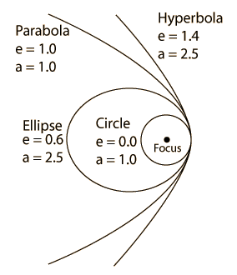 |  | 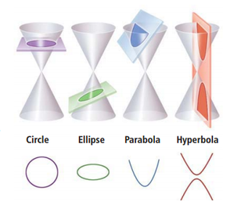  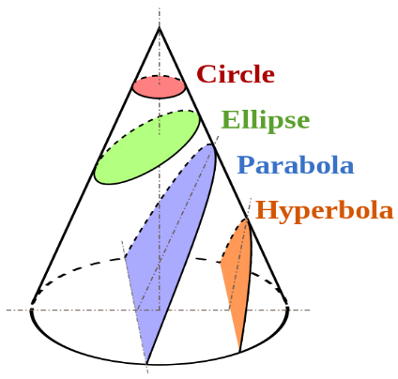 |  |  | NA

Circle | $$x^{2}+y^{2}=r^{2}$$  $${(x-h)}^{2}+{(y-k)}^{2}=r^{2}$$  General Form:  $$Ax^{2}+Bxy+Cy^{2}+Dx+Ey+F=0$$  $$where A=C and B=0$$  Center: $\left(h,k\right)$  Vertices: NA  Focus: $\left(h,k\right)$  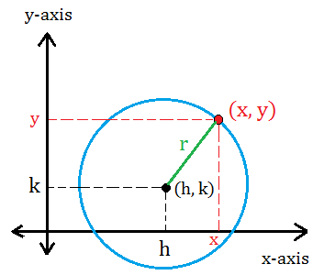 | Centered at Origin:  r = a (constant)  $$θ = θ \left[0, 2π\right] or [0, 360°]$$  Centered at $(r_{0},ϕ)$:  $$r^{2}+r_{0}^{2}-2rr_{0}\cos\left(θ-ϕ\right)=R^{2}$$  Hint: Law of Cosines  or  $$r=r_{0}\cos\left(θ-ϕ\right)+\sqrt{a^{2}-r_{0}^{2} \sin^{2}(θ-ϕ)}$$  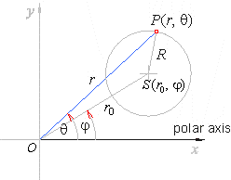 | $$ρ= constant$$  $$θ= θ [0, 2π]$$  $$ϕ=constant=0$$ | $$x(t)=r\cos{(t)}+h$$  $$y(t)=r\sin{(t)}+k$$  $$\left[t_{min}, { t}_{max}\right]=[0, 2π)$$  Center: $\left(h,k\right)$  Focus: $\left(h,k\right)$ | NA | NA
Sphere | $$x^{2}+y^{2}+z^{2}=r^{2}$$  $${(x-h)}^{2}+{(y-k)}^{2}+{(z-l)}^{2}=r^{2}$$  $$Focus and center:$$  $$(h, k, l)$$  General Form:  $$Ax^{2}+By^{2}+Cz^{2}$$  $$+ Dxy+Eyz+Fxz$$  $$+ Gx+Hy+Iz+J=0$$  $where A=B=C$ > 0  Cylindrical to Rectangular:  $$x=r cos⁡(θ)$$  $$y=r sin⁡(θ)$$  $$z=z$$  Spherical to Rectangular:  $$x=r\sin{θ}\cos{ϕ}$$  $$y=r\sin{θ}\sin{ϕ}$$  $$z=r\cos{θ}$$ | Rectangular to Cylindrical:  $$r= \sqrt{x^{2}+y^{2}}$$  Spherical to Cylindrical:  $$ρ=r sin⁡(θ)$$  $$ϕ=ϕ$$  $$z=r cos⁡(θ)$$ | $$ρ= constant$$  $$θ= θ [0, 2π]$$  $$ϕ=ϕ [0, 2π]$$  Rectangular to Spherical:  $$r=\sqrt{x^{2}+y^{2}+z^{2}}$$  $$θ=arccos\left(\frac{z}{r}\right)$$  $$ϕ=arctan\left(\frac{y}{x}\right)$$  Cylindrical to Spherical:  $$r= \sqrt{ρ^{2}+z^{2}}$$  $$θ= arctan\left(\frac{ρ}{z}\right)=arccos\left(\frac{z}{r}\right)$$  $$ϕ=ϕ$$ | 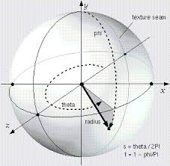 | Rectangular:  $$r≡\left[\begin{aligned}x \\ y \\ z\end{aligned}\right]$$  Cylindrical:  $$r≡\left[\begin{aligned}r cos⁡(θ) \\ r sin⁡(θ) \\ z\end{aligned}\right]$$  Spherical:  $$r≡\left[\begin{aligned}r\sin{θ}\cos{ϕ} \\ r\sin{θ}\sin{ϕ} \\ r\cos{θ}\end{aligned}\right]$$ | 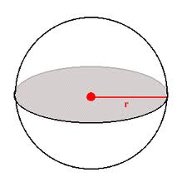
Ellipse | $$\frac{{(x-h)}^{2}}{a^{2}}+\frac{{(y-k)}^{2}}{b^{2}}=1$$  General Form:  $$Ax^{2}+Bxy+Cy^{2}+Dx+Ey$$  $$+F=0$$  where $B^{2}-4AC<0 or AC>0$  Center: $\left(h,k\right)$  Vertices: $\left(h±a, k\right)$  Co-Vertices: $\left(h, k±b\right)$  Foci: $\left(h±c, k\right)$  Focus length, c, from center:  $$c^{2}= a^{2}-b^{2}$$  Eccentricity:  $$e= \frac{c}{a}= \frac{\sqrt{a^{2}- b^{2}}}{a}$$  If B ≠ 0, then rotate coordinate system:  $$\cot{2θ}=\frac{A-C}{B}$$  $$x=x'\cos{θ-y'\sin{θ}}$$  $$y=y'\cos{θ+x'\sin{θ}}$$  New = (x’, y’), Old = (x, y)  rotates through angle $θ$ from x-axis | Vertical Axis of Symmetry:  $$r=\frac{a (1-e^{2})}{1±e\cos{θ}}$$  Horizontal Axis of Symmetry:  $$r=\frac{a (1-e^{2})}{1±e\sin{θ}}$$  $$Eccentricity: 0<e<1$$  $$r\left(θ\right)=\frac{a b}{\sqrt{{(b\cos{θ})}^{2}+{(a\sin{θ})}^{2}}}$$  relative to center $(h, k)$  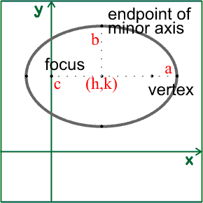 | 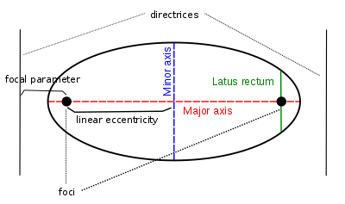  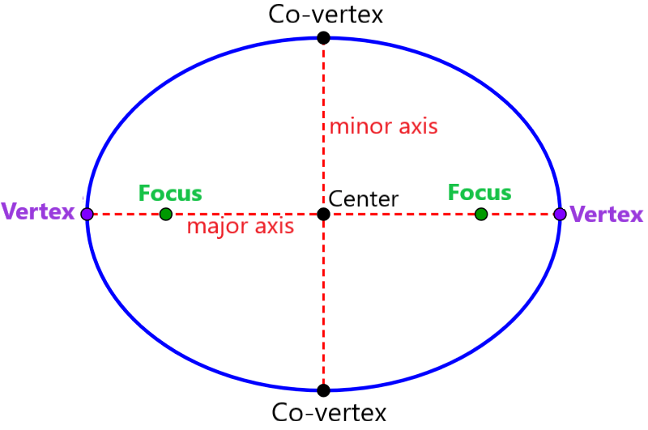  Interesting Note:  The sum of the distances from each focus to a point on the curve is constant.  $$\left|d_{1}+d_{2}\right|=k$$ | $$x(t)=a\cos{(t) }+h$$  $$y(t)=b\sin{(t})+ k$$  $$\left[t_{min}, { t}_{max}\right]=[0, 2π]$$  Center: $\left(h,k\right)$  Rotated Ellipse:  $$x\left(t\right)=a\cos{t\cos{θ-b\sin{t\sin{θ}}}}+h$$  $$y\left(t\right)=a\cos{t\sin{θ+b\sin{t\cos{θ}}}}+k$$  $θ$ = the angle between the x-axis and the major axis of the ellipse
Ellipsoid | $$\frac{{(x-h)}^{2}}{a^{2}}+\frac{{(y-k)}^{2}}{b^{2}}+\frac{{(z-l)}^{2}}{c^{2}}=1$$ | $$\frac{r^{2}\cos^{2}θ}{a^{2}}+\frac{r^{2}\sin^{2}θ}{b^{2}}+\frac{z^{2}}{c^{2}}=1$$ | $$\frac{r^{2}\cos^{2}θ \sin^{2}ϕ}{a^{2}}$$  $$+\frac{r^{2}\sin^{2}θ \sin^{2}ϕ}{b^{2}}$$  $$+\frac{r^{2}\cos^{2}ϕ}{c^{2}}=1$$ | $$x(t,u)=a\cos{(t) cos(u)}+h$$  $$y(t,u)=bcos\left(t\right) sin{(u})+ k$$  $z\left(t,u\right)=c sin(t)+ l$  $$\left[t_{min}, { t}_{max}\right]=\left[-\frac{π}{2}, \frac{π}{2}\right]$$  $$\left[u_{min}, { u}_{max}\right]=[-π, π]$$  $$Center: \left(h, k,l\right)$$ | 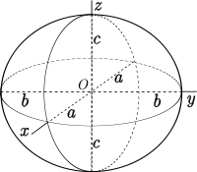 | $${\left(x-v\right)}^{T}A^{-1}\left(x-v\right)=1$$  Centered at vector $v$
Hyperbola | $$\frac{{\left(x-h\right)}^{2}}{a^{2}}-\frac{{\left(y-k\right)}^{2}}{b^{2}}=1$$  General Form:  $$Ax^{2}+Bxy+Cy^{2}+Dx+Ey+F=0$$  where $B^{2}-4AC>0 or AC<0$  If $A+C=0$, square hyperbola  Center: $\left(h,k\right)$  Vertices: $\left(h±a, k\right)$  Foci: $\left(h±c, k\right)$  Focus length, c, from center:  $$c^{2}= a^{2}+b^{2}$$  Eccentricity:  $$e= \frac{c}{a}= \frac{\sqrt{a^{2}+ b^{2}}}{a}=\sec{θ}$$  If B ≠ 0, then rotate coordinate system:  $$\cot{2θ}=\frac{A-C}{B}$$  $$x=x'\cos{θ-y'\sin{θ}}$$  $$y=y'\cos{θ+x'\sin{θ}}$$  New = (x’, y’), Old = (x, y)  rotates through angle $θ$ from x-axis | 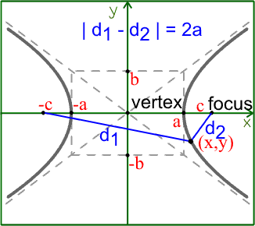  Interesting Note:  The difference between the distances from each focus to a point on the curve is constant.  $\left|d_{1}-d_{2}\right|=k$ | Vertical Axis of Symmetry:  $$r=\frac{a (e^{2}-1)}{1±e\cos{θ}}$$  Horizontal Axis of Symmetry:  $$r=\frac{a (e^{2}-1)}{1±e\sin{θ}}$$  $$Eccentricity: e>1$$  $$where e= \frac{c}{a}= \frac{\sqrt{a^{2}+ b^{2}}}{a}=\sec{θ>1}$$  relative to center (h, k)  $$-\cos^{-1}\left(-\frac{1}{e}\right)<θ<\cos^{-1}\left(-\frac{1}{e}\right)$$  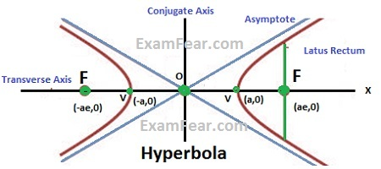  p = semi-latus rectum  or the line segment running from the focus to the curve in the directions $θ=± \frac{π}{2}$ | Left-Right Opening Hyperbola:  $$x(t)=a\sec{(t)}+h$$  $$y(t)=b\tan{(t)}+k$$  $$\left[t_{min}, { t}_{max}\right]=[-c, c]$$  Vertex: (h, k)  Alternate Form:  $$x(t)= ±a\cosh{(t)}+ h$$  $$y(t)=b\sinh{(t)}+ k$$  Up-Down Opening Hyperbola:  $$x(t)=a\tan{(t)}+h$$  $$y(t)=b\sec{(t)}+k$$  $$\left[t_{min}, { t}_{max}\right]=[-c, c]$$  Vertex: (h, k)  Alternate Form:  $$x(t)=a\sinh{(t)}+ h$$  $$y(t)=±b\cosh{(t)}+ k$$  General Form:  $$x(t)=At^{2}+ Bt+C$$  $$y(t)=Dt^{2}+ Et+F$$  where A and D have different signs
Hyperboloid | $$\frac{{\left(x-h\right)}^{2}}{a^{2}}+\frac{{\left(y-k\right)}^{2}}{b^{2}}-\frac{{\left(z-l\right)}^{2}}{c^{2}}=1$$  $$- \frac{{\left(x-h\right)}^{2}}{a^{2}} - \frac{{\left(y-k\right)}^{2}}{b^{2}}+\frac{{\left(z-l\right)}^{2}}{c^{2}}=1$$ | 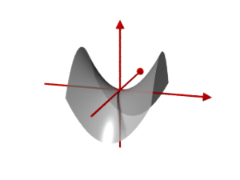 | 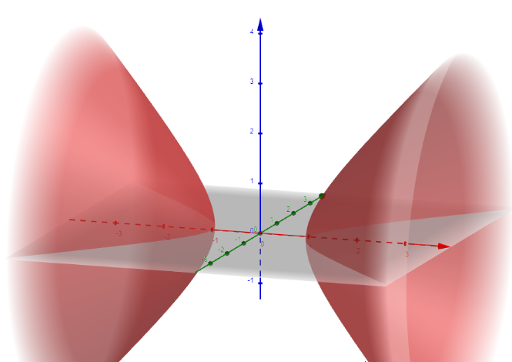
Parabola | Vertical Axis of Symmetry:  $$x^{2}=4 py$$  $${\left(x-h\right)}^{2}=4p(y-k)$$  Vertex: $\left(h,k\right)$  Focus: $\left(h,k+p\right)$  Directrix: $y=k-p$  Horizontal Axis of Symmetry:  $$y^{2}=4 px$$  $${\left(y-k\right)}^{2}=4p(x-h)$$  Vertex: $\left(h,k\right)$  Focus: $\left(h+p,k\right)$  Directrix: $x=h-p$  General Form:  $$Ax^{2}+Bxy+Cy^{2}+Dx+Ey+F=0$$  where $B^{2}-4AC=0$  or $AC=0$  If B ≠ 0, then rotate coordinate system:  $$\cot{2θ}=\frac{A-C}{B}$$  $$x=x'\cos{θ-y'\sin{θ}}$$  $$y=y'\cos{θ+x'\sin{θ}}$$  New = (x’, y’), Old = (x, y)  rotates through angle $θ$ from x-axis | Vertical Axis of Symmetry:  $$r=\frac{ed}{1±e\cos{θ}}$$  Horizontal Axis of Symmetry:  $$r=\frac{ed}{1±e\sin{θ}}$$  $$Eccentricity: e=1$$  and $d=2p$  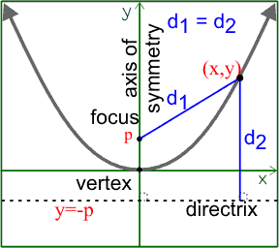 | 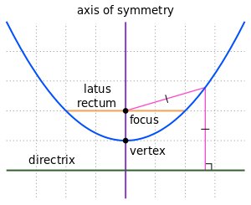  Interesting Note:  The distances from a point on the curve to the focus is the same as to the directrix. | Vertical Axis of Symmetry:  $$x\left(t\right)= 2pt+ h$$  $y\left(t\right)=pt^{2}+k$ (opens upwards)  $y\left(t\right)=-pt^{2}-k$ (opens downwards)  $$\left[t_{min}, { t}_{max}\right]=[-c, c]$$  Vertex: $\left(h,k\right)$  Horizontal Axis of Symmetry:  $$y\left(t\right)= 2pt+ k$$  $x\left(t\right)=pt^{2}+h$ (opens to the right)  $x\left(t\right)=-pt^{2}-h$ (opens to the left)  $$\left[t_{min}, { t}_{max}\right]=[-c, c]$$  Vertex: $\left(h,k\right)$  Projectile Motion:  $$x\left(t\right)=x_{0}+v_{x}t+\left(\frac{1}{2}\right)a_{x}t^{2}$$  $y\left(t\right)=y_{0}+v_{y}t-16t^{2}$ feet  $y\left(t\right)=y_{0}+v_{y}t-4.9t^{2}$ meters  $$v_{x}=v\cos{θ}$$  $$v_{y}=v\sin{θ}$$  General Form:  $$x=At^{2}+ Bt+C$$  $$y=Lt^{2}+ Mt+N$$  where A and L have the same sign
Paraboloid | $$\frac{{(x-h)}^{2}}{a^{2}}+\frac{{(y-k)}^{2}}{b^{2}}=\frac{{(z-l)}^{2}}{c^{2}}$$ | 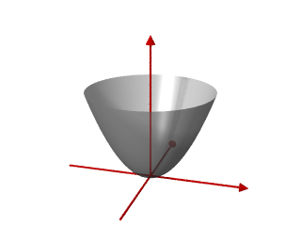

Limit | $$\lim_{x→c}{f(x)}=L$$ | 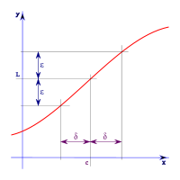 |  | 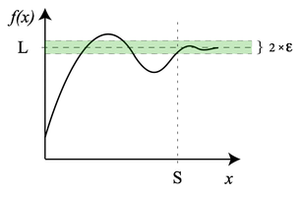
1st Derivative | $$f^{'}\left(x\right)=\lim_{h→0}{\frac{f\left(x+h\right)-f(x)}{h}}$$  $$f^{'}\left(c\right)=\lim_{x→c}{\frac{f\left(x\right)-f(c)}{x-c}}$$  $$f^{'}\left(x\right)=\frac{dy}{dx}=y^{'}=D_{x}$$ | $$\frac{dy}{dx}=\frac{\frac{dy}{dθ}}{\frac{dx}{dθ}}=\frac{\frac{dr}{dθ}\sin{θ}+ r\cos{θ}}{\frac{dr}{dθ}\cos{θ-r\sin{θ}}}$$  Hint: Use Product Rule for  $$y=r\sin{θ}$$  $$x=r cos θ$$ |  |  | $$\frac{dy}{dx}=\frac{\frac{dy}{dt}}{\frac{dx}{dt}} , provided\frac{dx}{dt}≠0$$ | $$\frac{d}{dt}\left(\vec{r}\right)= \vec{r} '$$  Unit tangent vector  $$\vec{T}\left(t\right)= \frac{ \vec{r}'(t)}{\left\|\vec{r}'(t)\right\|} where {\vec{r}}^{'}\left(t\right)≠\vec{0}$$
2nd Derivative | $$f^{''}\left(x\right)=\frac{d}{dx}\left(\frac{dy}{dx}\right)= \frac{d^{2}y}{dx^{2}}=y^{''}=D_{xx}$$ | $$\frac{d^{2}y}{dx^{2}}=\frac{d}{dx}\left(\frac{dy}{dx}\right)=\frac{\frac{d}{dθ}\left(\frac{dy}{dx}\right)}{\frac{dx}{dθ}}$$ |  |  | $$\frac{d^{2}y}{dx^{2}}=\frac{d}{dx}\left(\frac{dy}{dx}\right)=\frac{\frac{d}{dt}\left(\frac{dy}{dx}\right)}{\frac{dx}{dt}}=\frac{\frac{d}{dt}\left(\frac{\frac{dy}{dt}}{\frac{dx}{dt}}\right)}{\frac{dx}{dt}}$$ | Unit normal vector  $$\vec{N}\left(t\right)= \frac{ \vec{T}'(t)}{\left\|\vec{T}'(t)\right\|} where {\vec{T}}^{'}\left(t\right)≠\vec{0}$$
Integral | Fundamental Theorem of Calculus:  $$F\left(x\right)=\int_{a}^{b}{f\left(x\right) dx} =F\left(b\right)-F(a)$$ | 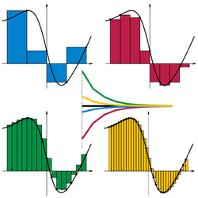 |  |  | Riemann Sum:  $$S=\sum_{i-1}^{n}{f(y_{i})(x_{i}-x_{i-1})}$$  Left Sum:  $$S= \left(\frac{1}{n}\right)\left[\begin{aligned}f\left(a\right)+f\left(a+\frac{1}{n}\right)+ \\ f\left(a+\frac{2}{n}\right)+…+f(b-\frac{1}{n})\end{aligned}\right]$$  Middle Sum:  $$S= \left(\frac{1}{n}\right)\left[f\left(a+\frac{1}{2n}\right)+f\left(a+\frac{3}{2n}\right)+…+f(b-\frac{1}{2n})\right]$$  Right Sum:  $$S= \left(\frac{1}{n}\right)\left[f\left(a+\frac{1}{n}\right)+f\left(a+\frac{2}{n}\right)+…+f(b)\right]$$ | $$\int_{a}^{b}{\vec{r}\left(t\right) dt= 〈\int_{a}^{b}{f\left(t\right)dt}, \int_{a}^{b}{g\left(t\right)dt}, \int_{a}^{b}{h\left(t\right)dt}〉 }$$
Double Integral | $$\int_{a}^{b}{\int_{c(y)}^{d(y)}{f\left(x,y\right) dx dy}}$$ | $$Same as rectangular, but$$  $$f\left(x,y\right)⟶f(ρ\cos{ϕ}, ρ\sin{ϕ})$$
Triple Integral | $$\int_{a}^{b}{\int_{c(z)}^{d(z)}{\int_{e(y,z)}^{g(y,z)}{f\left(x,y,z\right) dx dy dz}}}$$ | $$Same as rectangular, but$$  $$f\left(x,y,z\right)⟶f(ρ\cos{ϕ}, ρ\sin{ϕ},z)$$ |  | $$Same as rectangular, but$$  $$f\left(x,y,z\right)⟶f(ρ\cos{θ}\sin{ϕ},$$  $$ρ\sin{θ}\sin{ϕ},ρ\cos{ϕ})$$ | NA | NA | NA
Inverse Functions | $$If f\left(x\right)= y, then f^{-1 }(y)=x$$  Inverse Function Theorem:  $$f^{-1}\left(f^{'}\left(a\right)\right)= \frac{1}{f^{'}\left(a\right)}$$ | if $y=sin θ$  if $y=\cos{θ}$  if $y=\tan{θ}$  if $y= csc θ$  if $y=\sec{θ}$  if $y=\cot{θ}$ | $$then θ=\sin^{-1}{y}$$  $$then θ=\cos^{-1}{y}$$  $$then θ=\tan^{-1}{y}$$  $$then θ=\csc^{-1}{y}$$  $$then θ=\sec^{-1}{y}$$  $$then θ=\cot^{-1}{y}$$ | or $θ=\arcsin{y}$  or $θ=\arccos{y}$  or $θ=\arctan{y}$  or $θ=\operatorname{arccsc}{y}$  or $θ=\operatorname{arcsec}{y}$  or $θ=\operatorname{arccot}{y}$ | NA | NA | NA
Arc Length | $$L= \int_{a}^{b}{\sqrt{1+{[f^{'}\left(x\right)]}^{2}} dx}$$  Proof:  $$∆s= \sqrt{{\left(x-x_{0}\right)}^{2}+ {\left(y- y_{0}\right)}^{2}}$$  $$∆s = \sqrt{{(∆x)}^{2}+ ({∆y)}^{2}}$$  $$ds= \sqrt{{dx}^{2}+dy^{2}}$$  $$ds= \sqrt{{dx}^{2}+dy^{2}\left(\frac{dx^{2}}{dx^{2}}\right)}$$  $$ds= \sqrt{{dx}^{2}+{\left(\frac{dy}{dx}\right)}^{2}dx^{2}}$$  $$ds= \sqrt{{dx}^{2} \left(1+{\left(\frac{dy}{dx}\right)}^{2}\right)}$$  $$ds= \sqrt{1+{\left(\frac{dy}{dx}\right)}^{2}}dx$$  $$L= \int{ds}$$ | Polar:  $$L= \int{\sqrt{r^{2}+ {\left(\frac{dr}{dθ}\right)}^{2}} dθ}$$  Where $r=f(θ)$  Circle:  $$L=s=rθ$$  Proof:  $$L=\left(fraction of circumference\right)∙$$  $$π∙(diameter)$$  $$L=\left(\frac{θ}{2π}\right)π (2r)=rθ$$ |  | C = πd = 2πr  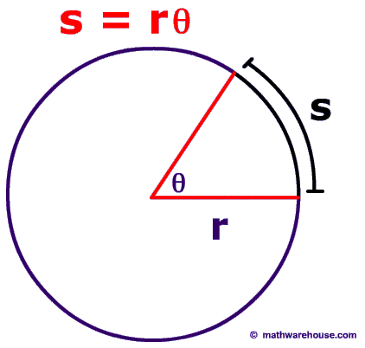 | Rectangular 2D:  $$L= \int_{α}^{β}{\sqrt{{\left(\frac{dx}{dt}\right)}^{2}+ {\left(\frac{dy}{dt}\right)}^{2}} dt}$$  Rectangular 3D:  $$L= \int_{α}^{β}{\sqrt{{\left(\frac{dx}{dt}\right)}^{2}+ {\left(\frac{dy}{dt}\right)}^{2}+ {\left(\frac{dz}{dt}\right)}^{2}} dt}$$  Cylindrical:  $$L= \int_{t_{1}}^{t_{2}}{\sqrt{{\left(\frac{dr}{dt}\right)}^{2}+r^{2}{\left(\frac{dθ}{dt}\right)}^{2}+{\left(\frac{dz}{dt}\right)}^{2}}dt}$$  Spherical:  $$L=$$  $$\int_{t_{1}}^{t_{2}}{\sqrt{{\left(\frac{dρ}{dt}\right)}^{2}+ρ^{2}\sin^{2}φ{\left(\frac{dθ}{dt}\right)}^{2}+ρ^{2}{\left(\frac{dφ}{dt}\right)}^{2}} dt}$$ | $$L= \int_{a}^{b}{\left\|\vec{r}'(t)\right\|} dt$$  s(t)$= \int_{0}^{t}{\left\|\vec{r}'(u)\right\|} du$ | NA
Curvature | $$κ= \frac{\left|y^{''}\right|}{{(1+y^{'2})}^{3/2}}$$ | $$κ(θ)= \frac{\left|r^{2}+2r^{'2}-rr^{''}\right|}{{(r^{2}+r^{'2})}^{3/2}}$$  for r($θ$) |  | NA | $$κ= \frac{\sqrt{\begin{aligned}{\left(z^{''}y^{'}-y^{''}z^{'}\right)}^{2}+ \\ {\left(x^{''}z^{'}-z^{''}x^{'}\right)}^{2}+ \\ {(y^{''}x-x^{''}y^{'})}^{2} \end{aligned}}}{{(x^{'2}+y^{'2}+z^{'2})}^{3/2}}$$  where f(t) = (x(t), y(t), z(t)) | $$κ= \left|\frac{d \vec{T}}{ds}\right|$$  $$κ=\frac{\left\|\vec{T}'(t)\right\|}{\left\|\vec{r}'(t)\right\|}$$  $$κ=\frac{\left\|{\vec{r}}^{'}\left(t\right) × \vec{r}''(t)\right\|}{{\left\|\vec{r}'(t)\right\|}^{3}}$$ | (See Wikipedia : Curvature)
Perimeter | Square: P = 4s  Rectangle: P = 2l + 2w  Triangle: P = a + b + c  Circle: C = πd = 2πr  Ellipse: $C≈π(a+b)$ | Ellipse: $C≈2π\sqrt{\frac{a^{2}+b^{2}}{2}}$  $$C≈π \left[3\left(a+b\right)-\sqrt{(3a+b)(a+3b)}\right]$$  $$C≈π \left(a+b\right)\left(1+\frac{3h}{10+\sqrt{4-3h}}\right)$$ |  | Ellipse: $C=4a\int_{0}^{\frac{π}{2}}{\sqrt{1-k^{2}\sin^{2}θ} dθ}$  $$h=\frac{{\left(a-b\right)}^{2}}{{\left(a+b\right)}^{2}} \& k^{2}=\left(1-\frac{b^{2}}{a^{2}}\right)$$ | NA | NA | NA
Area | Square: A = s²  Rectangle: A = lw  Rhombus: A = ½ ab  Parallelogram: A = Bh  Trapezoid: $A=\frac{\left(B_{1}+{ B}_{2}\right)}{2} h$  Kite: $A = \frac{d_{1} d_{2}}{2}$  Triangle: A = ½ Bh  Triangle: A = ½ ab sin(C)  Triangle using Heron’s Formula:  $$A= \sqrt{s\left(s-a\right)\left(s-b\right)\left(s-c\right)}$$  $$where s=\frac{a+b+c}{2}$$  Equilateral Triangle: $A = ¼\sqrt{3}s^{2}$  Frustum: $A=\frac{1}{3}\left(\frac{B_{1}+B_{2}}{2}\right)h$  Circle: A = πr²  Circular Sector: A = ½ r²$θ$  Ellipse: A = πab | $$A= \int_{α}^{β}{\frac{1}{2}{[f(θ)]}^{2}dθ}$$  where $r=f(θ)$  Proof:  Area of a sector:  $$A=\int{s dr= }\int{r ∆θ dr=\frac{1}{2}r^{2} ∆θ}$$  where arc length $s=r ∆θ$  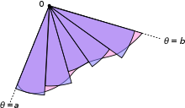 |  | NA | $$A=\int_{α}^{β}{g\left(t\right) f^{'}\left(t\right) dt}$$  where $f\left(t\right)=x$ and $g\left(t\right)=y$  or  x(t) = f(t) and y(t) = g(t)  Simplified:  $$A=\int_{α}^{β}{y\left(t\right) \frac{dx(t)}{dt} dt}$$  Proof:  $$\int_{a}^{b}{f\left(x\right)} dx$$  y = f(x) = g(t)  $$dx =\frac{df\left(t\right)}{dt}dt=f’(t) dt$$ | $$A=\iint_{D}^{ }{\left|\frac{∂r}{∂u}×\frac{∂r}{∂v}\right|du dv}$$ | NA
Lateral Surface Area | Cylinder: SA = 2πrh  Cone: SA = πrl  $$SA= 2π\int_{a}^{b}{f\left(x\right) \sqrt{1+{[f^{'}\left(x\right)]}^{2}} dx}$$ | For rotation about the x-axis:  $$SA= \int{2πy} ds$$  For rotation about the y-axis:  $$SA= \int{2πx} ds$$  $$ds= \sqrt{r^{2}+{\left(\frac{dr}{dθ}\right)}^{2}} dθ$$  $$r=f\left(θ\right), α≤ θ≤β$$ |  | Sphere: SA = 4πr² | For rotation about the x-axis:  $$SA= \int{2πy} ds$$  For rotation about the y-axis:  $$SA= \int{2πx} ds$$  $$ds= \sqrt{{\left(\frac{dx}{dt}\right)}^{2}+{\left(\frac{dy}{dt}\right)}^{2}} dt$$  $$if x=f\left(t\right), y=g\left(t\right), α≤ t≤β$$ | NA | NA
Total Surface Area | Cube: SA = 6s²  Rectangular Box: SA = 2lw + 2wh + 2hl  Regular Tetrahedron: SA = 2bh  Cylinder: SA = 2πr (r + h)  Cone: SA = πr² + πrl = πr (r + l)  Sphere: SA = 4πr² | Ellipsoid: SA $≈$  $$4π{\left(\frac{a^{p}b^{p}+a^{p}c^{p}+b^{p}c^{p}}{3}\right)}^{1/p}$$  Where p $≈1.6075, \left|Relative Error\right|≤1.061\%$  (Knud Thomsen’s Formula) |  | Ellipsoid: S = | 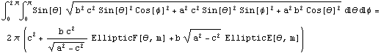  where 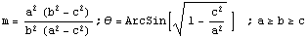
Surface of Revolution | For revolution about the x-axis:  $$A=2π \int_{a}^{b}{f(x)}\sqrt{1+{\left(\frac{dy}{dx}\right)}^{2}} dx$$  For revolution about the y-axis:  $$A=2π \int_{a}^{b}{x}\sqrt{1+{\left(\frac{dx}{dy}\right)}^{2}} dy$$ | For revolution about the x-axis:  $$A=2π\int_{α}^{β}{r\cos{θ}} \sqrt{r^{2}+ {\left(\frac{dr}{dθ}\right)}^{2}} dθ$$  For revolution about the y-axis:  $$A=2π\int_{α}^{β}{r\sin{θ}}\sqrt{r^{2}+{\left(\frac{dr}{dθ}\right)}^{2}}dθ$$ |  | Sphere: S = 4πr² | For revolution about the x-axis:  $$A_{x}=2π\int_{a}^{b}{y\left(t\right)} \sqrt{{\left(\frac{dx}{dt}\right)}^{2}+ {\left(\frac{dy}{dt}\right)}^{2}} dt$$  For revolution about the y-axis:  $$A_{y}=2π\int_{a}^{b}{x\left(t\right)} \sqrt{{\left(\frac{dx}{dt}\right)}^{2}+ {\left(\frac{dy}{dt}\right)}^{2}} dt$$ | NA | NA
Volume | Cube: V = s³  Rectangular Prism: V = lwh  Cylinder: V = πr²h  Triangular Prism: V= Bh  Tetrahedron: V= ⅓ Bh  Pyramid: V = ⅓ Bh  Cone: V = ⅓ Bh = ⅓ πr²h  Sphere: $V=\frac{4}{3}πr^{3}$  Ellipsoid: V = $\frac{4}{3}$πabc  $$\int{\int{\int{f\left(x, y, z\right) dx dy dz}}}$$ | $$\int{\int{\int{\begin{aligned}f\left(r\cos{θ}, r sin θ, z\right)r \\ dz dr dθ\end{aligned}}}}$$ |  | $$\int{\int{\int{f\left(\begin{aligned}ρsin φ{\cos{θ}}, \\ ρ\sin{φ }\sin{θ}, \\ ρ\cos{φ}\end{aligned}\right)}}}$$  $$… ρ^{2}\sin{φ} dρ dφ dθ$$ |  |  | Ellipsoid:  $$V=\frac{4}{3}π\sqrt{det\left(A^{-1}\right)}$$
Volume of Revolution | Disk Method  $$V=\int_{a}^{b}{(area of circle) d\left(thickness\right)}$$  Rotation about the x-axis:  $$V= \int_{a}^{b}{π {\left[f\left(x\right)\right]}^{2}dx}$$  Rotation about the y-axis:  $$V= \int_{c}^{d}{πx^{2}dy}$$ | 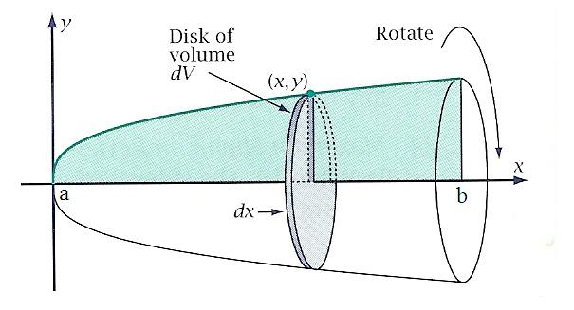
 | Washer Method  Rotation about the x-axis:  $$V= \int_{a}^{b}{π \{}[{f(x)]}^{2}-[g{\left(x\right)]}^{2}\} dx$$ | $$V=V_{Outer Disk}-V_{Inner Disk}$$
 | Shell Method  $$V=\int_{a}^{b}{\left(circumference\right) \left(hight\right) dx}$$  Rotation about the y-axis:  $$V=\int_{a}^{b}{2πx f\left(x\right) dx}$$  Rotation about the x-axis:  $$V=\int_{c}^{d}{2πy g\left(y\right) dy}$$ | 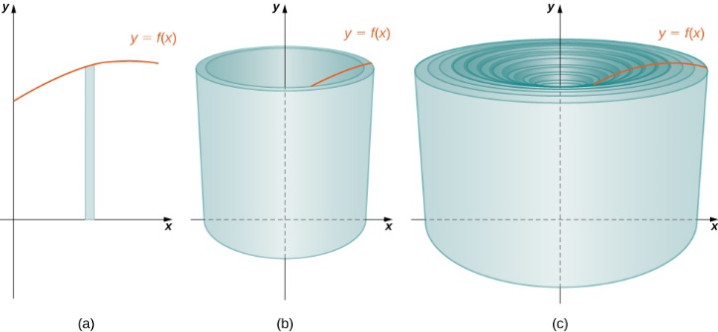 |  |  | 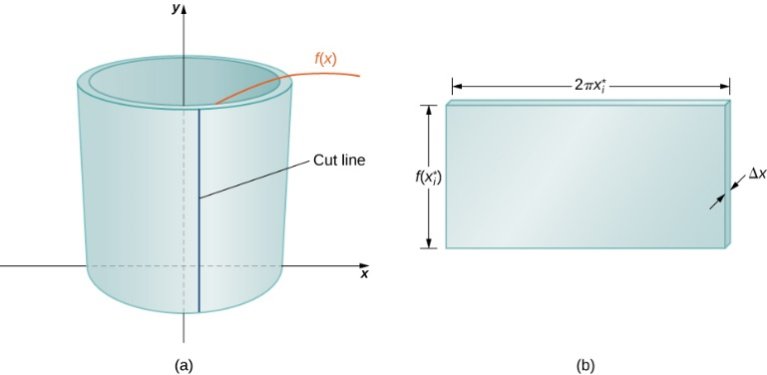
Moments of Inertia | $$I= \sum_{i=1}^{N}{m_{i} r_{i}^{2}}=\int_{0}^{a}{m r^{2} dr}$$ | NA |  | NA |  | $$I= \iiint_{V}^{ }{ρ\left(r\right){ d(r)}^{2} dV(r)}$$ | (see Wikipedia)
Center of Mass | $$R=\frac{1}{M} \sum_{i=1}^{N}{m_{i} r_{i}}$$  where $M= \sum_{i=1}^{N}{m_{i}}$  1D for Discrete:  $$x_{cm}=\frac{m_{1}x_{1}+m_{2}x_{2}}{m_{1}+m_{2}}$$ | 2D for Discrete:  $$M_{y}=\sum_{i=1}^{N}{m_{i} x_{i} }$$  $$M_{x}=\sum_{i=1}^{N}{m_{i} y_{i} }$$  $$\overline{x}=\frac{M_{y}}{M}, \overline{y}=\frac{M_{x}}{M}$$ |  | 3D for Discrete:  $$x_{cm}=\overline{x}=\frac{1}{M} \sum_{i=1}^{N}{m_{i} x_{i} }$$  $$y_{cm}=\overline{y}=\frac{1}{M} \sum_{i=1}^{N}{m_{i} y_{i} }$$  $$z_{cm}=\overline{z}=\frac{1}{M} \sum_{i=1}^{N}{m_{i} z_{i} }$$ | 3D for Continuous:  $$\overline{x}=\frac{1}{M} \int_{0}^{M}{x dm}$$  $$\overline{y}=\frac{1}{M} \int_{0}^{M}{y dm}$$  $$\overline{z}=\frac{1}{M} \int_{0}^{M}{z dm}$$  where $M=\int_{0}^{M}{dm}$  and $dm=ρ dz dy dx$ | $$R=\frac{1}{M} \int{r dm}$$  $$R=\frac{1}{M} \iiint_{V}^{ }{ρ\left(r\right) r dV}$$  Where $r$ is distance from the axis of rotation, not origin.
Gradient | $$∇ ƒ= \frac{∂f}{∂x}i+\frac{∂f}{∂y}j+\frac{∂f}{∂z}k$$ | $$∇ ƒ(ρ,ϕ,z)= \frac{∂f}{∂ρ}e_{ρ}+\frac{1}{ρ}\frac{∂f}{∂ϕ}e_{ϕ}+\frac{∂f}{∂z}e_{z}$$ |  | $$∇ ƒ\left(r,θ,ϕ\right)=$$  $$\frac{∂f}{∂r}e_{r}+\frac{1}{r}\frac{∂f}{∂θ}e_{θ}+\frac{1}{r \sin{θ}}\frac{∂f}{∂ϕ}e_{ϕ}$$ | 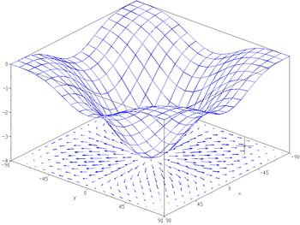 | $$\left(∇ ƒ\left(x\right)\right)•v= D_{v}f(x)$$  $$∇ ƒ= \frac{∂f_{i}}{∂x_{j}}e_{i}e_{j}$$  where $ƒ=(ƒ_{1},ƒ_{2},ƒ_{3})$
Line Integral | $$\int_{C}^{ }{f ds}= \int_{a}^{b}{f\left(r\left(t\right)\right)\left|r^{'}(t)\right| dt}$$ | NA |  | NA |  | $$\int_{C}^{ }{F(r) •dr}= \int_{a}^{b}{F\left(r\left(t\right)\right)• r^{'}(t) dt}$$
Surface Integral | $$\int_{S}^{ }{f dS}=$$  $$\iint_{T}^{ }{f\left(x\left(s,t\right)\right)} \left|\frac{∂x}{∂s} × \frac{∂x}{∂t}\right|ds dt$$  Where $x\left(s,t\right)=$  $$\left(x\left(s,t\right), y\left(s,t\right), z\left(s,t\right)\right)$$  and  $$\left(\frac{∂x}{∂s} × \frac{∂x}{∂t}\right)=$$  $$\left(\frac{∂(y,z)}{∂(s,t)}, \frac{∂(z,x)}{∂(s,t)},\frac{∂(x,y)}{∂(s,t)} \right)$$ | NA |  | NA | 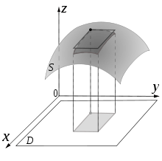 | $$\int_{S}^{ }{v •dS}=$$  $$\int_{S}^{ }{\left(v•n\right) dS}=$$  $$\iint_{T}^{ }{v\left(x\left(s,t\right)\right)} •\left(\frac{∂x}{∂s} × \frac{∂x}{∂t}\right)ds dt$$

