Harold’s Center of Mass
Cheat Sheet
13 August 2020

Terms
Term | Description | Units
$$\overline{x}$$ | Center of Mass along the x-axis. Same as $x_{cm}$. | $$m or ft$$
$$\overline{y}$$ | Center of Mass along the y-axis. | $$m or ft$$
$$\overline{z}$$ | Center of Mass along the z-axis. | $$m or ft$$
$$\overline{x}$$  $$\left(\overline{x}, \overline{y}\right)$$  $$(\overline{x}, \overline{y}, \overline{z})$$ | Center of Mass. The coordinates (point) where the object is perfectly balanced. (Centroid) | $$m or ft$$
$$M$$ | Total mass. How heavy the object is. Is equal to it’s area or volume if uniform density. (similar to Weight) | $$kg or lb$$
$$M_{x} and M_{y}$$ | Moment. The line or axis on which the object can spin perfectly balanced. | $$kg or lb$$
$$M_{x}$$ | Moment of Inertia about the x-axis | $$kg or lb$$
$$M_{y}$$ | Moment of Inertia about the y-axis | $$kg or lb$$
$$I$$ | Moment of Inertia, mass moment of Inertia, or rotational inertia of a body. $I_{0}=$ polar moment of inertia (about origin) | $$kg m^{2} or lb ft^{2}$$
$$ρ$$ | Greek symbol rho for density or mass / volume or mass / area. | $$ρ=\frac{kg}{m^{3}} or \frac{lb}{{ft}^{3}}$$
$$A$$ | Area of lamina or plate | $$m^{2} or {ft}^{2}$$
$$V$$ | Volume of a body or solid | $$m^{3} or {ft}^{3}$$
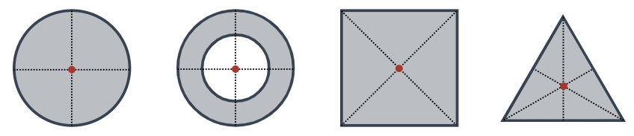
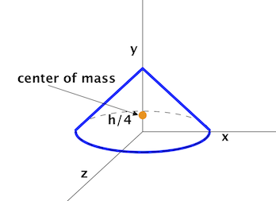
Discrete
Term | 1-D | 2-D | 3-D
$$\overline{x}$$ | $$\overline{x}=\frac{m_{1}x_{1}+m_{2}x_{2}}{m_{1}+m_{2}}$$ | $$\overline{x}=\frac{M_{y}}{M}$$ | $$\overline{x}=\frac{1}{M} \sum_{i=1}^{N}{m_{i} x_{i} }$$
$$\overline{y}$$ | NA | $$\overline{y}=\frac{M_{x}}{M}$$ | $$\overline{y}=\frac{1}{M} \sum_{i=1}^{N}{m_{i} y_{i} }$$
$$\overline{z}$$ | NA | NA | $$\overline{z}=\frac{1}{M} \sum_{i=1}^{N}{m_{i} z_{i} }$$
$$M$$ | $$M= \sum_{i=1}^{N}{m_{i}}$$
$$M_{x}$$ | $$M_{x}=\sum_{i=1}^{N}{m_{i} y_{i} }$$
$$M_{y}$$ | $$M_{y}=\sum_{i=1}^{N}{m_{i} x_{i} }$$
$$I$$ | $$I=m r^{2}=\frac{L}{⍵}$$ | $$I= \sum_{i=1}^{N}{m_{i} r_{i}^{2}}$$ | NA
$$I_{x}$$ | $$I_{x}=\sum_{i=1}^{j}{x_{i}^{2}\frac{M}{L}∆x}$$ | $$I_{x}=\sum_{i=1}^{k}{\sum_{j=1}^{l}{y^{2} ρ\left(x,y\right) ∆A}}$$ | $$I_{x}=\sum_{i=1}^{l}{\sum_{j=1}^{m}{\sum_{k=1}^{n}{(y^{2}+z^{2}) ρ\left(x,y,z\right) ∆V}}}$$
$$I_{y}$$ | NA | $$I_{y}=\sum_{i=1}^{k}{\sum_{j=1}^{l}{x^{2} ρ\left(x,y\right) ∆A}}$$ | $$I_{y}=Above with \left(x^{2}+z^{2}\right)$$
$$I_{z}$$ | NA | NA | $${Iz}_{y}=Above with \left(x^{2}+y^{2}\right)$$
$$I_{0}$$ | $$I_{0}=I_{x}$$ | $$I_{0}=I_{x}+I_{y}$$ | $$I_{0}=I_{x}+I_{y}+I_{z}$$
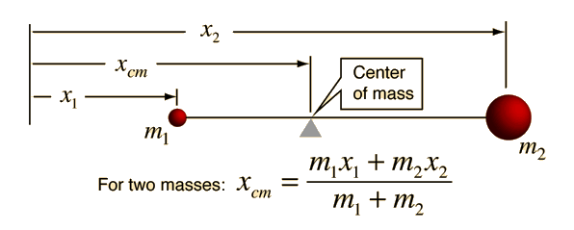

Continuous
Term | 2-D | 3-D
$$\overline{x}$$ | $$\overline{x}=\frac{M_{y}}{M}$$ | $$\overline{x}=\frac{1}{M} \int_{0}^{M}{x dm}=\frac{M_{yz}}{M}$$
$$\overline{y}$$ | $$\overline{y}=\frac{M_{x}}{M}$$ | $$\overline{y}=\frac{1}{M} \int_{0}^{M}{y dm}=\frac{M_{xz}}{M}$$
$$\overline{z}$$ | NA | $$\overline{z}=\frac{1}{M} \int_{0}^{M}{z dm}=\frac{M_{xy}}{M}$$  $$\overline{z}=\frac{1}{V} \int_{z_{min}}^{z_{max}}{z dV}$$
$$M$$ | $$M=ρ (Area)$$  $$M= ρ\int_{a}^{b}{f\left(x\right) dx}$$  $$M=\iint_{R}^{ }{dm}=\iint_{R}^{ }{ρ\left(x,y\right) dA}$$  $$dm=ρ(x,y) dy dx$$ | $$M=ρ (Volume)$$  $$M=\iiint_{Q}^{ }{dm}=\iiint_{Q}^{ }{ρ\left(x,y,z\right) dV}$$  $$dm=ρ\left(x,y,z\right) dz dy dx$$
$$M_{x}$$ | $$M_{x}=ρ\iint_{R}^{ }{y dA}= ρ\int_{a}^{b}{\frac{1}{2}\left({\left[f\left(x\right)\right]}^{2}\right)} dx$$ | $$M_{xy}=\iiint_{Q}^{ }{z ρ\left(x,y,z\right) dV}$$
$$M_{y}$$ | $$M_{y}=ρ\iint_{R}^{ }{x dA}= ρ\int_{a}^{b}{x f(x)} dx$$ | $$M_{yz}=\iiint_{Q}^{ }{x ρ\left(x,y,z\right) dV}$$
$$M_{z}$$ | NA | $$M_{xz}=\iiint_{Q}^{ }{y ρ\left(x,y,z\right) dV}$$
$$I$$ | $$I=\int_{0}^{a}{m r^{2} dr}$$  $$I=\iint_{A}^{ }{ρ\left(r\right){ d(r)}^{2} dA(r)}$$ | $$I= \iiint_{V}^{ }{ρ\left(r\right){ d(r)}^{2} dV(r)}$$
$$I_{x}$$ | $$I_{x}=\iint_{R}^{ }{y^{2} ρ\left(x,y\right) dA}$$ | $$I_{x}=\iiint_{Q}^{ }{(y^{2}+z^{2}) ρ\left(x,y,z\right) dV}$$
$$I_{y}$$ | $$I_{y}=\iint_{R}^{ }{x^{2} ρ\left(x,y\right) dA}$$ | $$I_{y}=\iiint_{Q}^{ }{(x^{2}+z^{2}) ρ\left(x,y,z\right) dV}$$
$$I_{z}$$ | NA | $$I_{z}=\iiint_{Q}^{ }{(x^{2}+y^{2}) ρ\left(x,y,z\right) dV}$$
