Harold’s Geometry
“Cheat Sheet”
26 November 2017

Parallel Lines with Traversals
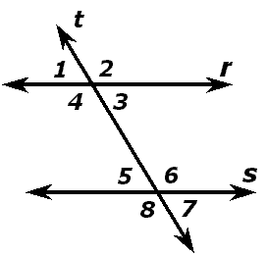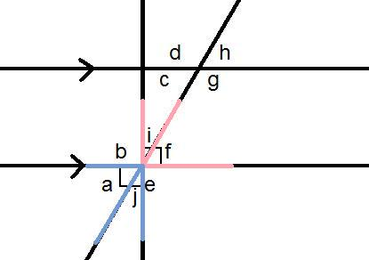

Givens:
- Line r is parallel to line s.
- Line t transverses lines r and s.

Rule # | Rule | Angles
1 | Corresponding angles are congruent (= alt. int. + vert.) | 1&5, 2&6, 4&8, 3&7
2 | Vertical angles are congruent | 1&3, 2&4, 5&7, 6&8
3 | Alternate interior angles are congruent | 3&5, 4&6
4 | Alternate exterior angles are congruent | 1&7, 2&8
5 | Supplementary angles add to 180° | 1&2, 2&3, 3&4, 4&1, 5&6, 6&7, 7&8, 8&5
6 | Complimentary angles add to 90° | a&j (blue), i&f (red)

