Harold’s High School Physics 1st Semester
Cheat Sheet
17 February 2026

The 7 Base Units of Measure

Quantity Name | Symbol  (Value) | Metric Units (SI) | Imperial Units (English)
1. Length / Distance | $$w, x, y, z$$ | meter ($m$) | foot ($ft$)
2. Mass | $$m$$ | kilogram ($kg$) | slug (or $lb$)
3. Time | $$t$$ | second ($s$)
4. Temperature | $$T$$ | Kelvin ($K$)  Celsius ($⁰C$) | Fahrenheit ($⁰F$)
5. Electrical Current | $$i$$ | Ampere ($A$)
6. Amount of Substance | $$M, χ$$ | mole ($mol$) | 1 mol = 6.022 140 76 × 10²³
7. Luminous Intensity | $$lv$$ | Candela ($cd$)
Note: The 7 base units are mutually independent from each other.
All other units of measurement can be derived from them.

Derived Units of Measure

Quantity Name | Symbol  (Value) | Metric Units  (SI) |  | Imperial Units  (English)
Length / Displacement | $$d, l, h, r, s$$ | meter ($m$) | $$m$$ | foot ($ft$) | $$ft$$
Area | $$A, SA$$ |  | $$m^{2}$$ |  | $$ft^{2}$$
Volume | $$V$$ | liter ($l$) | $$m^{3}$$ | fluid ounce (fl) | $$ft^{3}$$
Velocity / Speed | $$v, s$$ |  | $$\frac{m}{s}$$ |  | $$\frac{ft}{s}$$
Acceleration | $$a, g$$ |  | $$\frac{m}{s^{2}}$$ |  | $$\frac{ft}{s^{2}}$$
Impulse | $$I$$ |  | $$N∙s$$  $$kg∙\frac{m}{s}$$ |  | $$lb∙\frac{ft}{s}$$
Linear Momentum | $$p$$ |  | $$kg∙\frac{m}{s}$$ |  | $$lb∙\frac{ft}{s}$$
Force | $$F$$ | Newton ($N$) | $$kg∙\frac{m}{s^{2}}$$ | pound ($lb$) | $$slug∙\frac{ft}{s^{2}}$$
Energy / Work / Heat | $$E, W,$$  $$K or KE,$$  $$U_{g}, U_{s}, U_{E},$$  $$Q$$ | Joule ($J$) | $$N∙m$$  $$C∙V$$  $$W∙s$$  $$kg∙\frac{m^{2}}{s^{2}}$$ | calorie ($cal$) | $$ft∙lb$$
Power | $$P$$ | Watt ($W$) | $$\frac{J}{s}$$  $$V∙A$$  $$kg∙\frac{m^{2}}{s^{3}}$$ | horsepower ($hp$) | $$ft∙\frac{lb}{s}$$
Conversions

Constant Name | Symbol | Metric Units  (SI) | Imperial Units  (English)
Length | $$x$$ | $$1.0 m$$ | $$39.37 in$$  $$3.281 ft$$
Length | $$x$$ | $$2.54 cm$$ | $$1.0 in$$
Length | $$x$$ | $$30.48 cm$$ | $$1.0 ft$$
Length | $$x$$ | $$1.61 km$$ | $$1.0 mi$$
Length | $$x$$ | $$1.0 km$$ | $$0.621 mi$$
Length | $$x$$ | $$1 km=1,000 m$$ | $$1 mi=5,280 ft=1,760 yd$$
Mass | $$m$$ | $$1.0 kg$$ | $$2.205 lb$$
Mass | $$m$$ | $$0.454 kg$$ | $$1.0 lb$$
Mass | $$m$$ | $$1.0 g$$ | $$0.035 oz$$
Mass | $$m$$ | $$14.594 kg$$ | $$1 slug$$
Mass | $$m$$ | (standard gravity) | $$1 slug=32.174 lb$$
Time | $$t$$ | $$1 yr=365.24 d$$  $$1 d=24 h$$ | $$1 h=60 min$$  $$1 min=60 s$$
Temperature | $$T$$ | $$0 ℃$$ | $$32 ℉$$
Temperature | $$T$$ | $$100 ℃$$ | $$212 ℉$$
Temperature | $$T$$ | $$-17.8 ℃$$ | $$0 ℉$$
Temperature | $$T$$ | $$37.8 ℃$$ | $$100 ℉$$
Temperature | $$T$$ | $$0 K=-273.15 ℃$$ | $$-459.67 ℉$$
Force | $$F$$ | $$1.00 N$$ | $$0.225 lb$$
Force | $$F$$ | $$4.45 N$$ | $$1.00 lb$$
Volume | $$V$$ | $$3.785 L$$ | 1.0 $gallon$
Volume | $$V$$ | $$1.0 L$$ | $$1.057 quarts$$  $$0.264 gallons$$

How to Solve Physics Word Problems
Modified GUESS Method |  | - Read  - Diagram  - Givens  - Observations  - Unknowns | - Equations  - Solve  - Substitute  - Double-Check |  | 
Scenario

A marching band cadet marches on a football field.
First, he marches 10 yards East, then 40 feet North.
What is the shortest distance he must march to return to where he started?
# | Step |  |  | Example
 | 1. Carefully read the problem.  Translate each word of each sentence into math. |  |  | Reread the problem several times to make sure you did not miss anything.
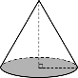 | 2. Draw a diagram.  Clearly label everything. |  |  | a  b  c  N
G | 3. Write down the givens as variables with units.  What information did they provide?  Are any of them extraneous? |  |  | a = 10 yards East  b = 40 feet North
 | 4. Calculate observations or easily derived information.  Don’t forget unit conversions for consistency. |  |  | $$10 yards×\left(\frac{3 feet}{1 yard}\right)=30 feet$$
U | 5. Write down the unknowns.  What are they asking for? |  |  | The shortest distance is a straight line, or the hypotenuse. ‘$c$’.  $c$ = ____?____ <units>
E | 6. Recall relevant equations and formulas. |  |  | Since the path marched is a right triangle, we can use the Pythagorean Theorem: $a^{2}+b^{2}=c^{2}$
S | 7. Solve symbolically for the unknown variable.  Reduce algebraically to the simplest form.  Do not substitute until fully solved. |  |  | $$a^{2}+b^{2}=c^{2}$$  $$c=\sqrt{c^{2}}=\sqrt{a^{2}+b^{2}}$$
S | 8. Substitute the givens into the solved formula.  Use a calculator as needed to calculate the answer. |  |  | $a$ = 30 feet  $b$ = 40 feet  $$c=\sqrt{{(30 feet)}^{2}+{(40 feet)}^{2}}=50 feet$$
✓✓ | 9. Double-check your work.  Ask yourself if the answer is reasonable and makes  sense. Don’t forget the units. Box in your answer. |  |  | The shortest distance the cadet must march is 50 feet.

See also: GUESS Method for problem-solving.

Chapter 1: Let’s Move! (Velocity)

Term | Equation | Description
Vector Quantity | $$\vec{x}=10\frac{m}{s} East$$ | A quantity that includes direction.  (e.g., magnitude and direction)
Scalar Quantity | $$b$$ | A quantity that does not include direction.
Friction | $$F_{μ}$$ | A force that resists motion when two bodies are in contact.
Inertia | $$I$$ | The tendency of a body to resist changes in its velocity.
Average Velocity | $$v_{ave}=\frac{v_{f}-v_{i}}{Δt}$$ | The average of the velocity over a given time interval.
Instantaneous Velocity | $$v=\frac{Δx}{Δt}$$ | The velocity at a given instant in time.
Acceleration | $$a=\frac{Δv}{Δt}$$ | A change in an object’s velocity.
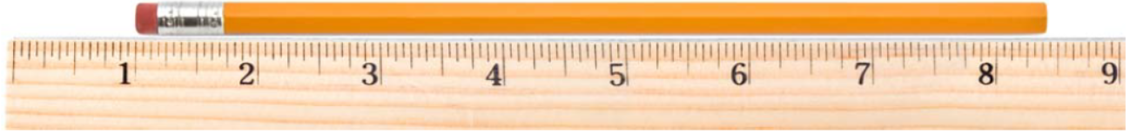
Rulers | When using a ruler that is marked off in 16ths of an inch, report your answers to a hundredth of an inch.
Units | $$g=-9.81\frac{m}{s^{2}}$$ | You must always list the units after the number.  (The units are just as important as the number.)
Significant Figures | - All non-zero figures (1, 2, 3, 4, 5, 6, 7, 8, & 9) are significant.  - A zero (0) is significant if it is between two significant digits.  - A zero (0) is also significant if it is at the end of the number and to the right of the decimal point.
Using SigFigs | - When adding and subtracting measurements, you must report your answer to the same precision as the least precise number in the problem.  - When multiplying and dividing measurements, you must report your answer with the same number of significant figures as the measurement that has the fewest significant figures.  - There is always some error in the last significant figure of a measurement.
Precision vs. Accuracy | - Precision: The consistency and reproducibility of measurements (e.g., 10 decimal places).  - Accuracy: How close a measurement is to the true or accepted value.
Scientific Notation | 14,000,000 = 1.4⨯10⁷ = 1.4E7 |  | 0.00000014 = 1.4⨯10⁻⁷ = 1.4E–7
Systematic Errors | “Science cannot prove anything.”  There is always a possibility that our experiments are wrong since they contain systematic errors.
Unit Conversion (Train Track Method) | 17 years = ? sec
  17 yr | 365.24 days | 24 hours | 60 min | 60 sec | 536,464,512 sec
   | 1 yr | 1 day | 1 hour | 1 min
Prefixes
  Prefix | Abbreviation | Meaning | Scientific
  giga | G | 1,000,000,000 | 10⁹
  mega | M | 1,000,000 | 10⁶
  kilo | k | 1,000 | 10³
  hector | H | 100 | 10²
  deca | Da | 10 | 10¹
  centi | c | 0.01 | 10⁻²
  milli | m | 0.001 | 10⁻³
  micro | μ | 0.000001 | 10⁻⁶
  nano | n | 0.000000001 | 10⁻⁹
Speed | $$s=\frac{Δd}{Δt}$$ | Speed ($s$) is a scalar quantity.
Velocity | $$v=\frac{Δx}{Δt}$$ | Velocity ($v$) is a vector quantity.
Relative Velocity | $$v_{relative}=v_{moving_object}-v_{reference_object}$$
Unit Consistency | Before solving a problem, look at the units and make sure they are consistent.  If they are not, convert the inconsistent units before you continue. ($ft$ vs. $m$)
Newton's First Law of Motion  (Law of Inertia) | An object will remain at rest, or in motion at a constant velocity ($v$ or constant speed in a straight line), unless acted upon by a net external force ($F$). |  |  | 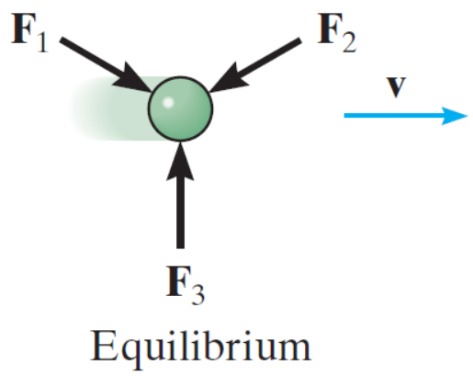
Velocity with Acceleration | - When acceleration and velocity are in the same direction $(⇉)$, an object’s speed increases. $(↑)$  - When acceleration and velocity are in opposite directions $(⇄)$, an object’s speed decreases. $(↓)$
Velocity Graph | 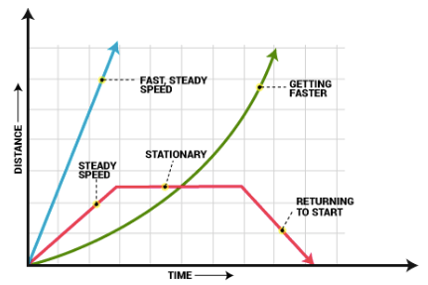
Slope = Velocity | The slope of a position ($x$) versus time ($t$) graph is the velocity ($v$).

Chapter 2: Force and Acceleration

Term | Equation | Description
Newton's Second Law of Motion  (Law of Acceleration) | At any instant of time, the net force on an object is equal to the object's mass multiplied by its acceleration $(F=ma)$ or, equivalently, the rate at which the object's momentum changes with time $\left(∆p/∆t\right)$. |  | 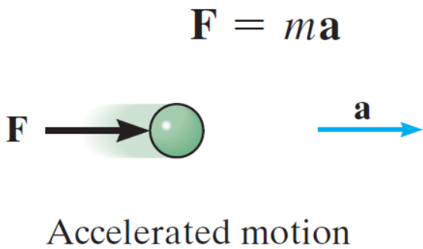
Free Fall | The motion of an object when the only force acting on it is the force due to gravity $(F_{g})$.
Air Resistance | The force with which air resists motion through it.
Acceleration | $$a=\frac{Δv}{Δt}$$ | A change in an object’s velocity.
Acceleration Graph | 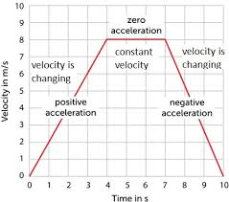
Slope = Acceleration | The slope of a velocity ($v$) versus time ($t$) graph is the acceleration ($a$).
Force | $$F=ma$$ | Force ($F$) is any interaction that, when unopposed, changes the motion of an object.
Acceleration | $$v=v_{0}+at$$ | $$a=\frac{Δv}{Δt}=\frac{v_{f}-v_{0}}{t}$$
Velocity | $$v^{2}=v_{0}^{2}+2a∙Δx$$ | Derivation: Solve for $t$, set $t=t$, then simplify.  $$\frac{v_{f}+v_{0}}{2}=\frac{Δx}{t} and v_{f}=v_{0}+at$$
Position  (Displacement) | $$x=x_{0}+v_{0}t+\frac{1}{2}at^{2}$$  $$Δx=v_{0}t+\frac{1}{2}at^{2}$$ | Displacement ($Δx$) is the area underneath a velocity versus time graph.
$a$ is Constant | $$J=\frac{Δa}{Δt}$$  (Jerk/Jolt) | These equations of motion apply only when the acceleration ($a$) is constant.
Gravity | $$g=-9.81\frac{m}{s^{2}}$$  $$g=-32.2\frac{ft}{s^{2}}$$ | The acceleration due to gravity ($g$) on the surface of the Earth is the same for all objects.  It is negative ($-$) since it is directed downwards $(↓)$.
Weight vs. Mass | $$weight=mg$$ | Weight is a force.  Since $F=ma,$ and $a$ on Earth is $g$, then $weight=mg$.

Chapter 3: Friction

Term | Equation | Description
Newton’s Third Law of Motion  (Law of Action and Reaction) | If object A exerts a force on object B, then B will exert an equal but opposite force on A. |  | 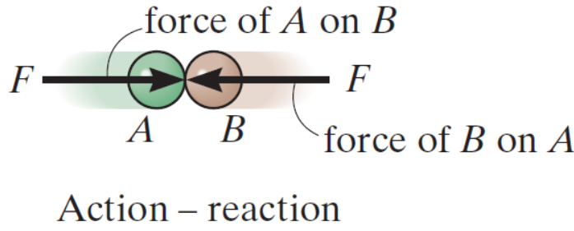
Static Friction ($μ_{s}$) | The frictional force between two surfaces that are stationary relative to each other. |  |  | 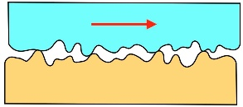
Kinetic Friction ($μ_{k}$) | The frictional force between two surfaces that are moving relative to each other.
Tension ($T$) | A force transmitted through a rope or similar object (e.g., a thread or chain) when it is pulled.
Streamlined Shape | A shape that reduces air resistance.
Wind Resistance | The faster an object moves through the air, the stronger the air resistance.
Terminal Velocity | The maximum velocity $(v_{max})$ attained by a falling object.
Normal Force ($N or F_{N}$) | $$F_{f}=μ∙F_{n}$$ | 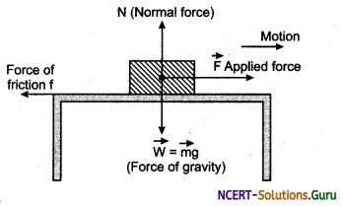
Coefficient of Friction ($μ$) | The coefficient of friction is unitless. It represents a percentage of the normal force that is opposing the applied force.  Static friction ($μ_{s}$) is generally larger than kinetic friction ($μ_{k}$).  $$0≤μ≤1$$
  Material | Static ($μ_{s}$) | Kinetic ($μ_{k}$)
  Zero friction | 0 | 0
  Ice or grease | 0.15 | 0.03
  Paper | 0.35 | 0.25
  Wood | 0.5 | 0.4
  Rubber | 0.9 | 0.8
Block and Tackle  (Pully System) | 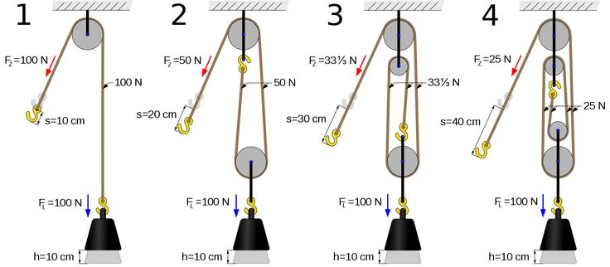
Chapter 4: Two-Dimensional Vectors

Term | Equation |  | Description
Vector Anatomy | An arrow is used to represent a two-dimensional vector.  You must always put an arrowhead on your vectors.  The length of the arrow is the magnitude (a scalar quantity).  The counterclockwise angle from the positive x-axis is the direction.  3D arrow symbols: ⊙ out of page (+), ⨂ into the page (–).
Vectors “Float” | Arrows representing vectors can be moved freely, as long as their length and direction are not changed.
Hypotenuse | The longest side of a right triangle.
Trig Review | 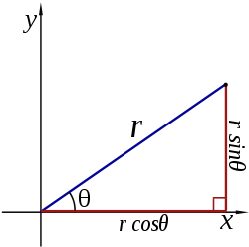
Converting Between Coordinate Systems | Polar Rect.  $r ∠ θ$ $(x , y)$  $$x=r\cos{θ}$$  $$y=r\sin{θ}$$  $$\tan{θ}=\left(\frac{y}{x}\right)$$ | Rect. Polar  $(x , y)$ $r ∠ θ$  $$r^{2}= x^{2}+y^{2}$$  $r= \sqrt{x^{2}+ y^{2}}$  $$θ=\tan^{-1}\left(\frac{y}{x}\right)$$
Vertical Component | $$A_{y}=A∙sin⁡(θ)$$
Horizontal Component | $$A_{x}=A∙cos⁡(θ)$$
Angle | $$θ=\tan^{-1}\left(\frac{A_{y} }{A_{x}}\right)$$  You may need to add $180°$ to put $θ$ into quadrants I or II.
Magnitude | $$|A|=\sqrt{A_{x}^{2}+A_{y}^{2}}$$  $$a^{2}+b^{2}=c^{2}$$
Vector Addition | When adding vectors A and B to get C, add each dimension separately.  $$C_{x}=A_{x}+B_{x}$$  $$C_{y}=A_{y}+B_{y}$$
Vector Addition | 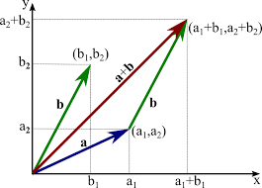

Chapter 5: Two-Dimensional Motion
Term | Equation | Diagram
Projectile | An object that has an initial velocity ($v_{0}$) but experiences only the force of gravity ($g$).
Parabolic Motion | Motion along a parabolic path, which is exhibited by projectiles.
Dimensions | Two-dimensional (2D) situations can often be analyzed as two one-dimensional (2x 1D) situations. Time (t) spans all dimensions.
Orthoganal | In two-dimensional (2D) motion, perpendicular ($⊥$) components of the motion operate independently.
Graph Orientation | The way we define the angle makes motion up ($↑$) and motion to the right ($→$) (or to the east) positive (+).  These are the best definitions to use with our one-dimensional (1D) motion equations.
Projectile Motion | 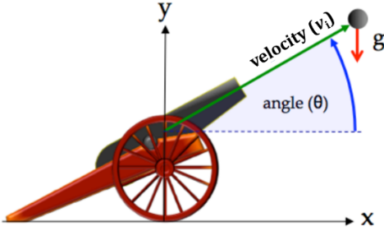  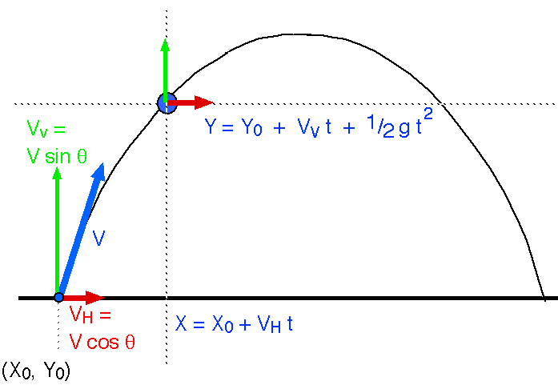  2
 | Horizontal (x-axis) | Vertical (y-axis)
Position Equations | $$x(t)= x_{0}+v_{x}t+\frac{1}{2}a_{x}t^{2}$$ | $$y(t)= y_{0}+v_{y}t-\frac{1}{2}gt^{2}$$
Velocity Equations | $$v_{x}=v cos(θ)$$ | $$v_{y}=v sin(θ)$$
Range Equations | $$range=x_{max}=\frac{v^{2}∙sin⁡(2θ)}{g}$$ | $$height=y_{max}=y\left(\frac{t_{max}}{2}\right)$$
Air Resistance | Assume no air/wind resistance (drag).  (If we factor in air/wind resistance, then differential calculus is needed.) | 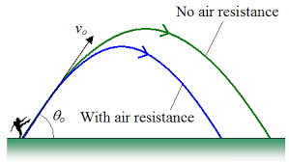

Chapter 6: Newton’s Second Law and Two-Dimensional Motion

Term | Equation |  | Diagram
Translational Equilibrium | The state in which the net force ($F$) acting on an object is equal to zero (0).
Static Translational Equilibrium | The state in which an object is in translational equilibrium and is not moving ($v=0$).
Dynamic Translational Equilibrium | The state in which an object is in translational equilibrium and is moving ($v≠0$).
Accelerometer | A device that measures acceleration ($a$).
Axis of Rotation | An imaginary line around which all points of a rotating body move in circles.
Rotational Equilibrium | Force ($F$) causes changes in translational motion, while  torque ($τ$) causes changes in rotational motion.
Tension | Tension ($T$) is a force on a string, rope, or cable.
Tension | 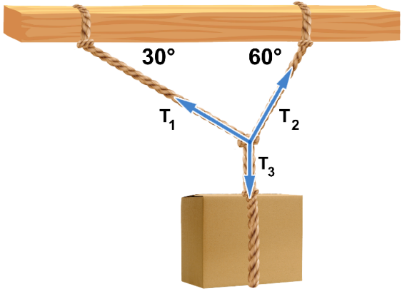 |  |  | 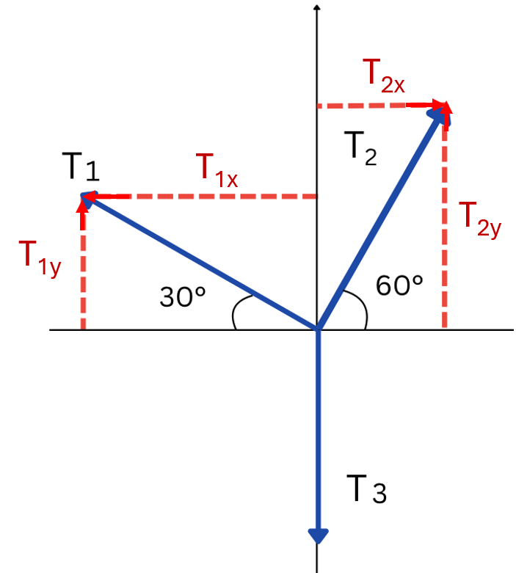  Free-Body Diagram (FBD)
Tension | Horizontal Forces  $$T_{1x}=T_{2x}$$  $$T_{1}\cos{(30°)}=T_{2}\cos{(60°)}$$ |  | Vertical Forces  $$T_{1y}+T_{2y}=T_{3}$$  $$T_{1}\sin{(30°)}+T_{2}\sin{(60°)}=mg$$
Gravity Components  (on an inclined plane) | On an incline, whose angle ($θ$) is defined relative to the horizontal, the component of the force due to gravity:  - Parallel to the incline: $mg∙\sin\left(θ\right).$  - Perpendicular to the incline: $mg∙cos(θ)$.
Gravity Components  (on an inclined plane) | $$F_{x}=mg∙\sin\left(θ\right)$$ |  | $$F_{y}=mg∙cos(θ)$$
Gravity Components  (on an inclined plane) | 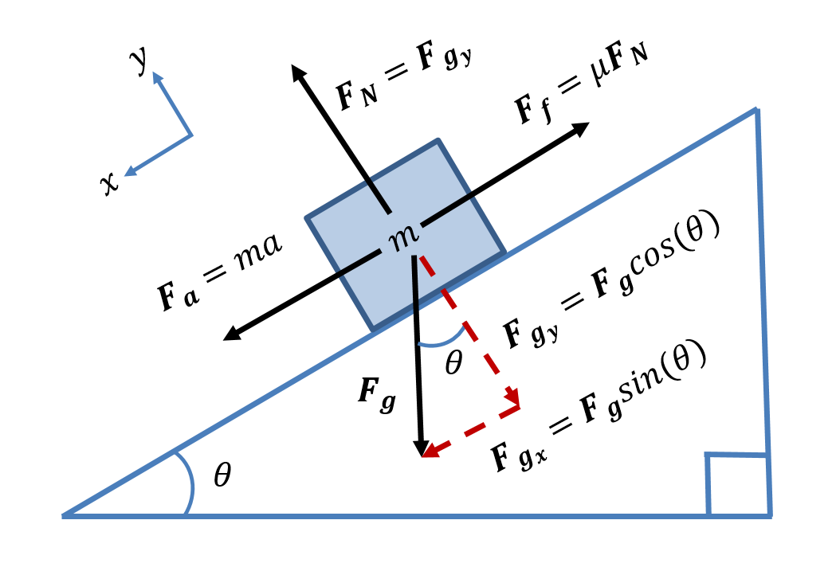
Coefficient of Friction | Static  $$μ_{s}=\frac{sin\left(θ\right)}{cos\left(θ\right)}=tan(θ)$$ |  | Use as the maximum angle before the mass starts to slide down the incline.  $$0≤μ≤1$$
Coefficient of Friction | Kinetic  $$μ_{k}=\frac{g sin\left(θ\right)-a}{g cos\left(θ\right)}$$ |  | Use when the mass is accelerating down the incline.
Translational Motion of Two Objects | 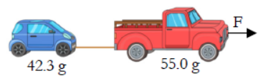
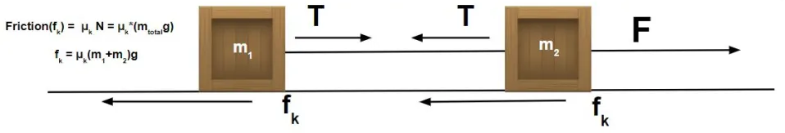
Torque | $$τ=F_{⊥}∙r$$ | 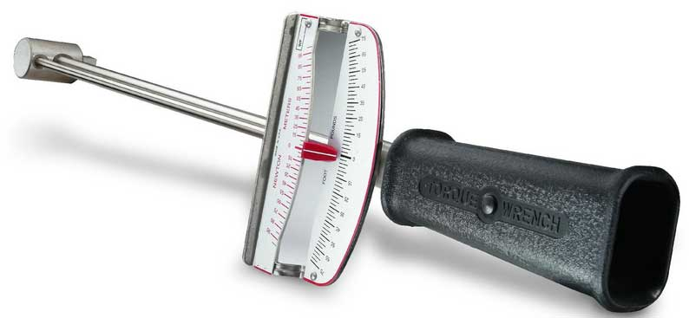
Lever Arm | The distance between the axis of rotation and the force used to produce rotational motion.
Lever Arm | 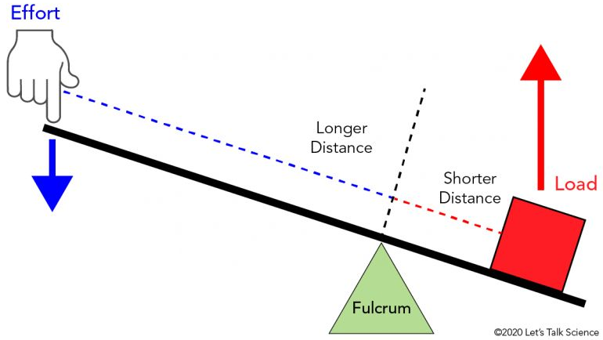
Static Rotational Equilibrium  (Rigid Bodies) | $$\sum{F}=\sum{ma}=0$$ |  | $$\sum{τ}=\sum{Fr}=0$$
Static Rotational Equilibrium  (Rigid Bodies) | 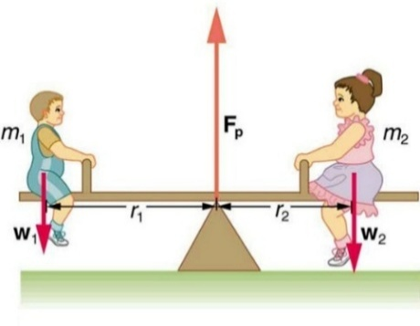 |  | 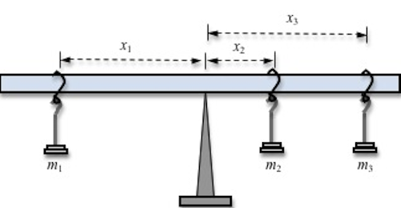
Chapter 7: Uniform Circular Motion and Gravity

Term | Equation | Diagram
Centripetal Force | A force directed to the center of a circle.
Period ($T$) | The time it takes to complete one full cycle (full circle or revolution).
Frequency ($f$) | The number of cycles that can be completed every second.
Gravity ($g$) | The acceleration of the attractive force that exists between all physical objects that have mass.
Satellite | A body that orbits another body.
Frequency  (Hertz (Hz)) | $$f=\frac{1}{T}$$  $$T=\frac{1}{f}$$ | 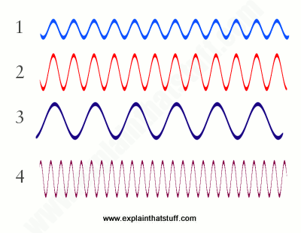
Speed  $$\left(\frac{m}{s}\right)$$ | $$v=\frac{circumference}{time per revolution}=\frac{2πr}{T}$$ | How fast it is going in circles.
Centripetal Acceleration  $$\left(\frac{m}{s^{2}}\right)$$ | $$a_{c}=\frac{v^{2}}{r}$$ | 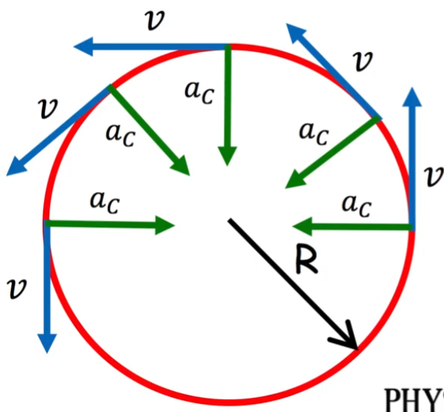
Centripetal Force  (Newtons, N) | $$F_{c}=ma_{c}=\frac{mv^{2}}{r}$$ | 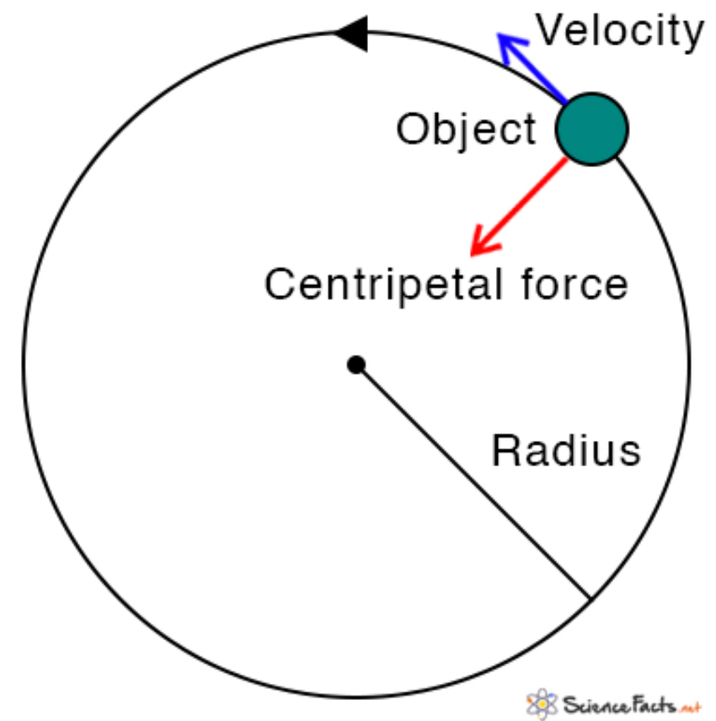
Gravitational Force | $$F_{g}=-\frac{Gm_{1}m_{2}}{r^{2}}$$ | 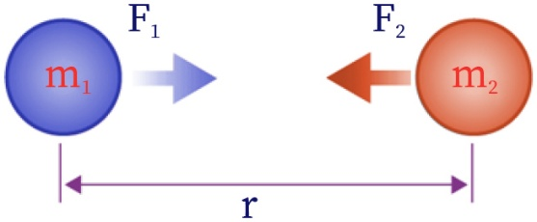
Gravitational Constant ($G$) | $$G≈6.67430×{10}^{-11}\frac{Nm^{2}}{kg^{2}}$$
Kepler’s Laws  (of planetary motion) | 1. Orbits: All planets move in elliptical orbits, with the sun at one focal point.  $$\frac{x^{2}}{a^{2}}+\frac{y^{2}}{b^{2}}=1$$ | 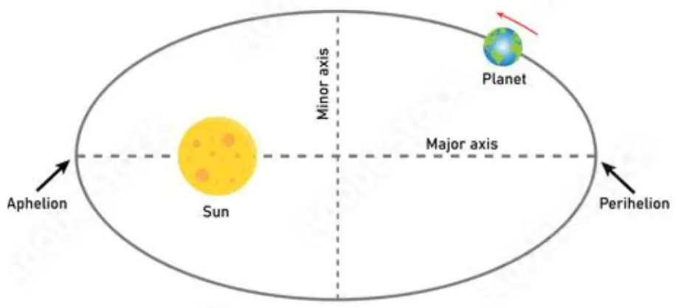
Kepler’s Laws  (of planetary motion) | 2. Areas: A line that connects a planet to the sun sweeps out equal areas in equal time intervals.  $$A_{1}=A_{2}$$ | 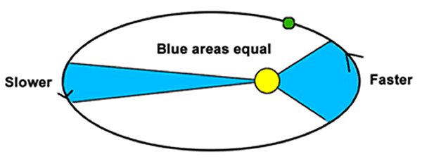
Kepler’s Laws  (of planetary motion) | 3. Periods: The square of a planet’s period is proportional to the cube of its orbit’s semi-major axis.  $$T^{2}∝a^{3}$$ | 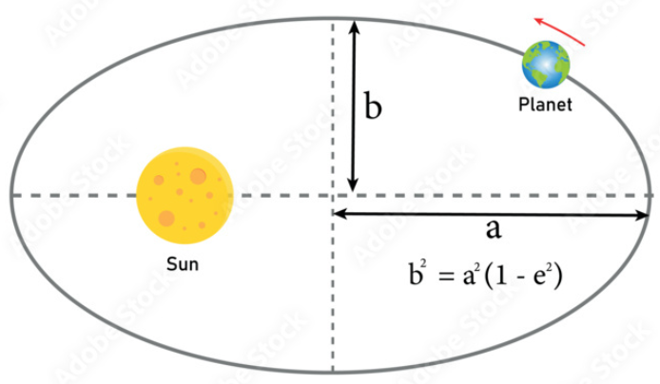

Planetary Constants

Property | Symbol | Sun | Earth | Moon | Mars
Mass | $$M$$ | 1.989 x 10³⁰ kg | 5.972 x 10²⁴ kg | 7.346 x 10²² kg | 6.42 x 10²³ kg
Radius | $$R$$ | 6.96 x 10⁸ m  (mean) | 6.371 x 10⁶ m (mean) | 1.74 x 10⁶ m | 3.39 x 10⁶ m
Gravity  (Acceleration) | $$g$$ | $$274 \frac{m}{s^{2}}$$ | $$9.81\frac{m}{s^{2}}$$ | $$1.625 \frac{m}{s^{2}}$$ | $$3.71 \frac{m}{s^{2}}$$
Distance  (Between each center of mass) | $$r$$ | NA | ~1.496 x 10¹¹ m (1 AU)  (Earth to Sun) | ~3.844 x 10⁸ m  (Moon to Earth) | ~2.279 x 10¹¹ m (1.52 AU)  (Mars to Sun)

Chapter 8: Energy

Term | Equation | Description
Energy | $$E$$ | The ability to do work.
Potential Energy (PE) | $$PE=mgh$$ | Energy that is stored but not currently doing work.
Potential Energy (PE) | $$PE=mgh$$ | Potential energy is relative, so it must be defined relative to a reference point.
Kinetic Energy (KE) | $$KE=\frac{1}{2}mv^{2}$$ | Energy in the form of motion.
PE KE | 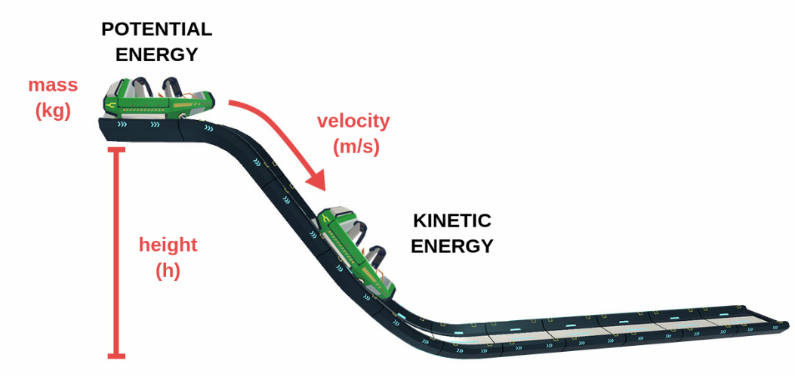
Heat (W_{f})  (Work due to Friction) | $$W_{f}=Q$$ |  | Examples: Brake pads, bent paper clip
Work (W) | $$W=Fd$$  $$W=F_{∥}∙∆x$$ |  | The magnitude of an object’s displacement times the parallel component of the applied force.
Work (W) |  |  | When a body does work, it loses energy.  When a body is worked on, it gains energy.
Total Energy (TE) | $$TE=PE+KE=constant$$  $TE=PE+KE+W_{f}=constant$ (added Work energy due to friction)  $TE=PE+KE+W_{f}+W=constant$ (added Work energy due to force)
Total Energy (TE) | $E=U_{g}+K+Q+W=constant$ (alternate representation)
Rotational Kinetic Energy (KE) | Rotational energy of a uniform sphere (e.g., ball bearing):  $$KE=\frac{1}{5}mv^{2}$$
The First Law of Thermodynamics | Energy ($E$) cannot be created or destroyed. It can only change forms.
Power | $$P=\frac{∆W}{∆t}$$  $$P=Fv=\frac{Fd}{t}$$ | The amount of energy converted or transferred per unit of time.
Units | $$E$$ | Joules ($J$)  ($kg∙m^{2}/s^{2}$)
Units | $$W$$
Units | $$PE or U$$
Units | $$KE or K$$
Units | $$TE or E_{Total}$$
Units | $$P$$ | Watt ($W$)  ($J/s$)
Sources
These chapters and content are taken verbatim from the High School textbook:
- Dr. Jay L. Wile (2023). Discovering Design with Physics, 1st Edition.
Image Sources
- Dr. Carl Rod Nave (1998). HyperPhysics, Conservation of Energy. http://hyperphysics.phy-astr.gsu.edu/hbase/conser.html

