Harold’s High School Physics 2nd Semester
Cheat Sheet
17 February 2026

Chapter 9: Momentum and Its Conservation

Term | Equations & Descriptions
Momentum | The mass of an object times its velocity.
Law of Momentum Conservation | When the net external force on a system is zero, the total momentum cannot change.
Elastic Collision | A collision in which the total energy of the colliding objects does not change.
Inelastic Collision | A collision in which the total energy of the colliding objects is lower after the collision.
Law of Angular Momentum Conservation | When the net external torque on a system is zero, the total angular momentum cannot change.

Momentum
(Linear Momentum)
Momentum | $$p=mv$$ | $$kg∙m/s$$
Impulse | $$∆p=F∙∆t$$  $$∆p=p_{final}-p_{initial}$$ | $N∙s$ or $kg∙m/s$  The change in momentum.
Collision Types | 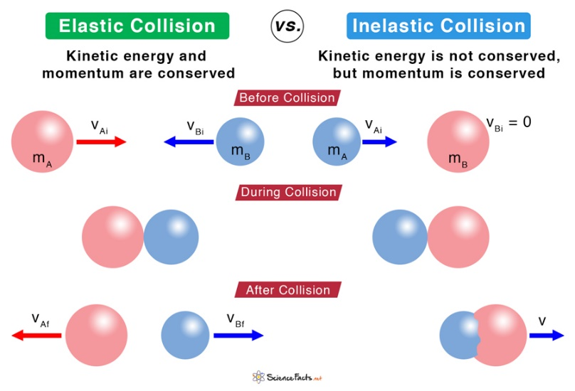
Newton’s Cradle | Example of an elastic collision

Angular Momentum
Angular Momentum | $$L=mvr$$ | $$kg∙m^{2}/s$$
Spinning Tire | A spinning bicycle tire requires effort to tilt since it has angular momentum $(L)$.  You must apply a torque $(τ)$ to change the angular momentum. | 

Conservation Laws
Conservation of Linear Momentum:  $$p_{i}=p_{f}$$ | Conservation of Energy:  $$E_{i}=E_{f}$$ | Conservation of Angular Momentum:  $$L_{i}=L_{f}$$
Conservation of Energy | The capacity for doing work.  “Energy can neither be created nor destroyed”.
Conservation of Momentum | When the net external force is zero: $p_{before}=p_{after}$
Conservation of Angular Momentum | When the sum of the torques is zero: $L_{before}=L_{after}$
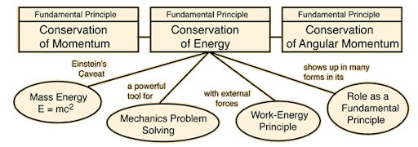
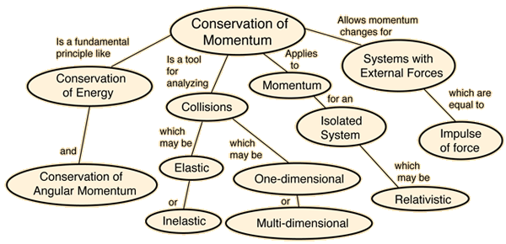
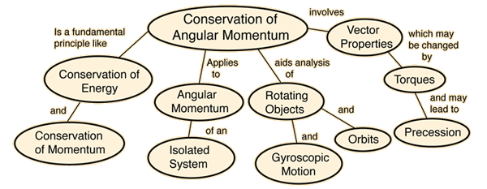
Chapter 10: Periodic Motion

Term | Equations and Descriptions
Periodic Motion | Motion that repeats itself in equal intervals of time.
Hooke’s Law | The restoring force exerted by an elastic object is directly proportional to the distance it is displaced from its equilibrium position.
Amplitude | The maximum extent of a periodic motion, defined from the equilibrium position.
Simple Harmonic Motion | Periodic motion produced by a restoring force that is directly proportional to the distance from the equilibrium position.
Damped Harmonic Motion | Periodic motion whose amplitude decreases over time.
Spring
Spring Force | $$F_{s}=-k∙Δx$$ | $$N$$
Equalibrium | 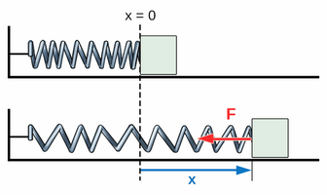
Spring Force Graph | 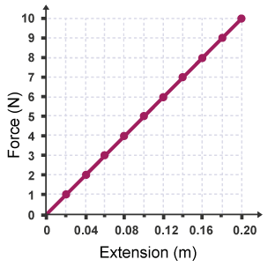 | Linear  $$y=mx+b$$  $$F=kx+0$$
Spring Period | $$T_{s}=2π\sqrt{\frac{m}{k}}$$ | $$s$$
Spring Period | The period of a mass / spring system depends on π because it is a one-dimensional projection of uniform circular motion.
Max. Spring PE | At the amplitude of a mass / spring system’s motion, the restoring force is the greatest, and the speed of the mass is zero.
Max. Spring KE | At the equilibrium position of a mass / spring system’s motion, the restoring force zero, and the speed of the mass is at its maximum value.
Spring Energy | $${PE}_{S}=\frac{1}{2}k{Δx}^{2}$$ | $${KE}_{S}=\frac{1}{2}mv^{2}$$
Spring Energy | $${TE}_{S}=\frac{1}{2}kA^{2}$$ | $A$ is amplitude in  $$x\left(t\right)=A\cos\left(2πft+ϕ\right)$$

Pendulum
Simple Pendulum | 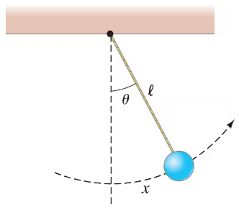
Small Displacement Simplification | A simple pendulum will exhibit simple harmonic motion if the angle that represents its amplitude is small. That is because the restoring force is directly proportional to the displacement only when $\sin{θ}≈θ$.
Pendulum Period | $$T_{p}=2π\sqrt{\frac{l}{g}}$$ | $$s$$
Simple Harmonic Motion | 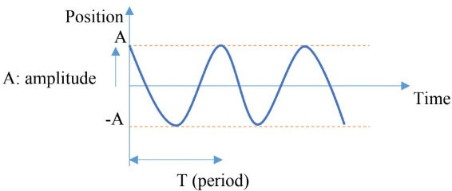
Damped Harmonic Motion | 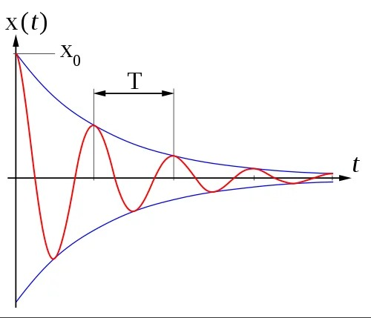
Mnemonic | “Life is Good, if you are a MonKey.”  $$T_{p}=2π\sqrt{\frac{l}{g}} and T_{s}=2π\sqrt{\frac{m}{k}}$$

Chapter 11: Sound and Light

Term | Equations & Descriptions
Oscillations | Regular variation in magnitude around a central point.
Wavelength | The distance between two crests or two troughs of a wave.
Transverse Wave | A wave whose oscillation is perpendicular to its translational motion.
Longitudinal Wave | A wave whose oscillation is parallel to its translational motion.
 | 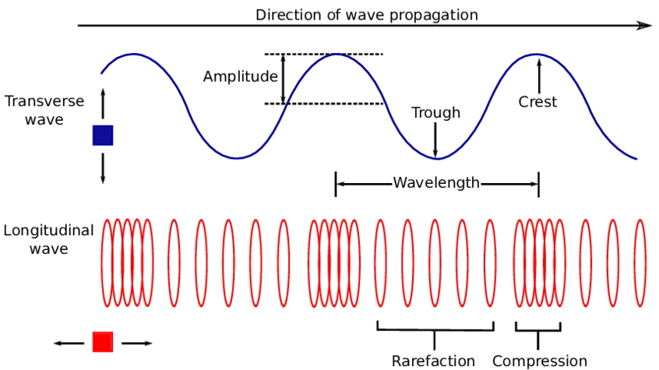
Doppler Effect | A change in the observed frequency of a wave caused by the motion of the wave’s source and/or the observer.
Sound
Sonic Waves | Waves that the typical person can hear, with frequencies of 20 Hz – 20,000 Hz.
Ultrasonic Waves | Waves with frequency greater than 20,000 Hz. $\left(f>20 kHz\right)$
Infrasonic Waves | Waves with frequency lower than 20 Hz. $\left(f<20 Hz\right)$
Timbre | The character of a sound that is not based on the frequency or amplitude of the main sound wave. Examples:  - air vs. bone conduction  - flute vs. violin
Wave-Particle Duality | The concept that light, as well as many subatomic particles, have the properties of both particles and waves.  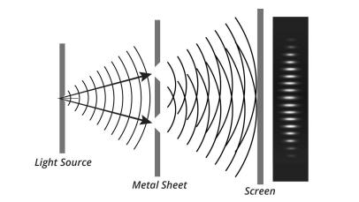
Frequency | $$f=\frac{v}{λ}$$ | Frequency and wavelength are inversely proportional; when one increases, the other decreases.
Medium | A wave oscillates a medium so that energy can move from one place to another.
Sound Volume & Frequency | - The higher the amplitude of a sound wave, the higher the volume of the sound.  - The higher the frequency of a sound wave, the higher the pitch of the sound.
Speed of Sound | $$v_{sound}=\left(331.3+0.606∙T_{C}\right)\frac{m}{s}$$  Where $T_{C}$ is the temperature in Celsius.
Speed of Sound | - The speed of sound increases with increasing elasticity and decreasing density.  - In general, it travels faster in solids, slower in liquids, and slowest in gases.  - For solids and gases, the lower the density, the faster the speed of sound.
  Physical State | Medium | Velocity (m/s) | Velocity (mph)
  Gas | Air (0°C) | 331 | 740
  Gas | Air (25°C) | 346 | 774
  Gas | Helium (0°C) | 972 | 2,174
  Liquid | Water (25°C) | 1,490 | 3,333
  Solid | Iron | 5,130 | 11,472
Doppler Effect (Sound) | $$f_{observed}=\left(\frac{v_{sound}±v_{observer}}{v_{sound}±v_{source} }\right)∙f_{stationary}$$  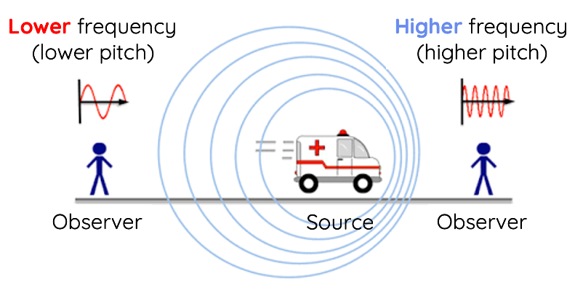
Doppler Effect (Sound) | - When a source of sound is moving, the frequency in front of the source is higher than the frequency behind the source.  - When the observer is moving, the frequency is higher as the observer moves towards the source, and it is lower as the observer moves away from the source.
Doppler Effect (Sound) | - Add $v_{obserer}$ when the observer is moving towards the source.  - Subtract it when the observer is moving away from the source.
Doppler Effect (Sound) | - Subtract $v_{source}$ when the source is moving towards the observer.  - Add it when the source is moving away from the observer.

Light
Electromagnetic Spectrum | The prefix “nano” is abbreviated with “n” and means ${10}^{-9}$.  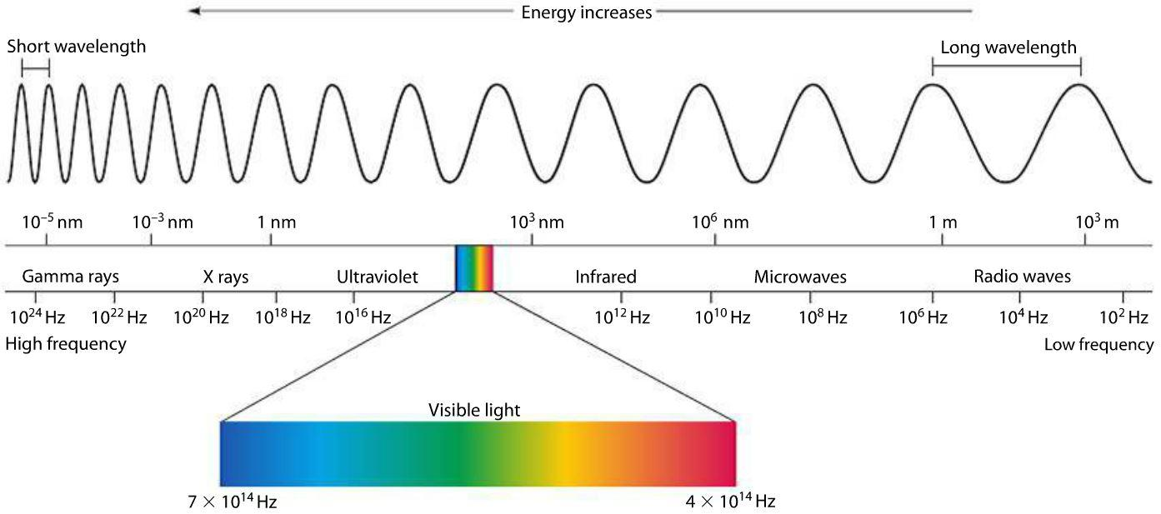
Photoelectric Effect | $$KE_{e_max}=h∙f-ϕ$$  $KE_{e_max}$ (Max. electronic kinetic energy)  $h=6.63×{10}^{-34} J∙s$ (Planck’s constant)  $ϕ$ (Work function) expressed in $eV$(electron-volt).  If $h<0$, then the electron cannot leave the metal when struck by a photon.  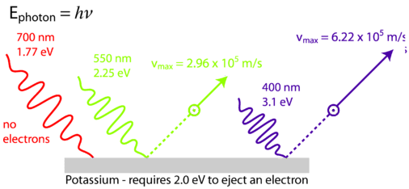
Electron-Volt | $$1 eV=1.602 ×{10}^{-19} J$$
Doppler Effect (Light) | - Blueshift: Higher frequency, so the star is moving towards the earth.  - Redshift: Lower frequency, so the star is moving away from the earth.  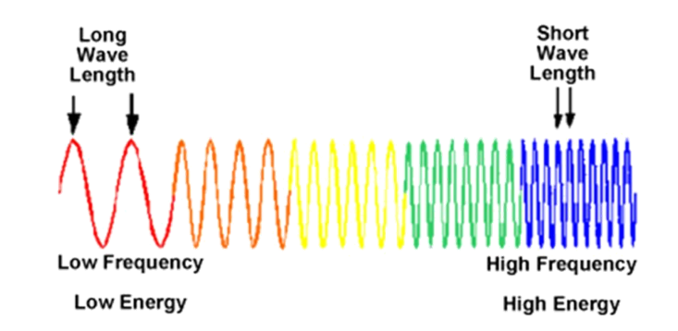

Chapter 12: Optics

Term | Equations & Descriptions
Law of Reflection
Virtual Image
Real Image
Refraction
Spherical Aberration
Chromatic Aberration
 |  | 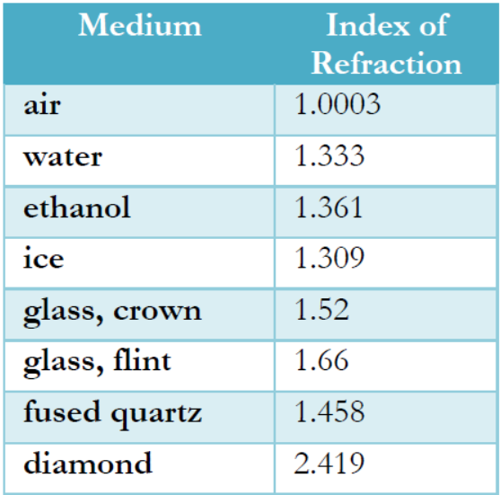

Chapter 13: The Electrostatic Force

Term | Equations & Descriptions
Electrostatic Force
Triboelectric Charging
Charging by Conduction
Charging by Induction
Conductor
Insulator
 |  | 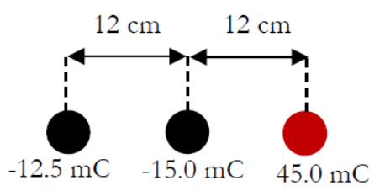
 |  | 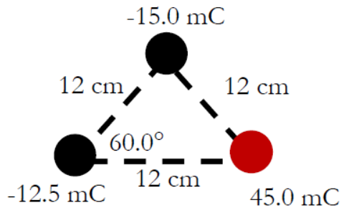
 |  | 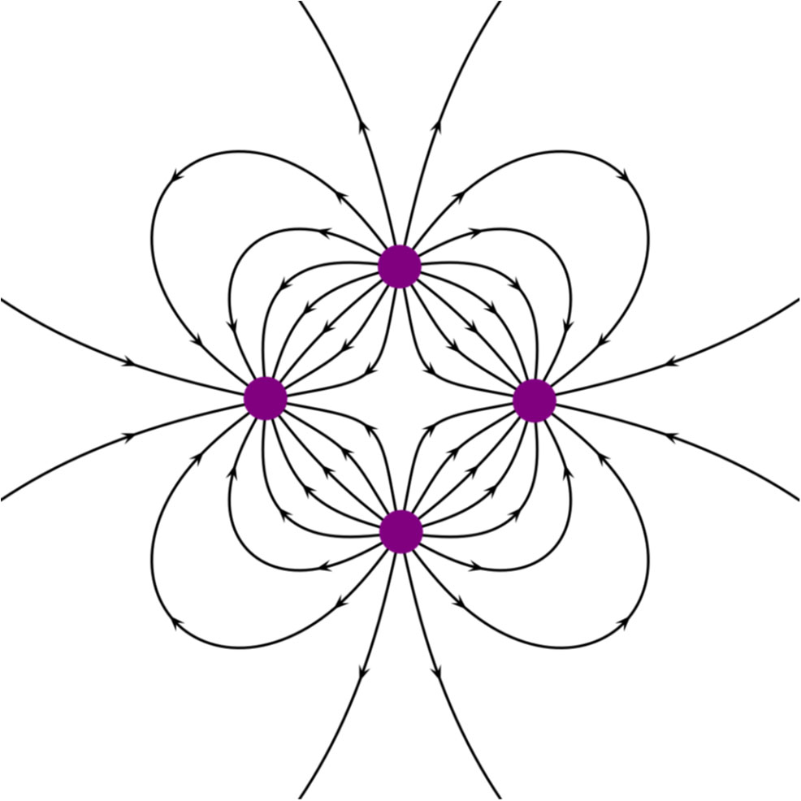

Chapter 14: Electricity Has Potential!

Term | Equations & Descriptions
Electric Potential
Electron Volt
Capacitor
Capacitance
Electric Permittivity ($ε$)
Ground (Electrical)
Law of Charge Conservation
Electric Current
Electric Circuit
 |  | 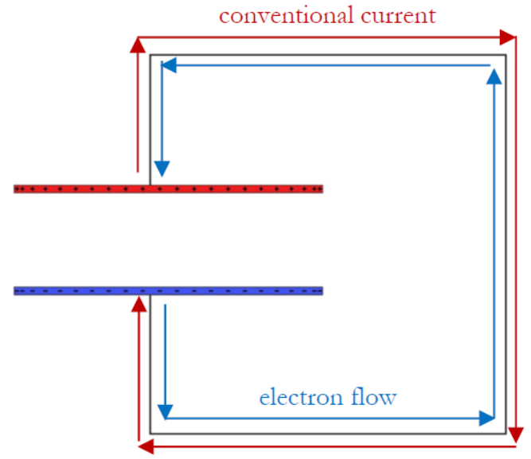

Chapter 15: Electric Circuits

Term | Equations & Descriptions
Drift Velocity
Resistor
Battery
(Voltage source)
Fuse
Capacitor
Switch
 |  | 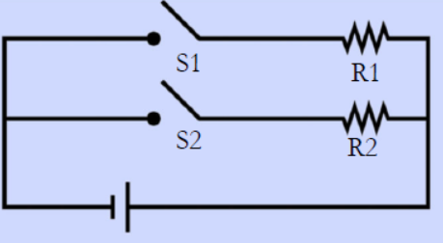
 |  | 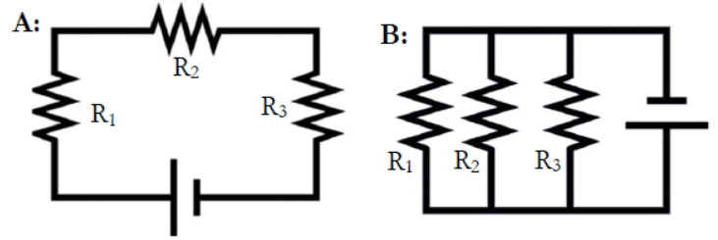
 |  | 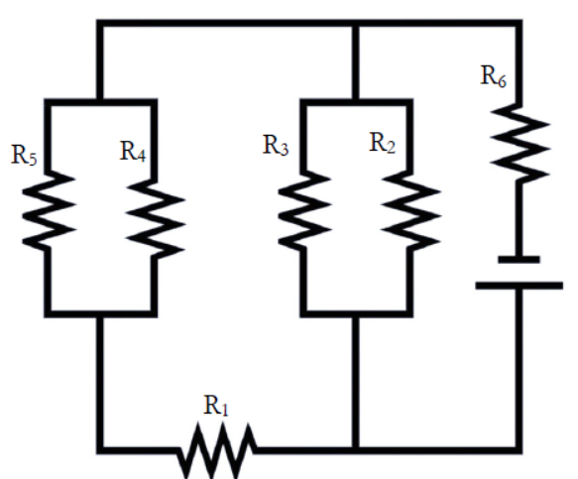
 |  | 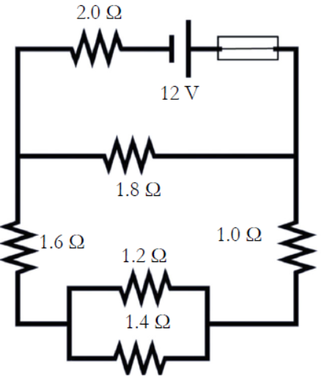
 |  | 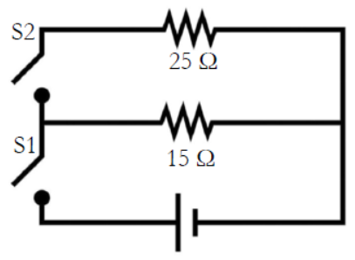
 |  | 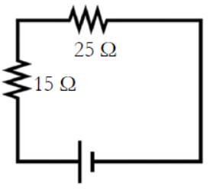
 |  | 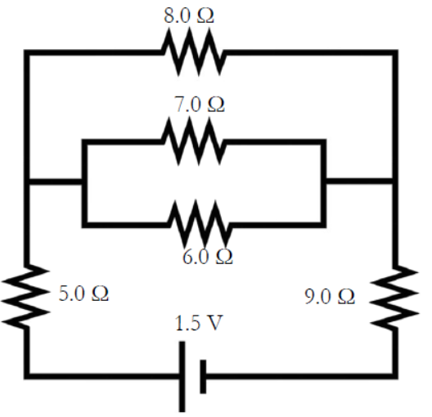
 |  | 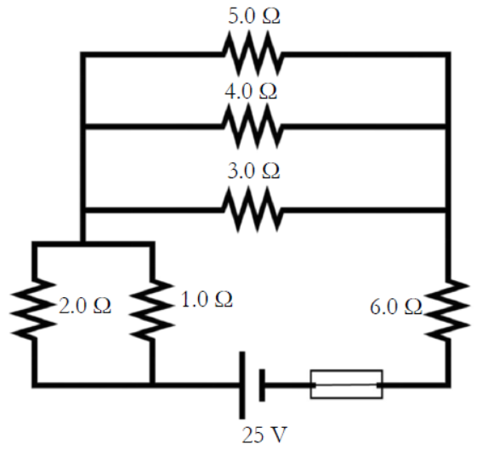

Chapter 16: Magnetism

Term | Equations & Descriptions
Basic Law of Magnetism
Magnetic Permeability ($μ$)
Right-Hand Rule
Diamagnetic Substance
Paramagnetic Substance
Ferromagnetic Substance
Faraday’s Law of Magnetic Induction
Electromotive Force
Alternating Current
Direct Current
Rectifier
Inverter
Lenz’s Law

Sources
These chapters and content are taken verbatim from the High School textbook:
- Dr. Jay L. Wile (2023). Discovering Design with Physics, 1st Edition.
Image Sources
- Dr. Carl Rod Nave (1998). HyperPhysics, Conservation of Energy. http://hyperphysics.phy-astr.gsu.edu/hbase/conser.html

