Harold’s Physics of Forces
“Cheat Sheet”
19 April 2016

The Classic Force on an Incline Problem
Diagram | 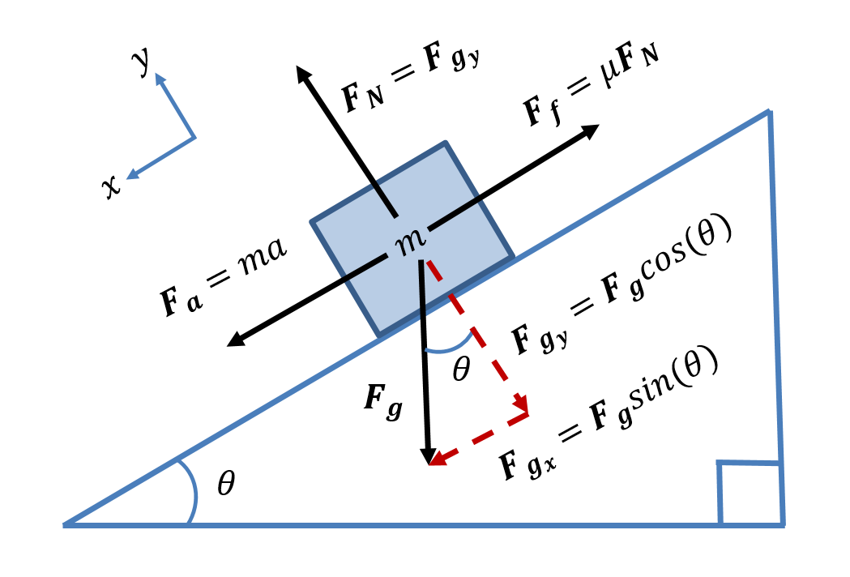
Givens | $m=100 kg$ Mass  $θ={30}^{°}$ Degrees inclined from horizontal
 | $$v=0$$ | $$v=constant$$ | $$a=constant$$
 | $$μ_{s}=0.30$$  Static coefficient of friction  (not moving) (0,1] | $$μ_{k}=$$  Kinetic coefficient of friction (moving) [0, 1) | $$μ_{k}=0.20$$
Unknowns | $$F_{f_{s}}= _______ N$$ | $$μ_{k}= _______$$ | $$a= _______ m/{s^{2}}$$
Observations | $$g=9.8 m/{s^{2}}$$
Equations | $$\sum{F_{y}}=F_{N}-F_{g_{y}}=0$$ | $$\sum{F_{x}}=F_{g_{x}}-F_{f_{k}}=0$$ | $$\sum{F_{x}}=F_{g_{x}}-F_{f_{k}}=F_{a}$$
 | Since $v=0$:  $$F_{g_{x}}<F_{f_{s}}$$ | Since $v=constant$:  $$F_{g_{x}}=F_{f_{k}}$$ | Since $a=constant$:  $$F_{a}=F_{g_{x}}-F_{f_{k}}$$
Solve | $$F_{g}=mg$$  $$F_{N}=F_{g_{y}}$$  $$F_{N}=F_{g}\cos\left(θ\right)=mg\cos\left(θ\right)$$  $$F_{g_{x}}<F_{f_{s} max}$$  $$F_{g_{x}}=F_{g}\sin\left(θ\right)=mg sin(θ)$$  $$F_{f_{s}}={μ_{s}F}_{N}=μ_{s}mg\cos\left(θ\right)$$ | $$F_{g_{x}}=F_{f_{k}}$$  $$F_{g_{x}}=F_{g}\sin\left(θ\right)=mg sin(θ)$$  $$F_{f_{k}}=μ_{k}F_{g_{y}}=μ_{k}mg\cos\left(θ\right)$$  $$mg\sin\left(θ\right)=μ_{k}mg\cos\left(θ\right)$$  $$μ_{k}=\tan\left(θ\right)$$ | $$F_{a}=ma$$  $$F_{g_{x}}=F_{g}\sin\left(θ\right)=mg\sin\left(θ\right)$$  $$F_{f_{k}}=μ_{k}F_{N}=μ_{k}mg\cos\left(θ\right)$$  $$F_{a}=F_{g_{x}}-F_{f_{k}}$$  $$ma=mg sin\left(θ\right)-μ_{k}mg\cos\left(θ\right)$$  $$a=g \left[sin\left(θ\right)-μ_{k}\cos\left(θ\right)\right]$$
Substitute | $$F_{g_{x}}=\left(100\right)\left(9.8\right) sin\left({30}^{°}\right)$$  $$=490 N$$  $$F_{f_{s} max}=(0.30)\left(100\right)(9.8)\cos\left({30}^{°}\right)=509 N$$ | $$μ_{k}=\tan\left({30}^{°}\right)=0.577$$ | $$a=\left(9.8\right)\left[sin\left({30}^{°}\right)-(0.20)\cos\left({30}^{°}\right)\right]=3.2m/{s^{2}}$$
Box & Check Your Answer | $$\boxed{F_{f_{s}}=490 N}$$  $$490 N<509 N$$ | $$\boxed{μ_{k}=0.577}$$  $$0.577<1.0$$ | $$\boxed{a=3.2m/{s^{2}}}$$

