Harold’s Physics of Projectiles
“Cheat Sheet”
26 November 2017

The Classic Cannon Ball Problem
Diagram | 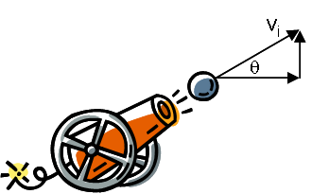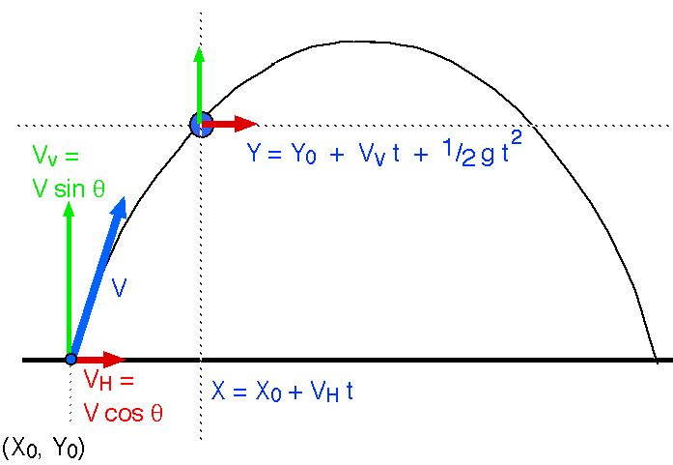  2  0  1
Givens | $$v=40 m/s$$  $θ={30}^{°}$ Degrees inclined from horizontal
Unknowns | Horizontal (x-axis) | Vertical (y-axis)
 | ❶ How far is it at time t? $\left(x\left(t\right)\right)$  ❹ How far will it land? ($x_{max}$) | ❷ How high is it at time t? $\left(y\left(t\right)\right)$  ❺ How high will it go? ($y_{max}$)
 | ❸ When will it land? ($t_{max}$)
Observations | Notes:  - Subscripts are dimensions, time, or both. Examples:  - $v_{x}$ is the velocity in the x direction.  - $x_{0}$ is the initial horizontal position, or horizontal position at time = 0 s.  - $v_{y0}$ is the initial velocity in the y direction (vertical)  - Horizontal and vertical dimensions are orthogonal (independent from one another).  - Assume no wind resistance (drag). If we factored in wind resistance, then differential calculus is needed.  - The cannon ball will reach its highest point exactly half way through its journey. [$t_{1}$ and $x_{1}]$
 | $x_{0}=0$, $x_{1}=\frac{1}{2}x_{2}$, $x_{2}=x_{max}$  $${v_{x}= v}_{x0}=v_{x1}=v_{x2}=constant$$  $$a_{x}=0$$ | $y_{0}=0$, $y_{1}=y_{max}$, $y_{2}=0$  $v_{y0}= ?$, $v_{y1}= 0$, $v_{y2}={-v}_{y0}$  $$a_{y}=g=-9.8 m/{s^{2}}$$
 | $t_{0}=0$, $t_{1}=\frac{1}{2}t_{2}$, $t_{2}=t_{max}$
Equations | $$x= x_{0}+v_{x0}t+\frac{1}{2}a_{x}t^{2}$$ | $$y= y_{0}+v_{y0}t+\frac{1}{2}a_{y}t^{2}$$
 | $$v_{x}=v cos(θ)$$ | $$v_{y}=v sin(θ)$$

We are now ready to solve for all 5 unknowns in the order 1,2,3,4,5.
 | Horizontal (x-axis) | Vertical (y-axis)
Solve | $$x= x_{0}+v_{x0}t+\frac{1}{2}a_{x}t^{2}$$  $$x=v_{x0}t$$ | $$y= y_{0}+v_{y0}t-\frac{1}{2}gt^{2}$$  $$y=v_{y0}t-\frac{1}{2}gt^{2}$$
 | $$x\left(t\right)=v_{x0}t= v cos\left(θ\right) t$$ | $$y\left(t\right)=v\sin\left(θ\right)t-\frac{1}{2}gt^{2}$$
Substitute | $$x\left(t\right)=40 cos\left({30}^{°}\right) t m$$ | $$y\left(t\right)=40 sin\left({30}^{°}\right) t-4.9 t^{2} m$$
Box Answer | $$❶ \boxed{x\left(t\right)=40 cos\left({30}^{°}\right) t m}$$  Distance travelled | ❷ $\boxed{y\left(t\right)=40 sin\left({30}^{°}\right) t-4.9 t^{2} m}$  Height travelled

Solve |  | $$y\left(t_{0}\right)=y_{0}=0=v_{y0}t-\frac{1}{2}gt^{2}$$  $$\left(t\right)\left(v_{y0}-\frac{1}{2}gt\right)=0$$  $$t=t_{0}=0, t=t_{2}=\frac{2v_{y0}}{g}$$  $$t_{max}=t_{2}=\frac{2v_{y0}}{g}=\frac{2(v sin(θ))}{g}$$
Substitute | $$t_{max}=\frac{2(40 sin\left({30}^{°}\right))}{9.8}=4.08 s$$
Box Answer | $$❸ \boxed{t_{max}=4.08 s}$$  Time the cannon ball was in the air

Solve | $$x_{max}=v_{x0}{ t}_{max}=v cos\left(θ\right){ t}_{max}$$ | $$y_{max}=y\left(t_{1}\right)=y\left(\frac{1}{2}t_{max}\right)$$  $$y_{max}=40 sin\left({30}^{°}\right)\left(\frac{1}{2}t_{max}\right)-4.9{\left(\frac{1}{2}t_{max}\right)}^{2}$$
Substitute | $$x_{max}=40 cos\left({30}^{°}\right) 4.08=141.3 m$$ | $$y_{max}=40\sin\left({30}^{°}\right)\left(\frac{4.08}{2}\right)-4.9{\left(\frac{4.08}{2}\right)}^{2}=20.41 m$$
Box Answer | ❹ $\boxed{x_{max}=141.3 m}$  Farthest distance the cannon ball travelled | ❺ $\boxed{y_{max}=20.41 m}$  Highest distance the cannon ball travelled

