Harold’s SAT Prep
Cheat Sheet
21 January 2026

Formerly the Scholastic Aptitude Test (SAT)
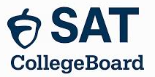
Exam Dates

Exam | Year in High School | Why
PSAT Exam | PSAT 8/9: Freshman year (9th grade) | Optional early practice
PSAT Exam | PSAT 10: Sophomore year (10th grade) | Practice run
PSAT Exam | PSAT/NMSQT: October of Junior year (11th grade) | October exam counts for National Merit Scholar eligibility (NMSQT)
SAT Exam | Spring of Junior year (11th grade) | Ideal first attempt  Aligns with Algebra 2 completion  Gives time for retakes
SAT Exam | August between Junior and Senior year | Popular for students who prep over the summer
SAT Exam | Fall of Senior year (12th grade) | Great for score improvement before early action (Nov 1)

Exam | 2026 Dates
PSAT Exam Dates | 1-Oct-26
SAT Exam Dates | 14-Mar-26  2-May-26  6-Jun-26  15-Aug-26  12-Sep-26  3-Oct-26  7-Nov-26  5-Dec-26
ACT Exam Dates | 14-Feb-26  11-Apr-26  13-Jun-26  11-Jul-26  19-Sep-26  17-Oct-26  12-Dec-26

SAT Scores

Section | Score Range
R&W Section | 200 – 800
Math Section | 200 – 800
Total Score | 400 - 1600
Scores are typically available 2–4 weeks after test day.

College Admission

School |  | Average Score of Enrolled Students | Level | State
Caltech | California Institute of Technology | 1555 | 1. Ivy Level | CA
JHU | Johns Hopkins University | 1555 | 1. Ivy Level | MD
Rice | Rice University | 1550 | 2. Top-Tier Private | TX
MIT | Mass. Inst. of Technology | 1545-1560 | 1. Ivy Level | MA
Stanford | Stanford University | 1545 | 1. Ivy Level | CA
Yale | Yale University | 1540 | 1. Ivy Level | CT
UC | University of Chicago | 1540 | 1. Ivy Level | IL
Harvard | Harvard University | 1520-1560 | 1. Ivy Level | MA
Princeton | Princeton University | 1500-1560 | 1. Ivy Level | NJ
SMU | Southern Methodist Univ. | 1400-1420 | 2. Top-Tier Private | TX
BYU | Brigham Young University Provo | 1374 | 2. Top-Tier Private | UT
UT | Univ. of Texas at Austin | 1360 | 3. Top Public Research | TX
BU | Baylor University | 1305 | 2. Top-Tier Private | TX
UTD | Univ. of Texas at Dallas | 1290 | 3. Top Public Research | TX
UD | University of Dallas | 1290 | 2. Top-Tier Private | TX
OU | University of Oklahoma | 1238 | 4. Mid-Tier Public | OK
UNT | University of North Texas | 1160 | 4. Mid-Tier Public | TX
BYU-I | BYU-Idaho | 1080-1090 | 5. Mid-Tier Private | ID
TWU | Texas Woman’s University | 1035-1060 (SAT optional) | 6. Mid-Tier Public | TX
CCCC | Collin County Community College | Does not require SAT scores | 7. Open Admission | TX

National Merit Scholarships

Item | Description
SNMQT Scholarship | National Merit Scholarship Qualifying Test (NMSQT)
Description | The NMSQT is the qualifying version of the PSAT/NMSQT—a standardized digital test that students take to be considered for recognition and scholarships through the National Merit Scholarship Program.
When to Take | Students typically take the PSAT/NMSQT as Juniors (11th grade)
Recognition | - 1.3 million students apply  - 50,000 are recognized  - 16,000 become semifinalists (Sept. of senior year)  - 15,000 become finalists (later in senior year)  - 7,500 are awarded (Top 0.5%) (later in senior year)
3 Reward Types | - National Merit $2500 Scholarship  - One-time payment  - All finalists considered
3 Reward Types | - Corporate-Sponsored Awards  - For finalists meeting sponsor criteria  - May be one-time or renewable  - Renewable typically $1,000–$10,000/year  - Renewable one-time $2,500–$10,000
3 Reward Types | - College-Sponsored Awards  - Finalists must name that college as their first choice, apply, and not have another NMSC award  - Renewable up to 4 years  - Typical annual stipend range $500–$2,000/year  - Awards are tied to that institution and are canceled if the student changes/transfers schools.
Parental Help | - Make sure your student takes the PSAT/NMSQT in 11th grade  - Keep grades strong  - Be ready to complete the application promptly if they’re named a semifinalist  - Essay  - Activities  - Recommendations

SAT Composition

Component | Time Allotted (minutes) | Number of Questions
Reading and Writing (R&W) | 64 (2x 32-min) | 54
Math | 70 (2x 35-min) | 44
Total | 134 | 98

Reading and Writing (R&W) Structure

Item | Description
R&W Question Types | - 100% 4-Option Multiple Choice  - Short passages (25–150 words)
Number of Questions | - Part 1: 27 questions, 32 min.  - Part 2: 27 questions, 32 min.
Average Time Per Question | - 1 min. 11 sec.

Content Domain | Measures
1. Information and Ideas | - Comprehension, analysis, reasoning skills, and knowledge  - Locate, interpret, evaluate, and integrate information and ideas  - Texts and informational graphics (tables, bar graphs, and line graphs).
2. Craft and Structure | - Comprehension, vocabulary, analysis, synthesis, and reasoning skills and knowledge  - Understand and use high-utility words and phrases in context  - Evaluate texts rhetorically  - Make connections between topically related texts
3. Expression of Ideas | - Revise texts to improve the effectiveness of written expression  - Meet specific rhetorical goals
4. Standard English Conventions | - Edit text to conform to core conventions of Standard English  - Sentence structure  - Usage (grammar)  - Punctuation

Math Structure

Item | Description
Math Question Types | - 75% 4-Option Multiple Choice  - 25% Student Produced Format (SPF)
Number of Questions | - Part 1: 22 questions, 35 min.  - Part 2: 22 questions, 35 min.
Average Time Per Question | - 1 min. 35 sec.

Content Domain | Measures
1. Algebra | - Linear equations in 1 variable  - Linear equations in 2 variables  - Linear functions  - Systems of 2 linear equations in 2 variables  - Linear inequalities in 1 or 2 variables
2. Advanced Math (STEM) | - Equivalent expressions  - Nonlinear equations in 1 variable  - Systems of equations in 2 variables  - Nonlinear functions (absolute value, quadratic, exponential, polynomial, rational, radical)
3. Problem Solving and Data Analysis | - Ratios, rates, proportional relationships, and units  - Percentages  - One-variable data: distributions and measures of center and spread (Statistics)  - Two variable data: models and scatterplots (Statistics)  - Probability and conditional probability  - Inference from sample statistics and margin of error  - Evaluating statistical claims: observational studies and experiments
4. Geometry and Trigonometry | - Area and volume formulas  - Lines, angles, and triangles  - Right triangles and trigonometry  - Circles

SAT Score Goals & Timeline

Tip | Description
Realistic Target Score Goals | ~2.34 SAT points per hour of tutoring
Realistic Target Score Goals | Research on improvement from the first SAT exam  - ≥6 hours = +21 points  - ≥6-8 hours = +90 points  - ≥20 hours = +115 points  - ~+21-39 points when students also:  - Took at least one full practice test  - Leveled up skills  - Followed personalized recommendations  Source: A joint College Board–Khan Academy technical report (2020)
Early Start Advantage | 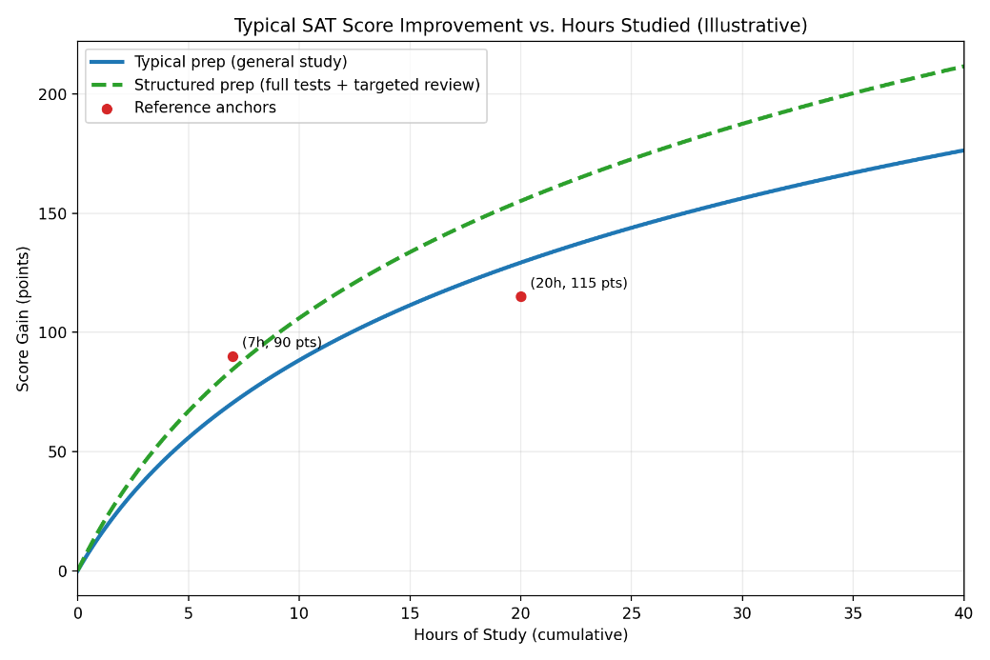
Prep Timeline | Best: 3x week for 9 weeks  Budget: 1x week for 6 weeks  Worst: None
Score Boosting Strategy | Top strategies supported across all research sources:  - Start with an official diagnostic  - Use adaptive, digital practice to match real conditions  - Review your mistakes more than you take new tests  - Prioritize accuracy early in adaptive modules  - Study consistently, not crammed  - Track patterns: pacing, error types, and question categories

Tips & Strategies

Tip | Description
Calculators | Allowed  - Scientific calculators  - TI-83 Plus, TI-84 Plus, TI-84 Plus CE, TI-84 Plus CE Python  - TI-Nspire CX (non-CAS), TI-Nspire CX II (non-CAS)  - Graphing calculators (as long as they are non‑CAS)  - Desmos  - Casio fx-9750GII / III, Casio fx-CGG50 (Prizm)  - HP-39, -40, -48, -50 series, HP Prime (in exam mode)  - Sharp EL-5200, EL-9200, EL-9300, EL-9600  Not Allowed  - Calculators with CAS (symbolic algebra)  - TI-Nspire CAS, TI-89 Titanium, TI-92 Plus  - HP 48Gii, HP 49G, HP 50G (CAS)  - Calculators with wireless/Bluetooth/internet  - Calculators with QWERTY keyboards  - Calculators with stylus input  - Mobile phone calculator apps  SAT Calculator Policy
Penalty for Guessing | - The SAT does NOT deduct points for wrong answers.  - A wrong answer gives you 0 points, and a correct answer gives you +1 point—so guessing can only help you.
Trig Questions | Each SAT exam has no more than 4 trigonometry questions
Rewards | The Digital SAT rewards consistency, accuracy, digital familiarity, and targeted practice, not brute-force memorization.
Timed | Practice under timed, adaptive conditions.
3-Ways to Solve | Every SAT math question has at least three (3) different ways it can be solved:  - Graphically (geometry, graph, diagram, table)  - Algebraically (equation, model)  - Calculator (TI-84 Plus C)  - Computer App (Desmos, WolframAlpha, ChatGPT, Google)  - Intuition (If numbers are hard to add, pretend they are currency)

Stress Management

Advice | Explanation
1. Do a “dry run” week | Take 1 full, timed practice test at the same time of day as your real SAT to reduce surprise stress.
2. Use box breathing | Use box breathing (4 seconds in, hold 4, out 4, hold 4) for 2–3 minutes before you start and anytime you feel panicky.
3. Make a simple test-day checklist | Checklist:  - ID  - Admission ticket  - Pencils  - Calculator (fully charged or with fresh batteries)  - Snack  - Water  - Hoodie  Pack it the night before.
4. Follow a sleep plan for 3 nights | Consistent bedtime/wake time; don’t try to “cram-sleep” only the night before.
5. Caffeine rules | Take no more caffeine than what you normally drink—no “extra” on test day (it can spike anxiety).
6. Warm up for 5–10 minutes | Warm up for 5–10 minutes with a few easy problems to get your brain going instead of jumping in cold.
7. Use a reset phrase | Use a reset phrase when you get stuck: “Skip, mark, return.” Move on quickly to protect your momentum.
8. Time checkpoints | Glance at the clock only at planned moments (e.g., every 10 questions) to avoid constant time anxiety.
9. Micro muscle release | Drop your shoulders, unclench your jaw, and relax your hands between passages/sections.
10. Break strategy | During breaks, stand up, sip water, eat a small snack, and take slow breaths—avoid post-mortem questions with others.
11. Hydration | Drink plenty of water. Dehydration can affect mental performance.

Resources

Resource (Links) | Description
College Board Bluebook App | The platform students must use to take the digital SAT, replacing the traditional paper‑and‑pencil format.  - Official SAT practice exams  - Desmos graphing calculator  - Performance analytics  - Locked-down, secure browser during actual test
College Board Bluebook Practice Tests | Free.
Khan Academy Official SAT Practice | Free.
Union Test Prep Free Study Guides | Free.  Study Guides:  - Reading/Writing  - Math  - Essay

Sources
- CollegeBoard (2026). SAT Suite of Assessments. https://sat.collegeboard.org

