Harold’s Algebra
Cheat Sheet
22 September 2025

Arithmetic Operations (+, –, ⦁, ÷)

Property | Equation | Tips
Commutative | $$a+b=b+a$$  $$a·b=b·a$$ | Reordering does not change the answer
Associative | $$\left(a+b\right)+c=a+\left(b+c\right)$$  $$\left(a·b\right)·c=a·\left(b·c\right)$$ | Regrouping does not change the answer
Distributive | $$a\left(b±c\right)=ab±ac$$ | Extract common terms ($a$)
Identity | $$a+0=a$$  $$a·1=a$$ | No change  0 plus anything = anything  1 times anything = anything
Unity | $$\left(\frac{anything}{anything}\right)=1$$ | Used often  Assuming $anything≠0$
Sum (Addition) | $$\frac{a}{b}±\frac{c}{d}=\frac{ad±bc}{bd}$$ | Need a common denominator  $$\left(\frac{a}{b}\right)\left(\frac{d}{d}\right)+\left(\frac{c}{d}\right)\left(\frac{b}{b}\right)=\frac{ad+bc}{bd}$$
Difference (Subtraction)
Product (Multiplication) | $$\frac{a}{b}·\frac{c}{d}=\frac{ac}{bd}$$ | Multiply numerator with numerator and denominator with denominator
Quotient (Division) | $$\frac{a}{b}÷\frac{c}{d}=\frac{a}{b}·\frac{d}{c}$$ | Invert and multiply
Cross Multiplication | $$If \frac{a}{b}=\frac{c}{d} then ad=bc$$ | Used often
Variable $×$ Fraction | $$a\left(\frac{b}{c}\right)=\frac{ab}{c}$$ | Set $a=\frac{a}{1}$, then  multiply numerator with numerator and denominator with denominator
Variable $÷$ Fraction | $$\frac{a}{\left(\frac{b}{c}\right)}=\frac{ac}{b}$$ | Invert $\left(\frac{b}{c}\right)$ then multiply
Distribute Denominator | $$\frac{a+b}{c}=\frac{a}{c}+\frac{b}{c}$$ | $c$ divides both sides of the numerator
Swapping Signs | $$\frac{a-b}{c-d}=\frac{b-a}{d-c}$$ | Multiplying both the numerator and denominator by (-1) cancels the negatives
Cancelling Terms | $$\frac{ab+ac}{a}=b+c$$ | Assuming $a≠0$
Fraction over a Fraction | $$\frac{\left(\frac{a}{b}\right)}{\left(\frac{c}{d}\right)}=\frac{ad}{bc}$$ | Invert the denominator then multiply
Fraction from Hell | $$\frac{\frac{\left(\frac{a}{b}\right)}{ \left(\frac{c}{d}\right) }}{\frac{\left(\frac{e}{f}\right)}{\left(\frac{g}{h}\right)}}=\frac{adfg}{bceh}$$ | $$\frac{\left(\frac{\left(\frac{N}{D}\right)}{\left(\frac{D}{N}\right)}\right)}{\left(\frac{\left(\frac{D}{N}\right)}{\left(\frac{N}{D}\right)}\right)}=\frac{NNNN}{DDDD}$$

Exponents ($a^{b}$)

Property | Equation | Example
Product Rule | $$a^{n}a^{m}=a^{n+m}$$ | $$a^{3}a^{2}=(a∙a∙a)(a∙a)=a^{3+2}=a^{5}$$
Power Rule | $${\left(a^{n}\right)}^{m}=a^{nm}$$ | $${\left(a^{3}\right)}^{2}=\left(a∙a∙a\right)\left(a∙a∙a\right)=a^{3∙2}=a^{6}$$
Zero Power | $$a^{0}=1$$ | By definition assuming $a≠0$
Negative Powers | $$a^{-n}=\frac{1}{a^{n}}$$  $$\frac{1}{a^{-n}}=a^{n}$$ | $$2^{-3}=\frac{1}{2^{3}}=\frac{1}{8}$$
Quotient Rule | $$\frac{a^{n}}{a^{m}}=a^{n-m}=\frac{1}{a^{m-n}}$$ | $$\frac{2^{4}}{2^{3}}=\frac{2∙2∙2∙2}{2∙2∙2}=2^{4-3}=2^{1}=2$$
Product Distribution | $${\left(ab\right)}^{n}=a^{n}b^{n}$$
Quotient Distribution | $${\left(\frac{a}{b}\right)}^{n}=\frac{a^{n}}{b^{n}}$$ | $${\left(\frac{1}{2}\right)}^{3}=\frac{1^{3}}{2^{3}}=\frac{1}{8}$$
Fractional Powers | $$a^{\frac{n}{m}}={\left(a^{\frac{1}{m}}\right)}^{n}={\left(a^{n}\right)}^{\frac{1}{m}}$$ | $$2^{\frac{3}{4}}={\left(2^{\frac{1}{4}}\right)}^{3}={\left(2^{3}\right)}^{\frac{1}{4}}$$
Negative Powers | $${\left(\frac{a}{b}\right)}^{-n}={\left(\frac{b}{a}\right)}^{n}$$ | $${\left(\frac{1}{2}\right)}^{-3}={\left(\frac{2}{1}\right)}^{3}=8$$
Domain | The domain of $a^{x}$ is  $$\left(-∞, ∞\right)$$ | 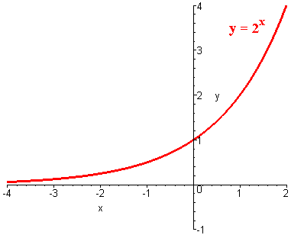

Radicals ($\sqrt[n]{a}$)

Property | Equation | Example
Fractional Powers | $$\sqrt[n]{a}=a^{\frac{1}{n}}$$ | $$\sqrt[3]{2}=2^{\frac{1}{3}}$$
Power Rule  (Nested Roots) | $$\sqrt[m]{\sqrt[n]{a}}=\sqrt[nm]{a}$$ | $$\sqrt[4]{\sqrt[3]{2}}=\sqrt[3∙4]{2}=\sqrt[12]{2}$$
Product Distribution | $$\sqrt[n]{ab}=\sqrt[n]{a} \sqrt[n]{b}$$ | $$\sqrt[3]{14}=\sqrt[3]{2} \sqrt[3]{7}$$
Quotient Distribution | $$\sqrt[n]{\frac{a}{b}}=\frac{\sqrt[n]{a}}{\sqrt[n]{b}}$$ | $$\sqrt[4]{\frac{2}{3}}=\frac{\sqrt[4]{2}}{\sqrt[4]{3}}$$
Odd | $\sqrt[n]{a^{n}}=a$ if $n$ is odd | Odd powers always keep their sign
Even | $\sqrt[n]{a^{n}}=±a$ if $n$ is even | Even roots of even powers can be both positive and negative.  Substitute to check if each solution is valid.
Domain | The domain of $\sqrt{x}$ is $x≥0$ | 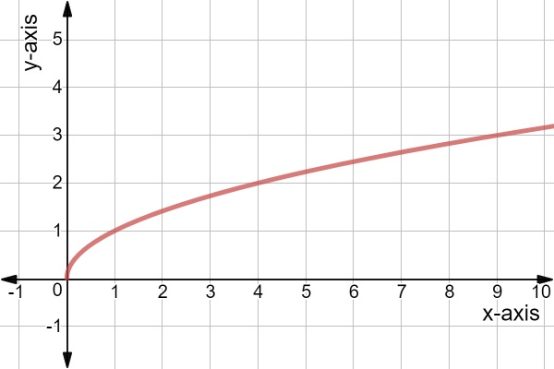

Logarithms ($\log_{b}{x}$)

Property | Equation |  | Example
Definition | $$b^{y}=x ⟺ \log_{b}\left(x\right)=y$$ |  | Pulls the exponent down to level
Example | $$5^{3}=125 ⟺ \log_{5}\left(125\right)=3$$ |  | Logs make large numbers very small
Special Logs | Natural log |  | $$\ln\left(x\right)=\log_{e}\left(x\right)$$
 | $ln$ = Logarithme Naturel (French) |  | where e ≈ 2.718281828 …
 | Common log |  | $$\log\left(x\right)=\log_{10}\left(x\right)$$
 | Computer science log |  | $$\log\left(x\right)=\log_{2}\left(x\right)$$
 | Pre-1950 US math textbooks log |  | $$\log\left(x\right)=\log_{e}\left(x\right)=\ln\left(x\right)$$
Rules | Common | Natural
Trivial Identities | $$\log_{b}\left(b\right)=1$$ | $$\ln\left(e\right)=1$$ | $$b^{1}=b$$
 | $$\log_{b}\left(1\right)=0$$ | $$\ln\left(1\right)=0$$ | $$b^{0}=1$$
Cancelling Exponentials | $$\log_{b}\left(b^{x}\right)=x$$ | $$\ln\left(e^{x}\right)=x$$ | Inverse function $f\left(f^{-1}\left(x\right)\right)=x$
 | $$b^{\log_{b}\left(x\right)}=x$$ | $$e^{\ln\left(x\right)}=x$$ | Inverse function $f^{-1}\left(f\left(x\right)\right)=x$
Exponential Rule | $$\log_{b}\left(x^{r}\right)=r \log_{b}\left(x\right)$$  $$\log_{b}\left(\sqrt[y]{x}\right)=\frac{1}{y}\log_{b}\left(x\right)$$ |  | $${\left(a^{n}\right)}^{m}=a^{nm}$$  Convert $\sqrt[y]{x}$ to $x^{\frac{1}{y}}$ first
Product Rule | $$\log_{b}\left(xy\right)=\log_{b}\left(x\right)+\log_{b}\left(y\right)$$ |  | $$a^{n}a^{m}=a^{n+m}$$  Basis of slide rules
Quotient Rule | $$\log_{b}\left(\frac{x}{y}\right)=\log_{b}\left(x\right)-\log_{b}\left(y\right)$$ |  | $$\frac{a^{n}}{a^{m}}=a^{n-m}$$
Change of Base | $$\log_{a}\left(b\right)=\frac{\log_{c}\left(b\right)}{\log_{c}\left(a\right)}$$ |  | $c$ is the new base  TI-84: [MATH] [MATH] [A:logBASE(]
Base Switch | $$\log_{b}{a}=\frac{1}{\log_{a}{b}}$$ |  | Can use instead of TI-84 function
Obscure Rules | $$x^{\log_{b}{y}}=y^{\log_{b}{x}}$$  $$\log_{b}{(a±c)}=\log_{b}{(a)}+\log_{b}\left(1±\frac{c}{a}\right)$$ |  | Useful in probability theory
Domain | The domain of $\log_{b}\left(x\right)$ is $x>0$ |  | 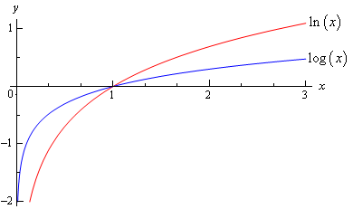

Factoring Formulas

Description | Equation |  | Notes
Quadratic | $$x^{2}+a^{2}=\left(x+ai\right) \left(x-ai\right)$$  $$x^{2}-a^{2}=\left(x+a\right) \left(x-a\right)$$  $${\left(x+a\right)}^{2}=x^{2}+2ax+a^{2}$$  $${\left(x-a\right)}^{2}=x^{2}-2ax+a^{2}$$  $$\left(x+a\right) \left(x+b\right)=x^{2}+\left(a+b\right)x+ab$$  $$\left(x-a\right) \left(x-b\right)=x^{2}-\left(a+b\right)x+ab$$ |  | 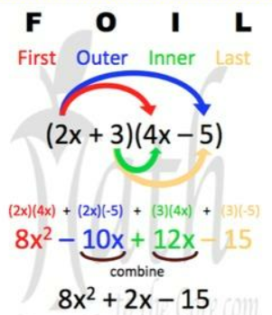
Cubic | $${\left(x+a\right)}^{3}=x^{3}+3ax^{2}+3a^{2}x+a^{3}$$  $${\left(x-a\right)}^{3}=x^{3}-3ax^{2}+3a^{2}x-a^{3}$$  $$x^{3}+a^{3}=\left(x+a\right) \left(x^{2}-ax+a^{2}\right)$$  $$x^{3}-a^{3}=\left(x-a\right) \left(x^{2}+ax+a^{2}\right)$$ |  | Binomial expansion (Pascal’s Triangle)  Notice one ‘$-$‘ and two ‘$+$’ for both
Even Powers | $$x^{2n}+a^{2n}=\left(a^{n}-{ix}^{n}\right) \left(a^{n}+ix^{n}\right)$$  $$x^{2n}-a^{2n}=\left(x^{n}-a^{n}\right) \left(x^{n}+a^{n}\right)$$ |  | The top equation is not often used since it requires imaginary numbers ($i$)
Odd Powers | $$x^{n}+a^{n}=\left(x+a\right) \left(x^{n-1}-ax^{n-2}+a^{2}x^{n-3}-…-a^{n-2}x+a^{n-1}\right)$$  $$x^{n}-a^{n}=\left(x-a\right) \left(x^{n-1}+ax^{n-2}+a^{2}x^{n-3}+…+a^{n-2}x+a^{n-1}\right)$$
End-Terms Method | $$2x^{2}+13x+15$$ | $$(2x±3|5) (x±5|3)$$  Four possibilities to get middle-term:  - $+3$ Select one 3  - $-3$  - $+5$ Select one 5  - $-5$
Box Method | 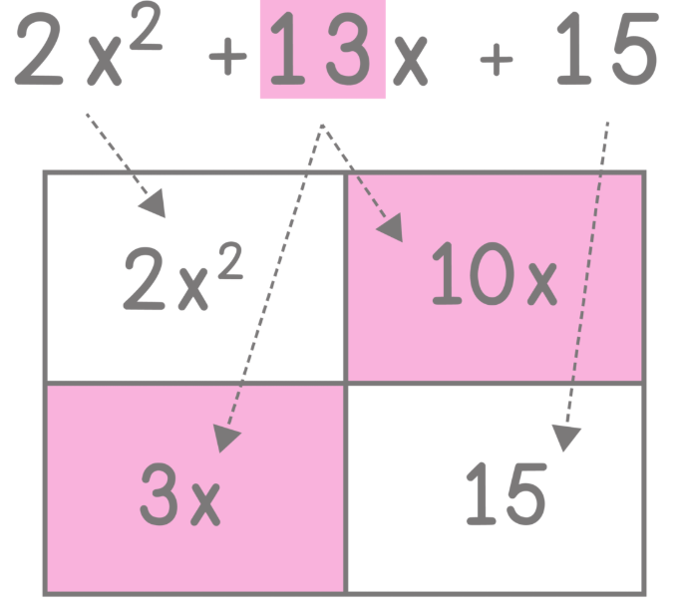 | 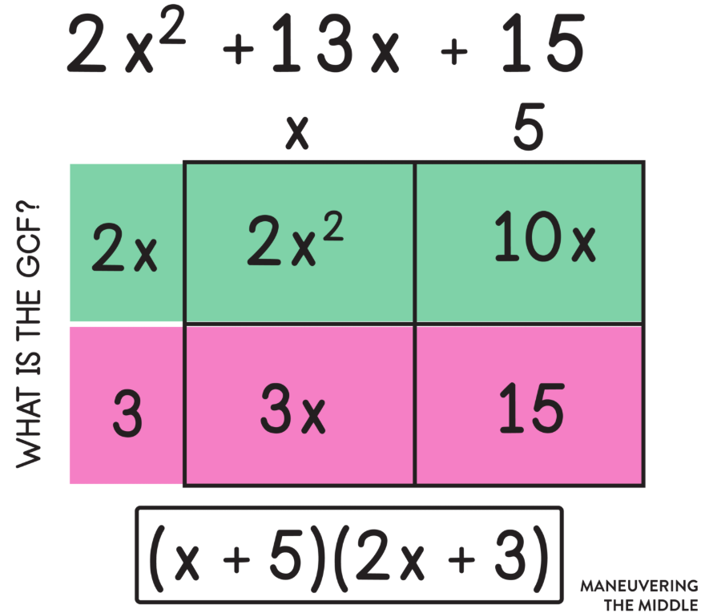
Visual Method | 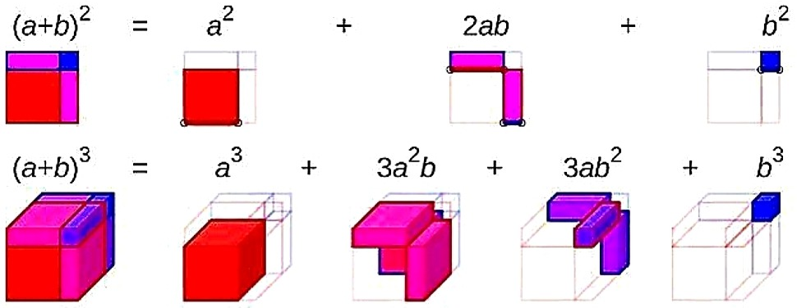
Quadratic Formula (x²)

Description | Equation | Notes
Quadratic Formula Form | $$ax^{2}+bx+c=0$$ | Remember, $b$ and $c$can be negative.
Quadratic Formula | $$x=\frac{-b±\sqrt{b^{2}-4ac}}{2a}$$ | - $\sqrt{b^{2}-4ac}>0$: two real unequal roots  - $\sqrt{b^{2}-4ac}=0$: repeated real roots (multiplicity of two)  - $\sqrt{b^{2}-4ac}<0$: two complex roots
Completing the Square | - Start with the quadratic formula form  $$ax^{2}+bx+c=0$$  - Divide both sides by $a$  $$x^{2}+\left(\frac{b}{a}\right)x+\left(\frac{c}{a}\right)=0$$  - Subtract the constant on the left to move it to the right side  $$x^{2}+\left(\frac{b}{a}\right)x=-\left(\frac{c}{a}\right)$$  - Cut the middle term in half, square it, then add it to both sides  $$x^{2}+\left(\frac{b}{a}\right)x+{\left(\frac{b}{2a}\right)}^{2}=-\left(\frac{c}{a}\right)+{\left(\frac{b}{2a}\right)}^{2}$$  - Use an identity to factor the left side  $$a^{2}+2ab+b^{2}={\left(a+b\right)}^{2}$$  $${\left[x+\left(\frac{b}{2a}\right)\right]}^{2}={\left(\frac{b}{2a}\right)}^{2}-\left(\frac{c}{a}\right)\left(\frac{4a}{4a}\right)$$  - Take the square root of both sides  $$x+\left(\frac{b}{2a}\right)=±\frac{\sqrt{b^{2}-4ac}}{2a}$$  - Solve for $x$ by subtracting the constant on the left to move it to the right  $$x=\frac{-b±\sqrt{b^{2}-4ac}}{2a}$$
Vertex | Vertex: $x=-b/2a$  Finds the minimum / maximum of a parabola.
$$\frac{d}{dx}\left[cx^{n}\right]=cnx^{n-1}$$
Calculus method: Power Rule
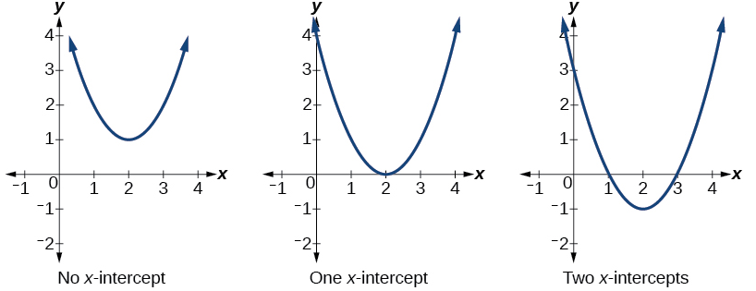

Cubic Formula (x³)

Description | Equation | Notes
Cubic Formula Form | $$ax^{3}+bx^{2}+cx+d=0$$ | Coefficients must be integers
Cubic Formula | $$x_{1}=\sqrt[3]{e+\sqrt{e^{2}+f^{3}}}+\sqrt[3]{e-\sqrt{e^{2}+f^{3}}}-\frac{b}{3a}$$  where  $$e=\left(\frac{bc}{6a^{2}}-\frac{d}{2a}-\frac{b^{3}}{27a^{3}}\right)$$  $$f=\left(\frac{c}{3a}-\frac{b^{2}}{9a^{2}}\right)$$  Find $x_{2}$ and $x_{3}$ using the quadratic formula.

Inequalities ($a>b$)

Property | Equation | Notes
Inequality Symbols | $$<, ≤ , =, ≠, ≥ , >$$ | $$≠: <>, !=$$
Sum | $$a<b$$  $$⟹a+c<b+c$$
Difference | $$a<b$$  $$⟹a-c<b-c$$
Product (Positive) | $$a<b and c>0$$  $$⟹ac<bc$$ | Multiplying or dividing by a positive number does not change the inequality direction
Quotient (Positive) | $$a<b and c>0$$  $$⟹\frac{a}{c}<\frac{b}{c}$$
Product (Negative) | $$a<b and c<0$$  $$⟹ac>bc$$ | Multiplying or dividing by a negative number changes the inequality direction  (e.g., $c=-1$)
Quotient (Negative) | $$a<b and c<0$$  $$⟹\frac{a}{c}>\frac{b}{c}$$
Inequality Notation | Interval Notation | Number Line Graph
$$a≤x$$ | $$[a,∞)$$ | 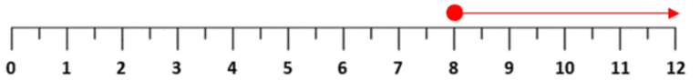
$$a<x$$ | $$(a,∞)$$ | 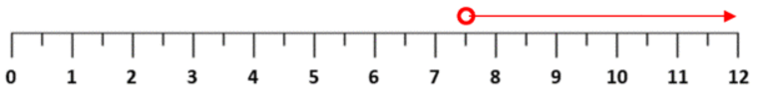
$$a≥x$$ | $$(-∞,a]$$ | 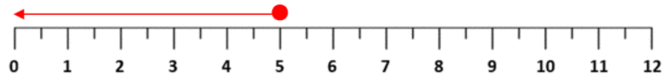
$$a>x$$ | $$(-∞,a)$$ | 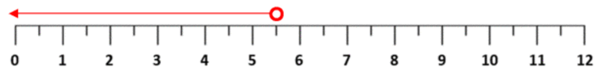
$$a≤x≤b$$ | $$[a,b]$$ | 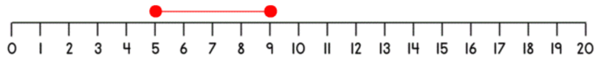
$$a<x<b$$ | $$(a,b)$$ | 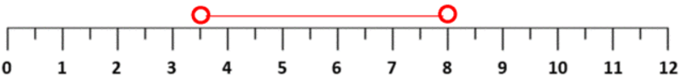
$$a≥x≥b$$ | $$\left(-∞, a\right]∪ \left[b, ∞\right)$$ | 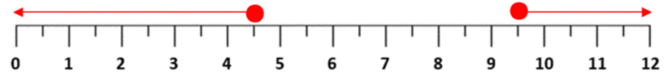
$$a>x>b$$ | $$\left(-∞, a\right)∪\left(b, ∞\right)$$ | 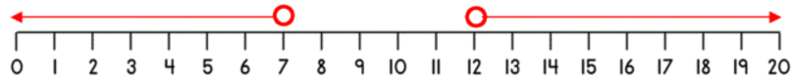

Absolute Values ($|a|$)

Property | Equation | Notes
Definition | $$\left|a\right|=\left\{\begin{aligned} a if a≥0 \\ -a if a<0\end{aligned}\right.$$ | Simply strip away the minus sign
Observations | $$\left|a\right|≥0$$ | Are never negative
 | $$|-a|=|a|$$ | We care about the magnitude only
Product Rule | $$\left|ab\right|=\left|a\right| |b|$$
Quotient Rule | $$\left|\frac{a}{b}\right|=\frac{|a|}{|b|}$$
Solving | $$\left|ax+b\right|=c$$ | Positive Case: $\left(ax+b\right)=c$  Negative Case: $-\left(ax+b\right)=c$
Triangle Inequality | $$\left|a+b\right|≤\left|a\right|+\left|b\right|$$  $$\left|a-b\right|≥\left||a|-|b|\right|$$ | 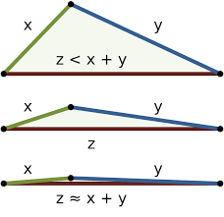

Distance Formula

Property | Equation
Distance Formula | $$d=\sqrt{{\left(x_{2}-x_{1}\right)}^{2}+{\left(y_{2}-y_{1}\right)}^{2}}$$  Same as Pythagorean Theorem  $$c^{2}=a^{2}+b^{2}$$
Graph | 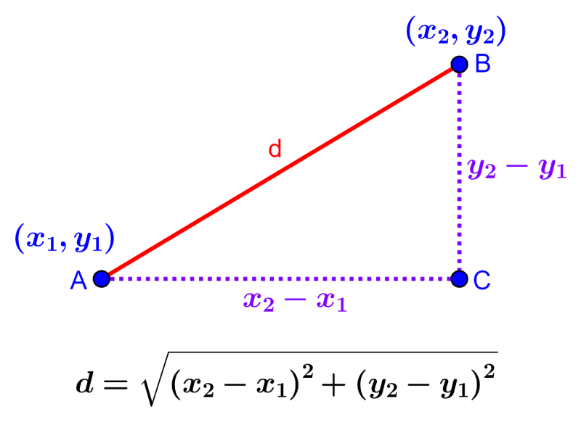

Complex Numbers ($a+bi$)

Property | Equation | Notes
Imaginary Number  (Adjacent Number) | $$i=\sqrt{-1}$$  $$i^{2}=-1$$  $$i^{3}=-i=-\sqrt{-1}$$  $$i^{4}=1$$ | $$i^{4n}=1$$  $$i^{4n+1}=i$$  $$i^{4n+2}=-1$$  $$i^{4n+3}=-i$$
Usage | $$\sqrt{-a}=i\sqrt{a}$$ | Assuming $a≥0$
Complex Number | $$a+bi$$ | Real + Imaginary
Sum | $$\left(a+bi\right)+\left(c+di\right)=a+c+\left(b+d\right)i$$
Difference | $$\left(a+bi\right)-\left(c+di\right)=a-c+\left(b-d\right)i$$
Product | $$\left(a+bi\right) \left(c+di\right)=ac-bd+\left(ad+bc\right)i$$
Quotient | $$\frac{c}{(a+bi)}=\frac{c}{(a+bi)} \frac{(a-bi)}{(a-bi)}=\frac{c(a-bi)}{a^{2}+b^{2}}$$
Conjugate | $$\overline{\left(a+bi\right)}=a-bi$$ | $$\overline{\left(a-bi\right)}=a+bi$$
Modulus | $$\left|a+bi\right|=\sqrt{a^{2}+b^{2}}$$ | Distance from origin $(0, 0)$ to $(a, b)$
Squares | $$a^{2}+b^{2}=\left(a+bi\right) \left(a-bi\right)$$  $${\left|a+bi\right|}^{2}=\left(a+bi\right) \left(a-bi\right)$$
Euler’s Identity | $$e^{iπ}+1=0$$
Graph | 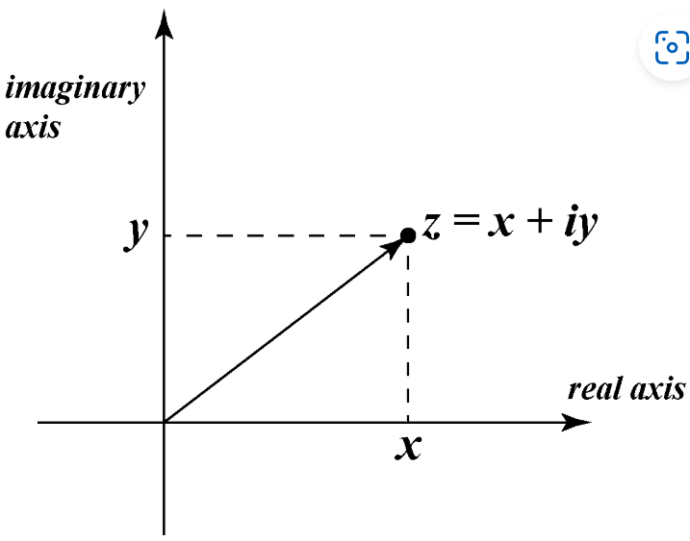

Conic Sections
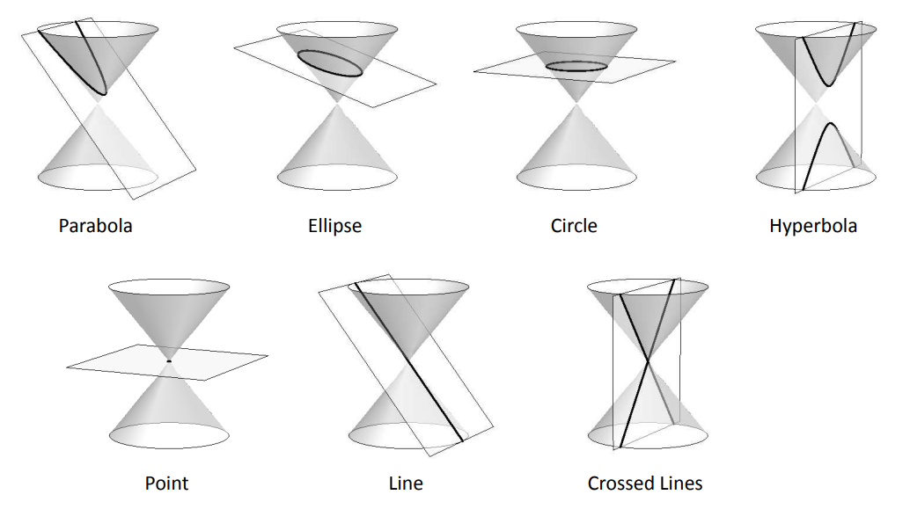
Line

Description | Equation | Notes
Slope | $$m=\frac{rise}{run}$$  $$m=\frac{y_{2}-y_{1}}{x_{2}-x_{1}}=\frac{∆y}{∆x}$$ | $$P_{1}=\left(x_{1}, y_{1}\right)$$  $$P_{2}=\left(x_{2}, y_{2}\right)$$  Passes through points $P_{1}$ and $P_{2}$
Standard Form | $$ax+by+c=0$$ | Where $a$ is positive
Slope-Intercept Form | $$y=mx+b$$  $$f(x)=mx+b$$ | $b$ is the $y$-axis intercept  Passes through point $(0, b)$
Point-Slope Form | $$y-y_{0}=m(x-x_{0})$$ | Manipulation of the slope formula
Intercept Form | $$\frac{x}{a}+\frac{y}{b}=1$$ | $a$is the $x$-intercept  $b$ is the $y$-intercept
Vertical Line | $$x=a$$ | Passes through point $(a, 0)$
Horizontal Line | $$y=b$$  $$f\left(x\right)=b$$ | Passes through point $(0, b)$
Domain | The domain of  $y=mx+b$ is $\left(-∞, ∞\right)$ | 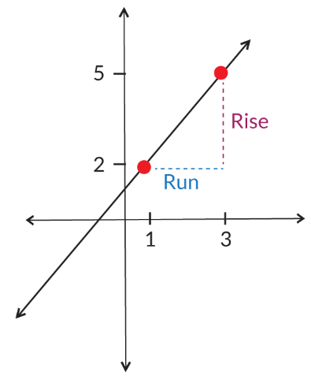

Circle

Description | $y$-Axis Symmetry | $x$-Axis Symmetry
Standard Form | $$x^{2}+y^{2}=r^{2}$$  $${(x-h)}^{2}+{(y-k)}^{2}=r^{2}$$ | Same
Radius | $$r$$  $$r=\sqrt{{\left(x_{1}-h\right)}^{2}+{\left(y_{1}-k\right)}^{2}}$$ | Same
Center | $$\left(h,k\right)$$ | Same
Vertices | None | Same
Focus | $$\left(h,k\right)$$ | Same
Graph | 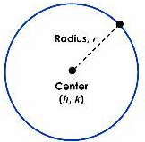 | Same

Parabola

Description | $y$-Axis Symmetry | $x$-Axis Symmetry
Standard Form | $$y=ax^{2}+bx+c$$  $$f(x)=ax^{2}+bx+c$$ | $$x=ay^{2}+by+c$$  $$g(y)=ay^{2}+by+c$$
Vertex Form | $$y=a{\left(x-h\right)}^{2}+k$$ | $$x=a{\left(y-k\right)}^{2}+h$$
Factored Form | $$y=a(x-r_{1})(x-r_{2})$$ | Roots $r_{1},r_{2}$
Graphing Form | $$x^{2}=4py$$  $${\left(x-h\right)}^{2}=4p(y-k)$$ | $$y^{2}=4px$$  $${\left(y-k\right)}^{2}=4p(x-h)$$
Vertex | $$\left(h,k\right)$$  $$\left(-\frac{b}{2a}, f\left(-\frac{b}{2a}\right)\right)$$ | $$\left(h,k\right)$$  $$\left(g\left(-\frac{b}{2a}\right), -\frac{b}{2a}\right)$$
Focus | $$\left(h,k+p\right)$$ | $$\left(h+p,k\right)$$
Directrix | $$y=k-p$$ | $$x=h-p$$
Direction | Opens up if $a>0$  Opens down if $a<0$ | Opens right if $a>0$  Opens left if $a<0$
Graph | 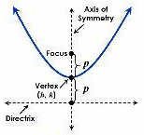 | 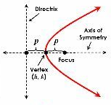

Ellipse

Description | $y$-Axis Symmetry | $x$-Axis Symmetry
Standard Form | $$\frac{x^{2}}{a^{2}}+\frac{y^{2}}{b^{2}}=1$$  $$\frac{{(x-h)}^{2}}{a^{2}}+\frac{{(y-k)}^{2}}{b^{2}}=1$$ | $$\frac{y^{2}}{a^{2}}+\frac{x^{2}}{b^{2}}=1$$  $$\frac{{(y-k)}^{2}}{a^{2}}+\frac{{(x-h)}^{2}}{b^{2}}=1$$
Center | $$(h, k)$$ | $$(h, k)$$
Vertices | $$\left(h±a, k\right)$$ | $$\left(h, k±a\right)$$
Co-Verticies | $$\left(h, k±b\right)$$ | $$\left(h±b, k\right)$$
Foci | $$\left(h±c, k\right)$$ | $$\left(h, k±c\right)$$
Focus Length | $$c^{2}= a^{2}-b^{2}$$ | $$c^{2}= a^{2}-b^{2}$$
Graph | 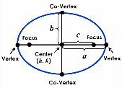 | 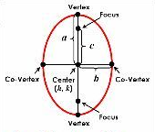
The sum of the distances from each focus to a point on the curve is constant. $\left|d_{1}+d_{2}\right|=k$

Hyperbola

Description | $y$-Axis Symmetry | $x$-Axis Symmetry
Standard Form | $$\frac{x^{2}}{a^{2}}-\frac{y^{2}}{b^{2}}=1$$  $$\frac{{\left(x-h\right)}^{2}}{a^{2}}-\frac{{\left(y-k\right)}^{2}}{b^{2}}=1$$ | $$\frac{y^{2}}{a^{2}}-\frac{x^{2}}{b^{2}}=1$$  $$\frac{{\left(y-k\right)}^{2}}{a^{2}}-\frac{{\left(x-h\right)}^{2}}{b^{2}}=1$$
Center | $$(h, k)$$ | $$(h, k)$$
Vertices | $$\left(h±a, k\right)$$ | $$\left(h, k±a\right)$$
Foci | $$\left(h±c, k\right)$$ | $$\left(h, k±c\right)$$
Focus Length | $$c^{2}= a^{2}+b^{2}$$ | $$c^{2}= a^{2}+b^{2}$$
Asymptotes | $$y=k±\left(\frac{b}{a}\right)(x-h)$$ | $$y=k±\left(\frac{a}{b}\right)(x-h)$$
Direction | Opens left/right | Opens up/down
Graph | 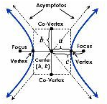 | 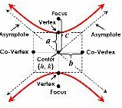
The difference between the distances from each focus to a point on the curve is constant. $\left|d_{1}-d_{2}\right|=k$

Sources:
- Brack, Tyne (2023, 24 January). Maneuvering the Middle, Factoring Polynomials with Special Cases. https://www.maneuveringthemiddle.com/factoring-polynomials-with-special-cases/

- Dawkins, Paul (2024). Paul’s Online Notes, Algebra Cheat Sheet. https://tutorial.math.lamar.edu

- Larson, Ron & Edwards, Bruce (2009). Algebra 1-Pager Reference, Calculus 9th Edition. https://www.amazon.com/Bruce-Edwards-Larson-Calculus-Hardcover/dp/B004QICACS/ref=sr_1_1

- Math Salamanders (2024). Inequalities on a Number Line. https://www.math-salamanders.com/inequalities-on-a-number-line.html

- TeachersPayTeachers.com (2019). Conic Section Graphs, All Things Algebra. https://www.pinterest.com/pin/612911830514800210/
