Harold’s Differential Equation Models
Cheat Sheet
7 April 2025

1. Exponential Growth and Decay
Observations:
- Population (Exponential): A population of bacteria grows at a rate directly proportional to the current population size.
- Finance: The more money you have invested the faster it grows.
$$\frac{dP}{dt} ∝P$$  $$\frac{dP}{dt}=kP$$  Separate variables and integrate:  $$\frac{dP}{P}=k dt$$  $$\int{\frac{dP}{P}} =\int{k dt}$$  $$\ln\left|P\right|=kt+c$$  Solve for $P(t)$:  $$e^{\ln\left|P\right|}= e^{kt+c}$$  $$\left|P\right|= e^{c} e^{kt}=Ce^{kt}$$  At $t=0$ (initial condition):  $$P\left(0\right)=Ce^{k*0}=C*1=C=P_{0}$$  Therefore:  For Population:  $$P\left(t\right)=P_{0}e^{kt}$$  For Finance:  $$A=Pe^{rt}$$ | Let:  - $dP/dt$: The instantaneous rate of change of $P$ over time.  - $∝$: Symbol for “is proportional to”.  - $P$: The quantity whose rate of change is being considered. Population, principle.  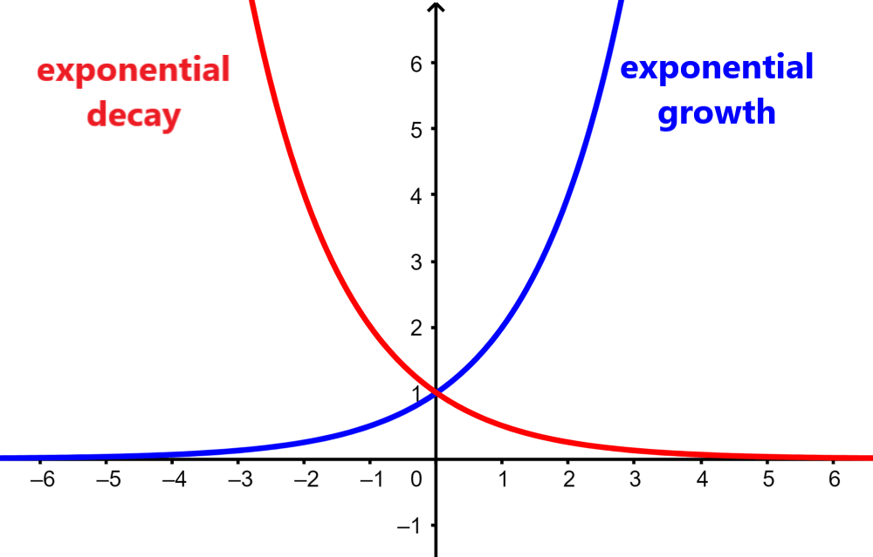  Grows exponentially if $k$ is positive $(k>0)$.  Decays exponentially if $k$ is negative $(k<0)$.

2. Newton’s Law of Cooling
Observation:
- The rate at which an object cools or heats is directly proportional to the temperature difference between the object and its surroundings.
$$\frac{dT}{dt} ∝ΔT$$  $$\frac{dT}{dt} ∝T_{a}-T$$  $$\frac{dT}{dt}=k\left(T_{a}-T\right)$$  $$\frac{dT}{dt}=-k(T-T_{a})$$  Separate variables:  $$\frac{dT}{(T-T_{a})}=-k dt$$  Integrate both sides:  $$\int{\frac{1}{(T-T_{a})}dT} =\int{-k dt}$$  $$\ln\left(T-T_{a}\right)=-kt-c$$  Solve for $T(t)$:  $$e^{\ln\left(T-T_{a}\right)}= e^{-kt-c}$$  $$T-T_{a}= e^{-c} e^{-kt}=-Ce^{-kt}$$  $$T\left(t\right)=T_{a}-Ce^{-kt}$$  At $t=0$ (initial condition):  $$T\left(0\right)=T_{a}-C= T_{0}$$  $$C= T_{a}-T_{0}$$  Therefore:  $$T\left(t\right)=T_{a}+(T_{a}-T_{0})e^{-kt}$$ | Let:  - $T(t)$: Represents the temperature of the object at time $t$.  - $T_{a}$: Represents the constant ambient temperature of the surroundings.  - $T_{0}$: Represents the initial temperature of the object.  - $k$: Represents a positive constant, often referred to as the cooling constant, which depends on the properties of the object and the surrounding medium.  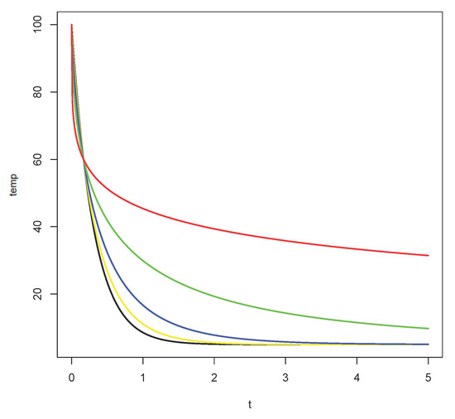  The solution shows that the object's temperature $T(t)$ approaches the ambient temperature $T_{a}$ exponentially over time.

3. Doomsday Differential Equation
Observation:
- Population (Logistic): The "doomsday differential equation," or "doomsday-extinction model," is a differential equation that models population growth. It can lead to either population extinction or a finite "doomsday" time where the population explodes to infinity.
$$\frac{dP}{dt} ∝P(M-P)$$  $$\frac{dP}{dt}=kP(M-P)$$  Separate variables:  $$\frac{dP}{P(M-P)}=k dt$$  Partial fraction decomposition:  $$\frac{1}{P\left(M-P\right)}=\frac{\frac{1}{M}}{P}+\frac{\frac{1}{M}}{M-P}$$  Substitute back in and multiply both sides by $M$:  $$\frac{1}{P}dP+\frac{1}{M-P}dP=kM dt$$  Integrate both sides:  $$\int{\frac{1}{P}dP}+\int{\frac{1}{M-P}dP} =\int{kM dt}$$  $$\ln{|P|}-\ln{|M-P|}=kMt+c$$  $$\ln\left(\frac{P}{M-P}\right)=kMt+c$$  Solve for $P(t)$:  $$e^{\ln\left(\frac{P}{M-P}\right)}= e^{kMt+c}$$  $$\frac{P}{M-P}= e^{c} e^{kMt}=Ce^{kMt}$$  Several algebra steps later:  $$P\left(t\right)=\frac{MC}{1+Ce^{-kMt}}$$  At $t=0$ (initial condition):  $$P\left(0\right)=P_{0} ⟶ C= \frac{P_{0}}{M-P_{0}}$$  Replacing $C$ and more algebra steps give:  $$P\left(t\right)=\frac{M}{{1+\left(\frac{M-P_{0}}{P_{0}}\right)e}^{-kMt}}$$ | Let:  - $P(t)$ represents the population size at time $t$.  - $k$ is a positive constant related to the growth rate $(k>0)$.  - $M$ is a constant representing a carrying capacity or a threshold.  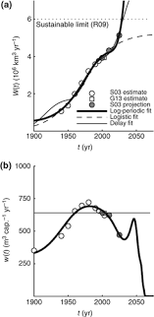  Doomsday vs. Extinction:  - Extinction: If the initial population $P\left(0\right)=P_{0}$ is less than $M$, the population will decline over time and eventually approach zero (extinction).  - Doomsday: If the initial population $P\left(0\right)=P_{0}$ is greater than $M$, the population will initially grow, but it will eventually reach a point where it explodes to infinity in a finite amount of time (doomsday).  If $P_{0}>M$  $$t_{doomsday}=\left(\frac{1}{kM}\right)\ln\left(\frac{P_{0}}{P_{0}-M}\right)$$

4. Drug Concentration in Body
Observation:
- The absorption of medicine into the body can be modeled using differential equations that describe how the concentration of the drug changes over time. A first-order absorption model assumes the rate of absorption is proportional to the amount of drug available at the absorption site (e.g., in the gastrointestinal tract (GI)).
1. Absorption Phase by the GI Track:  The drug leaves the absorption site at a rate proportional to how much is left there.  $$\frac{dA(t)}{dt} ∝A(t)$$  $$\frac{dA\left(t\right)}{dt}=-k_{a}A\left(t\right)$$  $$A(t)=De^{-k_{a}t}$$  2. Entry into Bloodstream:  The drug concentration in the bloodstream increases due to absorption and decreases due to elimination.  $$\frac{dC(t)}{dt}=Absorbed-Eliminated$$  $$\frac{dC\left(t\right)}{dt}=k_{a}A\left(t\right)-k_{e}C\left(t\right)$$  Substitute $A(t)$ into the $C(t)$ differential equation:  $$\frac{dC(t)}{dt}=k_{a}De^{-k_{a}t}-k_{e}C(t)$$  Solving for $C(t)$ (see next page) gives the solution for the amount of drug in the bloodstream over time:  Multiple Oral Doses Model:  $$C\left(t\right)=\frac{k_{a}D}{k_{e}-k_{a}}\left(e^{-k_{a}t}-e^{-k_{e}t}\right)+C_{0}e^{-k_{e}t}$$  Single Oral Dose Model:  $$A\left(0\right)=D$$  $$C\left(0\right)=C_{0}=0$$  $$C\left(t\right)=\frac{k_{a}D}{k_{e}-k_{a}}\left(e^{-k_{a}t}-e^{-k_{e}t}\right)$$ | Let:  - $A(t)$: Amount of drug at the absorption site at time $t$  - $C(t)$: Amount of drug (concentration) in the bloodstream at time $t$  - $C_{0}$ : Existing concentration before next dose  - $t$ : Time in hours  - $D$: Dose of the drug in milligrams  - $k_{a}$: Constant absorption rate of the drug  - $k_{e}$: Constant elimination rate of the drug  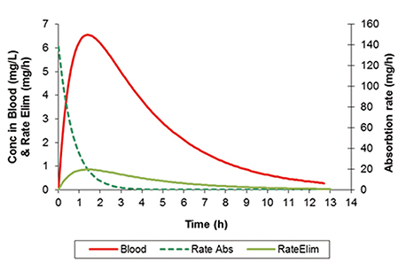  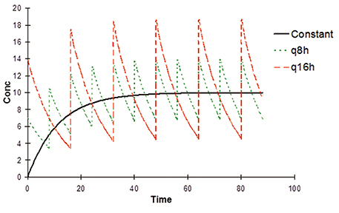  Interpretation:  - The first term is from absorption of the new dose.  - The second term is the decay of the existing concentration $C_{0}$ due to elimination.  - If $C_{0}=0$, we get the standard single-dose equation.
Solution:
Differential equation:
$$\frac{dC\left(t\right)}{dt}=k_{a}De^{-k_{a}t}-k_{e}C\left(t\right)$$

Move all C(t) variables to the left side:
$$\frac{dC(t)}{dt}+k_{e}C(t)=k_{a}De^{-k_{a}t}$$

Multiply both sides by the integrating factor, $e^{k_{e}t}$:
$$e^{k_{e}t}\frac{dC(t)}{dt}+k_{e}e^{k_{e}t}C(t)=k_{a}De^{(k_{e}-k_{a})t}$$

The left-hand side is the product rule derivative of:
$$\frac{d}{dt}\left(e^{k_{e}t}C\left(t\right)\right)=k_{a}De^{\left(k_{e}-k_{a}\right)t}$$

Integrate:
$$\int{\frac{d}{dt}\left[e^{k_{e}t}C\left(t\right)\right]}dt=\int{k_{a}De^{\left(k_{e}-k_{a}\right)t}dt}$$

$$e^{k_{e}t}C\left(t\right)=k_{a}D\int{e^{\left(k_{e}-k_{a}\right)t}}dt+K$$

Assume $k_{a}≠k_{e}$ to avoid division by zero (0):
$$e^{k_{e}t}C\left(t\right)=\frac{k_{a}D}{k_{e}-k_{a}}e^{\left(k_{e}-k_{a}\right)t}+K$$

Solve for $C(t)$:
$$C\left(t\right)=\frac{k_{a}D}{k_{e}-k_{a}}e^{-k_{a}t}+Ke^{-k_{e}t}$$

Apply initial condition $C\left(0\right)=C_{0}$:
$$C_{0}=\frac{k_{a}D}{k_{e}-k_{a}}+K$$

$$K=C_{0}-\frac{k_{a}D}{k_{e}-k_{a}}$$
Therefore:
$$C\left(t\right)=\frac{k_{a}D}{k_{e}-k_{a}}\left(e^{-k_{a}t}-e^{-k_{e}t}\right)+C_{0}e^{-k_{e}t}$$

