Harold’s Illegals
Cheat Sheet
18 August 2025

Algebra

Function | What is Undefined? | When is it Defined? | Graph
$$\frac{1}{x}$$ | Division by zero (0)  (vertical asymptote) | $$x≠0$$ | 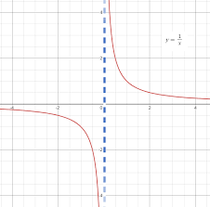  $$Domain:(-∞,0)∪(0,∞)$$
$$f\left(x\right)\frac{(x-c)}{(x-c)}$$ | Division by zero (0) – special case  (hole at $x=c$) | $$x≠c$$ | 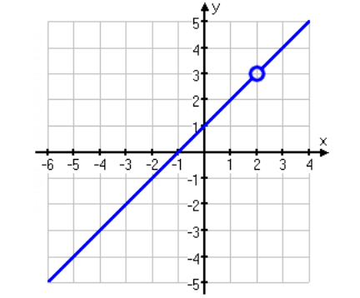  $$Domain: \left(-∞,c\right)∪(c,∞)$$
$$\sqrt{x}$$ | Negative square roots | $$x≥0$$ | 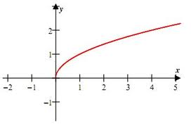  Domain: [$0,∞)$
$$\sqrt[2n]{x}=x^{\frac{1}{2n}}$$ | Negative even-powered roots | $$x≥0$$ | Domain: [$0,∞)$
$$\log{x}$$  $$\ln{x}$$ | Negative logarithms | $$x>0$$ | 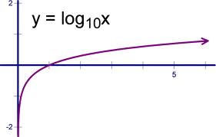  Domain: ($0,∞)$

Trigonometry

Function | What is Undefined? | When is it Defined? | Graph
$$\tan{x}$$  $$\sec{x}$$ | Trig functions with division by zero when $\cos{x}=0$ | $$x≠\frac{π}{2}±nπ$$ | 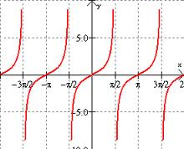  Domain: ($-\frac{π}{2},\frac{π}{2})$
$$\cot{x}$$  $$\csc{x}$$ | Trig functions with division by zero when $\sin{x}=0$ | $$x≠± nπ$$ | 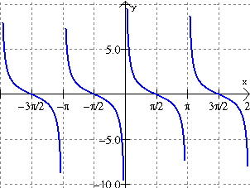  Domain: ($0,π)∪(π,2π)$
$$\sin^{-1}{x}$$  $$\cos^{-1}{x}$$ | Inverse trig functions where  $$\left|x\right|>1$$ | $$\left|x\right|≤1$$ | 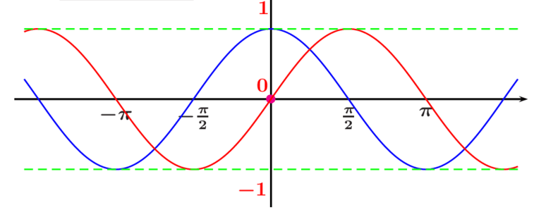  $$Domain: [-1, 1]$$
$$\sec^{-1}{x}$$  $$\csc^{-1}{x}$$ | Inverse trig functions where  $$\left|x\right|<1$$ | $\left|x\right|≥1$ | 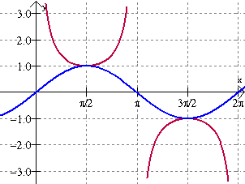  $$Domain: (-∞,-1]∪[1,∞)$$

Zero/Infinity

Number | What is Undefined? | When is it Defined?
Zero (0)  Infinity (∞) | $$\frac{0}{0},\frac{∞}{∞}, 0•∞, ∞-∞, 0^{0}, ∞^{0},1^{∞},x^{∞}$$ | $$0^{∞}→0, ∞^{∞}→∞$$  $$\frac{0}{∞}→0, \frac{∞}{0}→∞$$
Infinity (∞) | Treating infinity like a number.  $$f(∞)$$ | $$\lim_{x→∞}{f(x)}$$
Proof $2=1$ | Given:  a = b  Proof:  a = b  a² = a· b  a² – b² = a· b – b²  (a + b) (a – b) = b (a – b)  a + b = b  b + b = b  2b = b  2 = 1 | Can you find the illegal operation?

NOTE: Illegal = Undefined expression per Wikipedia

