Harold’s
Polar Parent Functions
Cheat Sheet
AKA Library of Functions
15 September 2025

Circle | $$0≤θ<2π$$
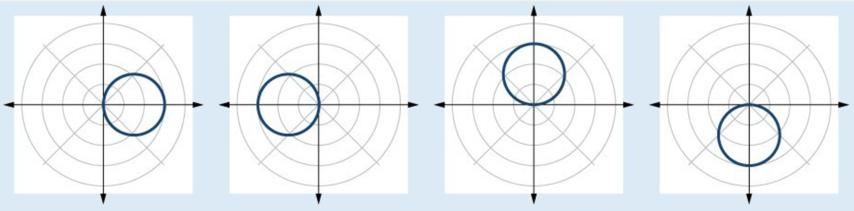
$$r=a\cos{(θ)}$$  $$a>0$$ | $$r=a\cos{(θ)}$$  $$a<0$$ | $$r=a\sin{(θ)}$$  $$a>0$$ | $$r=a\sin{(θ)}$$  $$a<0$$
Cardioid | $$0≤θ<2π$$
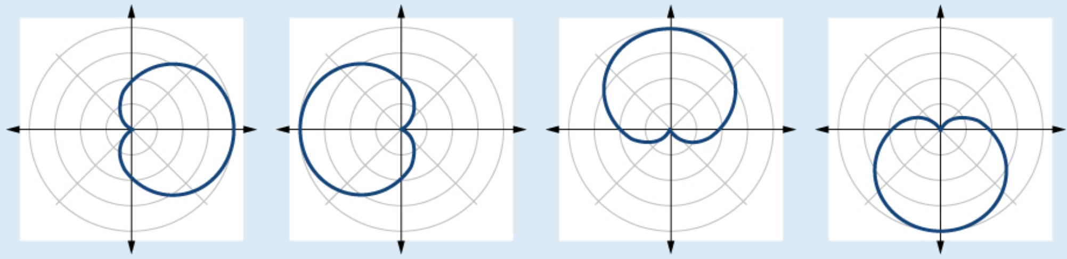
$$r=a+b\cos{(θ)}$$  $$a,b>0$$  $$\frac{a}{b}=1$$ | $$r=a-b\cos{(θ)}$$  $$a,b>0$$  $$\frac{a}{b}=1$$ | $$r=a+b\sin{(θ)}$$  $$a,b>0$$  $$\frac{a}{b}=1$$ | $$r=a-b\sin{(θ)}$$  $$a,b>0$$  $$\frac{a}{b}=1$$
One-Loop Limaçon | $$0≤θ<2π$$
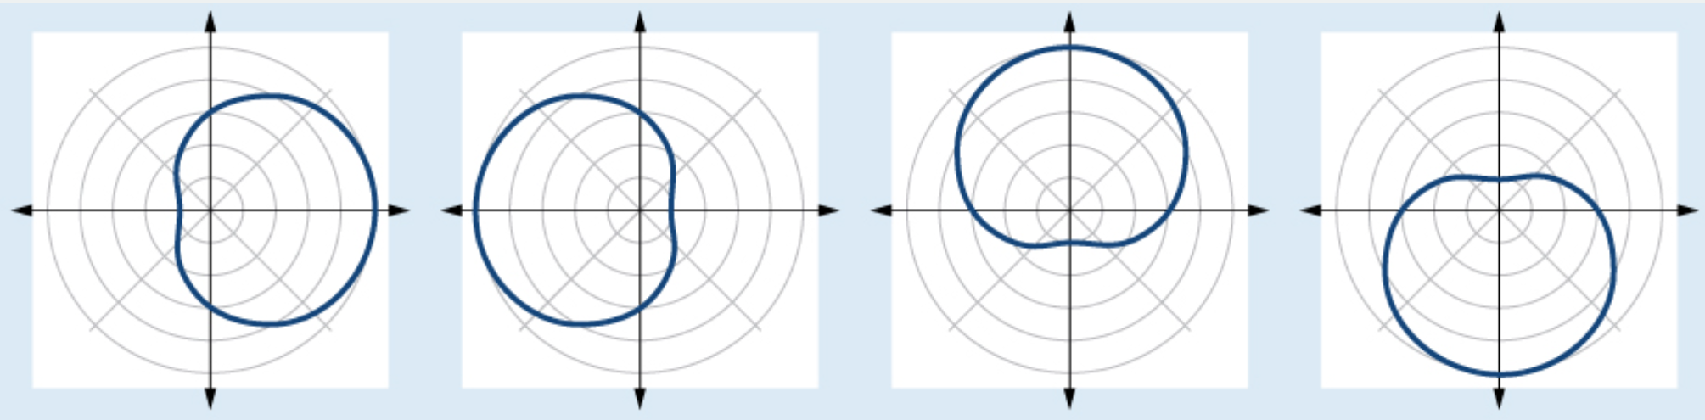
$$r=a+b\cos{(θ)}$$  $$a,b>0$$  $$1<ab<2$$ | $$r=a-b\cos{(θ)}$$  $$a,b>0$$  $$1<ab<2$$ | $$r=a+b\sin{(θ)}$$  $$a,b>0$$  $$1<ab<2$$ | $$r=a-b\sin{(θ)}$$  $$a,b>0$$  $$1<ab<2$$
Inner-Loop Limaçon | $$0≤θ<2π$$
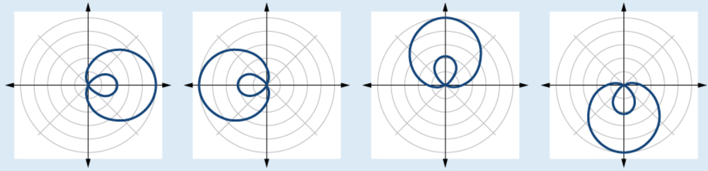
$$r=a+b\cos{(θ)}$$  $$a,b>0$$  $$a<b$$ | $$r=a-b\cos{(θ)}$$  $$a,b>0$$  $$a<b$$ | $$r=a+b\sin{(θ)}$$  $$a,b>0$$  $$a<b$$ | $$r=a-b\sin{(θ)}$$  $$a,b>0$$  $$a<b$$
lemniscate | $$0≤θ<2π$$
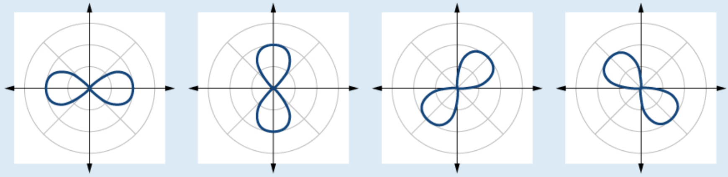
$$r^{2}=a^{2}\cos{(2θ)}$$  $$a≠0$$ | $$r^{2}=-a^{2}\cos{(2θ)}$$  $$a≠0$$ | $$r^{2}=a^{2}\sin{(2θ)}$$  $$a≠0$$ | $$r^{2}=-a^{2}\sin{(2θ)}$$  $$a≠0$$
Rose Curve | $$0≤θ<2π$$ | Archimedes’ Spiral
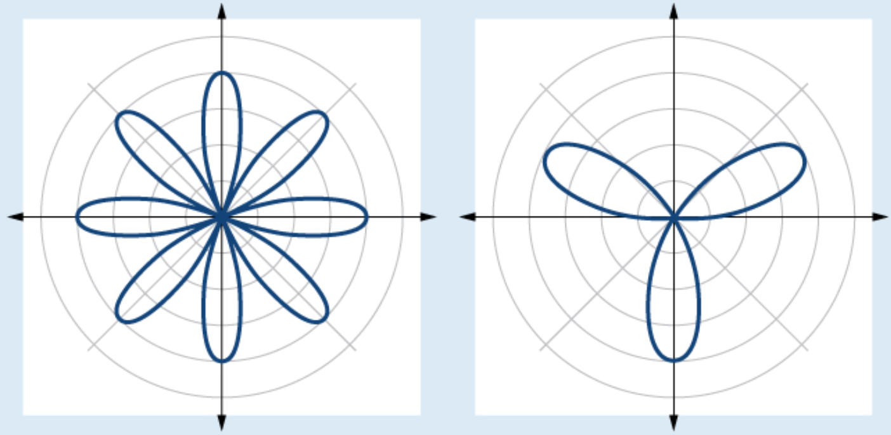 |  | 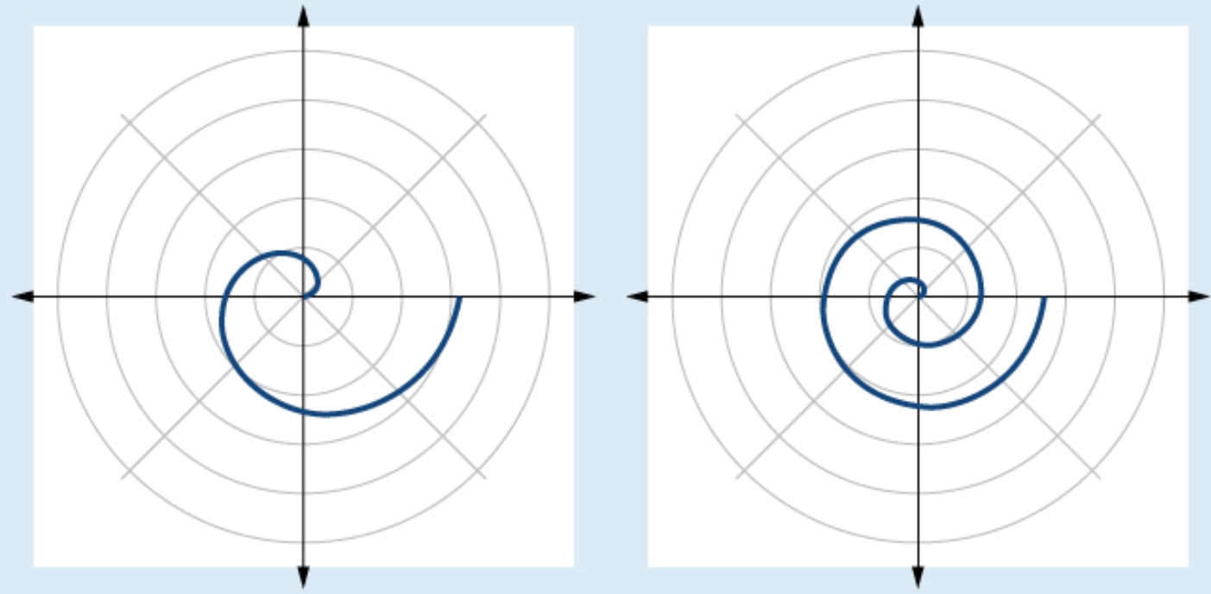
$$r=a\cos{(nθ)}$$  $$a≠0$$  $n$ even, $2n$ petals | $$r=a\sin{(nθ)}$$  $$a≠0$$  $n$ odd. $n$ petals | $$r=θ$$  $$θ>0$$  $$0≤θ≤2π$$ | $$r=θ$$  $$θ≥0$$  $$0≤θ≤4π$$

Sources:
- LibreTexts Mathematics (2025). 6.2: Graphing Basic Polar Equations.

See also:
- Harold’s Algebraic, Transcendental, and Conic Parent Functions Cheat Sheet
- Harold’s Trigonometry Parent Functions Cheat Sheet
- Harold’s Polar Parent Functions Cheat Sheet
