Harold’s
Trigonometry and Hyperbolic Parent Functions
Cheat Sheet
AKA Library of Functions
15 September 2025

Table of Contents:
- Trigonometry
- Inverse Trigonometry
- Hyperbolic
- Inverse Hyperbolic
- Graphing Tips

Trigonometry Functions
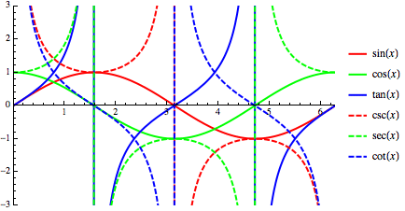
Hyperbolic Functions
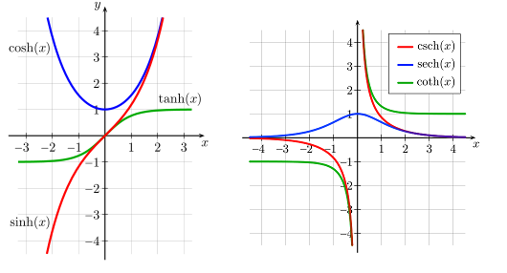
Trigonometry
Sine | $$f(x)=sin x$$ | 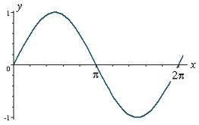 |  | Domain: ($-$∞, ∞) with T = 2π/|b|  Range: [$-$1, 1]  Inverse Function: $f^{-1 }(x)=\sin^{-1}{x}$  Restrictions: None  Odd/Even: Odd  General Form:  $$f\left(x\right)=a sin \left(b\left(x-h\right)\right)+k$$
Cosine | $$f(x)=\cos{x}$$ | 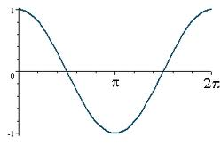 |  | Domain: ($-$∞, ∞) with T = 2π/|b|  Range: [$-$1, 1]  Inverse Function: $f^{-1 }(x)=\cos^{-1}{x}$  Restrictions: None  Odd/Even: Even  General Form:  $$f\left(x\right)=a \cos{ \left(b\left(x-h\right)\right)+k}$$
Tangent | $$f\left(x\right)=\tan{x}$$  $$= \frac{\sin{x}}{\cos{x}}$$ | 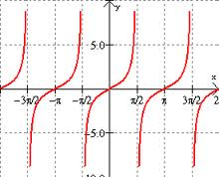 |  | Domain: ($-$∞, ∞) except for $x=\frac{π}{2}±nπ$  Range: ($-$∞, ∞)  Inverse Function: $f^{-1 }(x)=\tan^{-1}{x}$  Restrictions: Asymptotes at $x=\frac{π}{2}±nπ$  Odd/Even: Odd  General Form:  $$f\left(x\right)=a\tan{ \left(b\left(x-h\right)\right)+k}$$
Cosecant | $$f\left(x\right)=\csc{x}$$  $$= \frac{1}{\sin{x}}$$ | 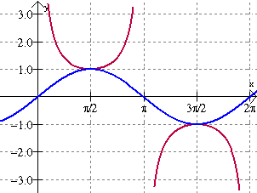 |  | Domain: ($-$∞, ∞) except for $x=±nπ$  Range: ($-$∞, -1] $∪$ [1, ∞)  Inverse Function: $f^{-1 }(x)=\csc^{-1}{x}$  Restrictions: Range is bounded  Odd/Even: Odd  General Form:  $$f\left(x\right)=a \csc{ \left(b\left(x-h\right)\right)+k}$$
Secant | $$f\left(x\right)=\sec{x}$$  $$= \frac{1}{\cos{x}}$$ | 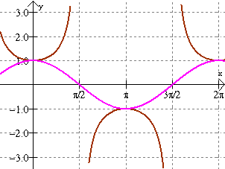 |  | Domain: ($-$∞, ∞) except for $x=\frac{π}{2}±nπ$  Range: ($-$∞,$-$1] $∪$ [1, ∞)  Inverse Function: $f^{-1 }(x)=\sec^{-1}{x}$  Restrictions: Range is bounded  Odd/Even: Even  General Form:  $$f\left(x\right)=a sec \left(b\left(x-h\right)\right)+k$$
Cotangent | $$f\left(x\right)=\cot{x}$$  $$= \frac{1}{\tan{x}}$$ | 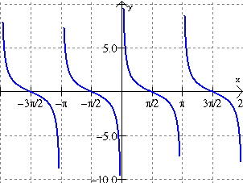 |  | Domain: ($-$∞, ∞) except for $x=±nπ$  Range: ($-$∞, ∞)  Inverse Function: $f^{-1 }(x)=\cot^{-1}{x}$  Restrictions: Asymptotes at x = $±nπ$  Odd/Even: Odd  General Form:  $$f\left(x\right)=a\cot{ \left(b\left(x-h\right)\right)+k}$$
Arcsine | $$f(x)=\sin^{-1}{x}$$ | 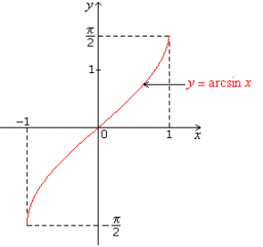 |  | Domain: [$-$1, 1]  Range: $\left[\frac{-π}{2}, \frac{π}{2}\right]$ or Quadrants I & IV  Inverse Function: $f^{-1 }\left(x\right)=\sin{x}$  Restrictions: Range & Domain are bounded  Odd/Even: Odd  General Form:  $$f\left(x\right)=a \sin^{-1 }\left(b\left(x-h\right)\right)+k$$
Arccosine | $$f(x)=\cos^{-1}{x}$$ | 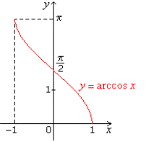 |  | Domain: [$-$1, 1]  Range: $\left[0, π\right]$ or Quadrants I & II  Inverse Function: $f^{-1 }\left(x\right)=\cos{x}$  Restrictions: Range & Domain are bounded  Odd/Even: None  General Form:  $$f\left(x\right)=a \cos^{-1}{ \left(b\left(x-h\right)\right)+k}$$
Arctangent | $$f(x)=\tan^{-1}{x}$$ | 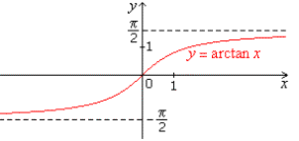 |  | Domain: ($-$∞, ∞)  Range: $\left(\frac{-π}{2}, \frac{π}{2}\right)$ or Quadrants I & IV  Inverse Function: $f^{-1 }\left(x\right)=\tan{x}$  Restrictions: Range is bounded  Odd/Even: Odd  General Form:  $$f\left(x\right)=a\tan^{-1}{ \left(b\left(x-h\right)\right)}{+ k}$$
Arccosecant | $$f(x)=\csc^{-1}{x}$$ | 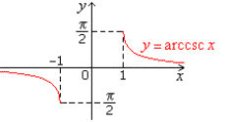 |  | Domain: ($-$∞,$-$1] $∪$ [1, ∞)  Range: $[ -\frac{π}{2}, 0)$ $∪$ $(0, \frac{π}{2}]$ or Quadrants I & IV  Inverse Function: $f^{-1 }\left(x\right)=\csc{x}$  Restrictions: Range & Domain are bounded  Odd/Even: Odd  General Form:  $$f\left(x\right)=a \csc^{-1}\left(b\left(x-h\right)\right)+k$$
Arcsecant | $$f(x)=\sec^{-1}{x}$$ | 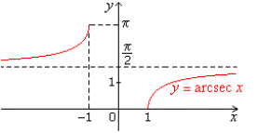 |  | Domain: ($-$∞,$-$1] $∪$ [1, ∞)  Range: $[0, \frac{π}{2})$ $∪$ ($\frac{π}{2}, π]$ or Quadrants I & II  Inverse Function: $f^{-1 }\left(x\right)=\sec{x}$  Restrictions: Range & Domain are bounded  Odd/Even: Neither  General Form:  $$f\left(x\right)=a \sec^{-1} \left(b\left(x-h\right)\right)+k$$
Arccotangent | $$f(x)=\cot^{-1}{x}$$ | 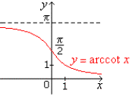 |  | Domain: ($-$∞, ∞)  Range: $(0, π)$ or Quadrants I & II  Inverse Function: $f^{-1 }\left(x\right)=\cot{x}$  Restrictions: Range is bounded  Odd/Even: Neither  General Form:  $$f\left(x\right)=a\cot^{-1}{ \left(b\left(x-h\right)\right)}{+k}$$
Hyperbolics
Hyperbolic Sine | $$f\left(x\right)=\sinh{x}$$  $$= \frac{e^{x}-e^{-x}}{2}$$ |  | 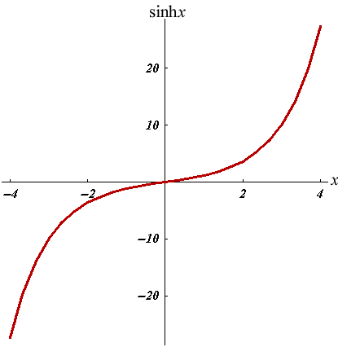 | Domain: ($-$∞, ∞)  Range: ($-$∞, ∞)  Inverse Function: $f^{-1 }(x)=\sinh^{-1}{x}$  Restrictions: None  Odd/Even: Odd  General Form:  $$f\left(x\right)=a sinh \left(b\left(x-h\right)\right)+k$$
Hyperbolic Cosine | $$f(x)=\cosh{x}$$  $$= \frac{e^{x}+e^{-x}}{2}$$ |  | 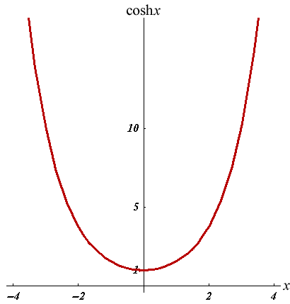 | Domain: ($-$∞, ∞)  Range: [1, ∞)  Inverse Function: $f^{-1 }(x)=\cosh^{-1}{x}$  Restrictions: None  Odd/Even: Even  General Form:  $$f\left(x\right)=a \cosh{ \left(b\left(x-h\right)\right)+k}$$
Hyperbolic Tangent | $$f\left(x\right)=\tanh{x}$$  $$= \frac{e^{2x}-1}{e^{2x}+1}$$ |  | 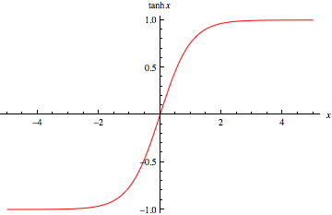 | Domain: ($-$∞, ∞)  Range: ($-$1, 1)  Inverse Function: $f^{-1 }(x)=\tanh^{-1}{x}$  Restrictions: Asymptotes at $y=±1$  Odd/Even: Odd  General Form:  $$f\left(x\right)=a\tanh{ \left(b\left(x-h\right)\right)+k}$$
Hyperbolic Cosecant | $$f\left(x\right)=\operatorname{csch}{x}$$  $$= \frac{1}{\sinh{x}}$$ |  | 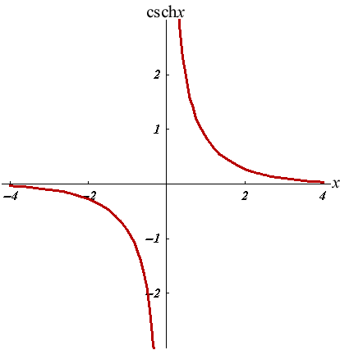 | Domain: ($-$∞, 0) $∪$ (0, ∞)  Range: ($-$∞, 0] $∪$ [0, ∞)  Inverse Function: $f^{-1 }(x)={csch}^{-1}{x}$  Restrictions: Asymptotes at $x=0, y=0$  Odd/Even: Odd  General Form:  $$f\left(x\right)=a \operatorname{csch}\left(b\left(x-h\right)\right)+k$$
Hyperbolic Secant | $$f\left(x\right)=\operatorname{sech}{x}$$  $$= \frac{1}{\cosh{x}}$$ |  | 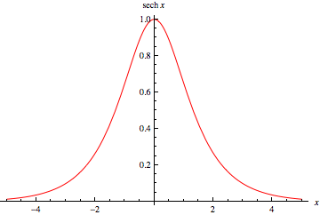 | Domain: ($-$∞, ∞)  Range: (0, 1]  Inverse Function: $f^{-1 }(x)={sech}^{-1}{x}$  Restrictions: Asymptote at $y=0$  Odd/Even: Even  General Form:  $$f\left(x\right)=a sech \left(b\left(x-h\right)\right)+k$$
Hyperbolic Cotangent | $$f\left(x\right)=\coth{x}$$  $$= \frac{1}{\tanh{x}}$$ |  | 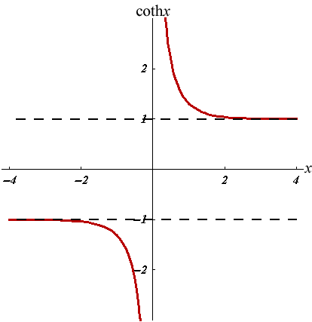 | Domain: ($-$∞, 0) $∪$ (0, ∞)  Range: ($-$∞, 1) $∪$ (1, ∞)  Inverse Function: $f^{-1 }(x)=\coth^{-1}{x}$  Restrictions: Asymptotes at $x=0, y=±1$  Odd/Even: Odd  General Form:  $$f\left(x\right)=a\coth\left(b\left(x-h\right)\right)+k$$
Hyperbolic Arcsine | $$f(x)=\sinh^{-1}{x}$$  $$=\ln{(x+\sqrt{x^{2}+1)}}$$ |  | 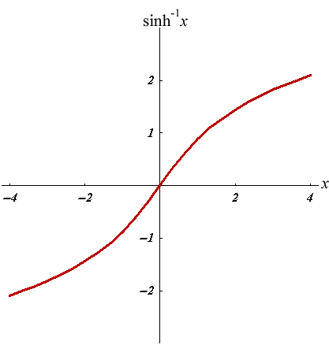 | Domain: ($-$∞, ∞)  Range: ($-$∞, ∞)  Inverse Function: $f^{-1 }\left(x\right)=\sinh{x}$  Restrictions: None  Odd/Even: Odd  General Form:  $$f\left(x\right)=a \sinh^{-1 }\left(b\left(x-h\right)\right)+k$$
Hyperbolic Arccosine | $$f(x)=\cosh^{-1}{x}$$  $$=\ln{(x+\sqrt{x^{2}-1)}}$$ |  | 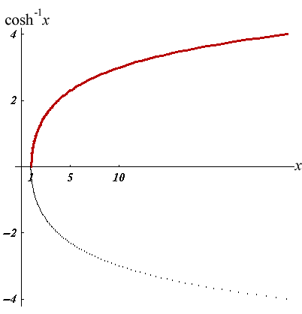 | Domain: [1, ∞)  Range: [0, ∞)  Inverse Function: $f^{-1 }\left(x\right)=\cosh{x}$  Restrictions: $y≥0$  Odd/Even: Neither  General Form:  $$f\left(x\right)=a \cosh^{-1}{ \left(b\left(x-h\right)\right)+k}$$
Hyperbolic Arctangent | $$f(x)=\tanh^{-1}{x}$$  $$=\frac{1}{2}\ln\left(\frac{1+x}{1-x}\right)$$ |  | 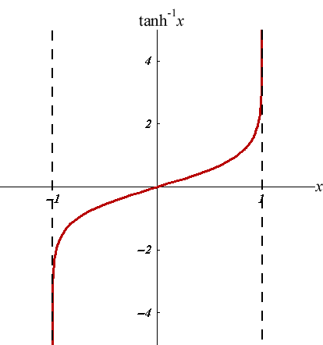 | Domain: ($-$1, 1)  Range: ($-$∞, ∞)  Inverse Function: $f^{-1 }\left(x\right)=\tanh{x}$  Restrictions: Asymptotes at $x=±1$  Odd/Even: Odd  General Form:  $$f\left(x\right)=a\tanh^{-1}{ \left(b\left(x-h\right)\right)}{+ k}$$
Hyperbolic Arccosecant | $$f\left(x\right)={csch}^{-1}{x}$$  $$=\ln\left(\frac{1}{x}+\sqrt{\frac{1}{x^{2}}+1}\right)$$ |  | 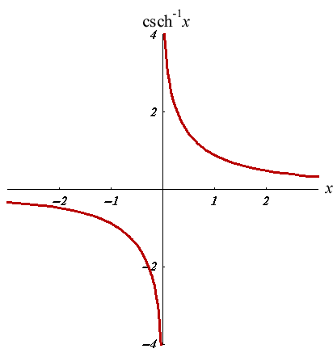 | Domain: ($-$∞, 0) $∪$ (0, ∞)  Range: ($-$∞, 0] $∪$ [0, ∞)  Inverse Function: $f^{-1 }\left(x\right)=\operatorname{csch}{x}$  Restrictions: Asymptotes at $x=0, y=0$  Odd/Even: Odd  General Form:  $$f\left(x\right)=a {csch}^{-1}\left(b\left(x-h\right)\right)+k$$
Hyperbolic Arcsecant | $$f\left(x\right)={sech}^{-1}{x}$$  $$=\ln\left(\frac{1}{x}+\sqrt{\frac{1}{x^{2}}-1}\right)$$ |  | 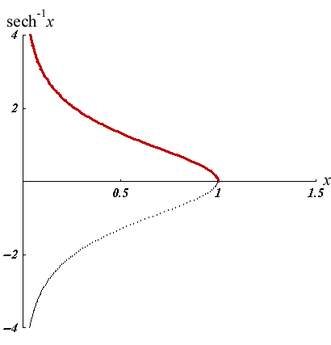 | Domain: (0, 1]  Range: [0, ∞)  Inverse Function: $f^{-1 }\left(x\right)=\operatorname{sech}{x}$  Restrictions:  Odd/Even: Neither  General Form:  $$f\left(x\right)=a {sech}^{-1} \left(b\left(x-h\right)\right)+k$$
Hyperbolic Arccotangent | $$f(x)=\coth^{-1}{x}$$  $$=\frac{1}{2}\ln\left(\frac{x+1}{x-1}\right)$$ |  | 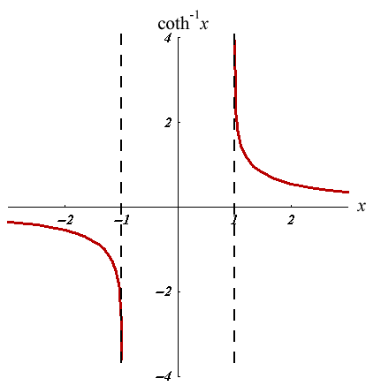 | Domain: $[-∞, -1)$ $∪$ $(1, ∞]$  Range: $(-∞, 0)$ $∪$ $(0, ∞)$  Inverse Function: $f^{-1 }\left(x\right)=\coth{x}$  Restrictions: Asymptotes at $x=0, y=±1$  Odd/Even: Odd  General Form:  $$f\left(x\right)=a\coth^{-1}{ \left(b\left(x-h\right)\right)}{+k}$$

Graphing Tips

$$f(x)=a<trig>(b(x-h))+k$$

The Six Trig “Levers” | y = a sin (b (x - h)) + k | Graphing Tips | Notes
- Move up/down ↕ | k (Vertical translation) | $$k= \frac{(max + min)}{2}$$ | If $k=f(x)$ then x-axis is replaced by $f(x)$-axis
- Move left/right ↔ | h (Phase shift) | ‘+‘ shifts right | $$\sin{(x)}=\cos{(x-π/2)}$$
- Stretch up/down ↕ | a (Amplitude) | $$a= \frac{(max - min)}{2}$$ | a is NOT peak-to-peak on y-axis
- Stretch left/right ↔ | b (Frequency $⦁$ 2$π$) | $$T=\frac{2π}{\left|b\right|}= \frac{1}{ƒ}$$ | T = peak-to-peak on $θ$-axis  $T=\frac{π}{|b|}$ for $tan (bx)$
- Flip about y-axis | b → $-$b | $f(x)$ → $f(-x)$ | Even Function: $\cos{(x)}=\cos{(-x)}$
- Flip about x-axis | a → $-$a | $f(x)$ → $-f(-x)$ | Odd Function: $\sin{(x)}=-sin{(-x)}$

See Also:
- Harold’s Algebraic, Transcendental, and Conic Parent Functions Cheat Sheet
- Harold’s Trigonometry & Hyperbolic Parent Functions Cheat Sheet
- Harold’s Polar Parent Functions Cheat Sheet

